PROPOSED

AMENDMENTS TO THE AREA DESIGNATIONS

FOR STATE AMBIENT AIR QUALITY STANDARDS,

INCLUDING

PROPOSED AMENDMENTS DUE TO

CHANGES IN AIR BASIN BOUNDARIES,

AND

PROPOSED
MAPS OF AREA DESIGNATIONS FOR THE STATE
AND NATIONAL AMBIENT AIR QUALITY STANDARDS

STAFF REPORT

November 21, 1996

Air Resources Board
2020 "L" Street
Sacramento, California

California Environmental Protection Agency
Air Resources Board
Technical Support Division
P.O. Box 2815
Sacramento, California 95812

This document has been reviewed and approved by the staff of the
California Environmental Protection Agency, Air Resources Board.
Approval does not signify that the contents necessarily reflect
the views and policies of the California Air Resources Board.

ACKNOWLEDGMENTS

This document was prepared by the staff of the
Air Quality Analysis Section, Technical Support Division

Principal Author

Cynthia Garcia
Air Pollution Specialist
Technical Support Division

Contributing Staff

David Ipps - Technical Support Division
Lawrence Larsen - Technical Support Division
Roy Moore - Technical Support Division
Marcella Nystrom - Technical Support Division
Judith G. Tracy - Office of Legal Affairs

Reviewed and Approved by:

Debora Popejoy, Manager, Air Quality Analysis Section
Rich Bradley, Chief, Air Quality Data Branch
Terry McGuire, Chief, Technical Support Division

TABLE OF CONTENTS

OVERVIEW AND RECOMMENDATION

A. Overview ................................................................................................. 1
1. Introduction ...............................................................................…. 1
2. Proposed Amendments to the Area Designations ........................... 1

3. Proposed Amendments to the Area Designations due to
Changes in Air Basin Boundaries ........................................... 2
B. Recommendation ................................................................................... 4

CHAPTER I

BACKGROUND

A. Introduction ........................................................................................... 5 B. Legal Requirements .............................................................................. 5 C. Summary of the Designation Criteria ................................................. 6 1. General Provisions .........................................................................……. 6
2. Data to Use ..................................................................................... 6
3. Highly Irregular or Infrequent Events ............................................ 6

4. Size of Designated Areas ............................................................... 7 5. Designation Categories .................................................................…….. 8
D. Implications of the Area Designations ................................................ 8 1. Areas Redesignated as Nonattainment ..........................................…….. 8 2. Areas Redesignated as Nonattainment-Transitional .......................…… 9 3. Areas Redesignated as Attainment or Unclassified .......................……. 10 E. Area Designation Review Process ........................................................ 10

CHAPTER II
PROPOSED AMENDMENTS TO THE AREA DESIGNATIONS

A. Introduction ............................................................................................ 11
B. Proposed Area Redesignation for Ozone ............................................ 11
1. Mono County
(Nonattainment to Nonattainment-Transitional) ..................... 12 C. Proposed Area Redesignations for Carbon Monoxide ...................... 12 1. El Dorado County (Lake Tahoe Air Basin)
(Nonattainment to Nonattainment-Transitional) .................... 13 2. Placer County (Lake Tahoe Air Basin)
(Unclassified to Attainment) .................................................. 14 3. Tuolumne County (Mountain Counties Air Basin)
(Unclassified to Attainment) .................................................. 14
4. Butte County
(Unclassified and Nonattainment to Attainment) ..............…. 15

TABLE OF CONTENTS
(continued)

C. Proposed Area Redesignations for Carbon Monoxide (cont)

5. Placer County (Sacramento Valley Air Basin)
(Unclassified to Attainment) ...............................................… 15 6. Sacramento Urbanized Area
(Nonattainment-Transitional to Attainment) ........................... 16 D. Proposed Area Redesignation for PM10 ............................................. . 16 1. Calaveras County
(Unclassified to Nonattainment) .............................................. 16 E. Proposed Area Redesignation for Sulfates ........................................... 17 1. San Joaquin Valley Air Basin
(Unclassified to Attainment) .................................................... 17 F. Areas Not Recommended for Redesignation ....................................... 17
1. Areas Not Recommend for Ozone Redesignation ........................... 18
a. Inyo County ............................................................................. 18 b. Plumas County .....................................................................……... 18 c. Sonoma County (North Coast Air Basin)................................….... 19
2. Areas Not Recommended for Nitrogen Dioxide Redesignation ..... 19
a. Los Angeles County (South Coast Air Basin) ........................ 19 3. Area Not Recommended for Sulfur Dioxide Redesignation ...........…… 20
a. San Luis Obispo County .................. ...................................... 20
4. Areas Not Recommended for Sulfate Redesignation ...................... 20
a. Los Angeles County (South Coast Air Basin) ......................... 20 b. Riverside County (South Coast Air Basin) .............................…… 21
5. Area Not Recommended for Lead Redesignation ........................... 21
a. Los Angeles County (South Coast Air Basin) ......................... 21 6. Areas Not Recommended for Hydrogen Sulfide Redesignation .....……. 22
a. Lake County ............................................................................ 23 b. Santa Barbara County ..........................................................…….. 23
c. San Luis Obispo County ......................................................... 23

CHAPTER III
PROPOSED AMENDMENTS TO THE AREA DESIGNATIONS DUE TO CHANGES IN THE MOJAVE DESERT, SALTON SEA, AND SOUTH COAST AIR BASIN BOUNDARIES

A. Background ............................................................................................ 25
B. Proposed Amendments to the Area Designations ............................... 25

TABLE OF CONTENTS
(continued)

B. Proposed Amendments to the Area Designations (cont)
1. Mojave Desert Air Basin ................................................................. 26
2. Salton Sea Air Basin ....................................................................... 30
3. South Coast Air Basin .................................................................... 33
C. Recommendation ................................................................................... 33

CHAPTER IV
ALTERNATIVES TO THE PROPOSED AMENDMENTS ........................ 35

CHAPTER V
IMPACTS OF THE PROPOSED AMENDMENTS TO THE AREA DESIGNATIONS

A. Public Health, Public Welfare and Environmental Impacts ............. 37
B. Economic Impacts .................................................................................. 38
C. Public Health, Public Welfare, and Environmental and Economic Impacts of Proposed Amendments due to Changes in the Air Basin
Boundaries .............................................................................................. 39

CHAPTER VI
DOCUMENTS RELIED UPON ....................................................................... 41

ATTACHMENTS

A. Relevant Sections of the Health and Safety Code .................................... 43 B. Maps and Tables of the Proposed Area Designations
for State and National Ambient Air Quality Standards .................... 53
C. Text of the Designation Criteria ................................................................ 91
D. Text of the Proposed Amendments to the Area Designations .................. 107
E. Expected Peak Day Concentrations and Designation Values ................... 129
F. Supporting Documents for Proposed Area Designations .......................... 177
G. Supporting Documents for Proposed Area Designations
due to changes in Air Basin Boundaries .......................................... 197
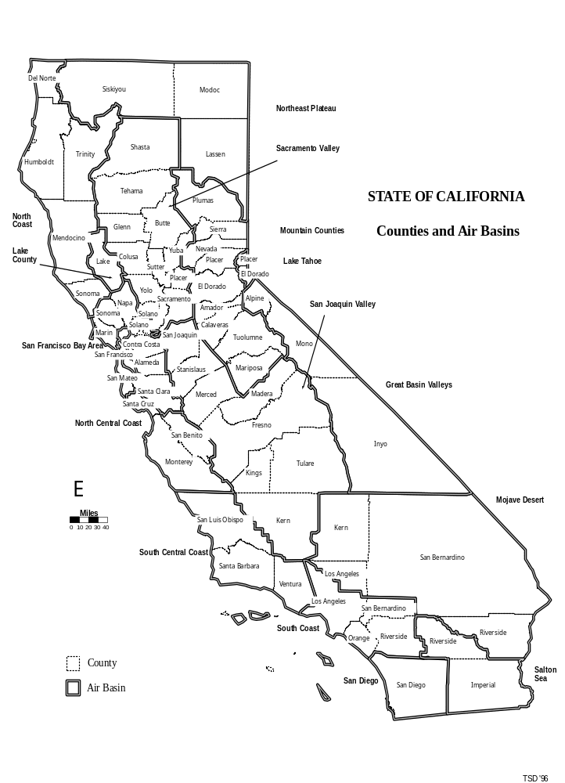

OVERVIEW AND RECOMMENDATION

A. OVERVIEW

1. Introduction

The Health and Safety Code (H&SC) section 39607(e) requires the Air Resources Board (ARB or Board) to establish area designation criteria for state ambient air quality standards (refer to Attachment A). These designation criteria provide the basis for the Board to designate areas as nonattainment, attainment, or unclassified for the State standards for specified pollutants (ozone, carbon monoxide, nitrogen dioxide, sulfur dioxide, PM10, sulfates, lead, hydrogen sulfide, and visibility reducing particles) set forth in section 70200 of Title 17 of the California Code of Regulations (CCR). H&SC section 39607(e) requires the Board to periodically review the designation criteria to ensure their continued relevance. Additionally, H&SC section 39608 requires the Board to establish and annually review the area designations (refer to Attachment A). Based on the most recently available three years of air quality data (data collected during 1993 through 1995), the staff recommends several amendments to the area designations. These proposed amendments are summarized in subsection 2, below.

In addition to the proposed amendments to the area designation reflecting the most recent air quality data, the staff recommends a number of other amendments to the area designations reflecting recent changes in the air basin boundaries. In May 1996, the Board adopted amendments to CCR, Title 17, sections 60104, 60109, and 60114. These amendments created the new Mojave Desert and Salton Sea Air Basins. In addition, the amendments revised the boundary for the South Coast Air Basin. These boundary changes have not yet been approved by the Office of Administrative Law. As a result of these amendments, the staff recommends amendments to the area designation regulations to be consistent with the new and revised air basin boundaries. These proposed amendments are summarized in subsection 3, below.

Finally, this Staff Report includes maps and tables showing the area designations for both the State and national ambient air quality standards (refer to Attachment B). ARB is required by section 40718 of the H&SC (refer to Attachment A) to publish and annually update this information. The maps and tables provided in Attachment B reflect the area designations for State standards as proposed in Chapters II and III of this Staff Report.

2. Proposed Amendments to the Area Designations Due to Annual Review

The proposed amendments to the area designations would make the following changes to the California Code of Regulations (CCR), Title 17, sections 60200 through 60209:

- Redesignate Mono County in the Great Basin Valleys Air Basin as nonattainment-transitional for ozone. Currently, Mono County is designated as nonattainment for ozone.

- Redesignate the portion of El Dorado County in the Lake Tahoe Air Basin as nonattainment-transitional for carbon monoxide. Currently, this portion of
El Dorado County is designated as nonattainment for carbon monoxide.

- Redesignate the portion of Placer County in the Lake Tahoe Air Basin as attainment for carbon monoxide. Currently, this portion of Placer County is designated as unclassified for carbon monoxide.

- Redesignate Tuolumne County in the Mountain Counties Air Basin as attainment for carbon monoxide. Currently, Tuolumne County is designated as unclassified for carbon monoxide.

- Redesignate Butte County in the Sacramento Valley Air Basin as attainment for carbon monoxide. Currently, the Chico Urbanized Area is designated as nonattainment, and the remainder of Butte County is designated as unclassified for carbon monoxide.

- Redesignate the portion of Placer County in the Sacramento Valley Air Basin as attainment for carbon monoxide. Currently, this portion of Placer County is designated as unclassified for carbon monoxide.

- Redesignate Sacramento County in the Sacramento Valley Air Basin as attainment for carbon monoxide. Currently, the Sacramento County portion of the Census Bureau Urbanized Area is designated as nonattainment-transitional, and the remainder of Sacramento County is designated as attainment for carbon monoxide.

- Redesignate Calaveras County in the Mountain Counties Air Basin as nonattainment for suspended particulate matter (PM10). Currently, Calaveras County is designated as unclassified for PM10.

- Redesignate the San Joaquin Valley Air Basin as attainment for sulfates. Currently, the San Joaquin Valley Air Basin is designated as unclassified for sulfates.

3. Proposed Amendments to the Area Designations Due to Changes in Air Basin Boundaries.

The Boards May 30, 1996, adoption of amendments to CCR, Title 17, sections 60104, 60109, and 60114 set the stage for area designations for the newly created Mojave Desert and Salton Sea Air Basins and the amended South Coast Air Basin. These amendments have not yet been approved by the Office of Administrative Law. For the most part, the counties affected retained their area designations under the new air basin names. These boundary changes do not reflect changes in air quality. The proposed amendments to the area designations would make the following changes to the CCR, Title 17, sections 60200 through 60209.

- Designate the Mojave Desert Air Basin as nonattainment for ozone and PM10.

- Designate those portions of Kern County and Riverside County in the
Mojave Desert Air Basin as unclassified for carbon monoxide.

- Designate those portions of Los Angeles and San Bernardino Counties in the Mojave Desert Air Basin as attainment for carbon monoxide.

- Designate the Mojave Desert Air Basin as attainment for nitrogen dioxide.

- Designate those portions of Kern, Los Angeles, Riverside, and San Bernardino Counties in the Mojave Desert Air Basin as attainment for sulfur dioxide and lead.

- Designate the San Bernardino County portion of the Searles Valley Planning Area in the Mojave Desert Air Basin as nonattainment for sulfates, and the remaining portion of the Mojave Desert Air Basin as attainment for sulfates.

- Designate those portions of Kern, Los Angeles, and Riverside Counties in the Mojave Desert Air Basin as unclassified for hydrogen sulfide.

- Designate the San Bernardino County portion of the Searles Valley Planning Area in the Mojave Desert Air Basin as nonattainment for hydrogen sulfide and the remaining portion of San Bernardino County in the Mojave Desert Air Basin as unclassified for hydrogen sulfide.

- Designate the Mojave Desert Air Basin as unclassified for visibility reducing particles.

- Designate the Salton Sea Air Basin as nonattainment for ozone and PM10.

- Designate that portion of Riverside County in the Salton Sea Air Basin as attainment for carbon monoxide.

- Designate the City of Calexico in Imperial County in the Salton Sea Air Basin as nonattainment and the remaining portion of Imperial County as unclassified for carbon monoxide.

- Designate the Salton Sea Air Basin as attainment for nitrogen dioxide and sulfates.

- Designate Imperial County and that portion of Riverside County in the Salton Sea Air Basin as attainment for sulfur dioxide and lead.

- Designate Imperial County and that portion of Riverside County in the Salton Sea Air Basin as unclassified for hydrogen sulfide.

- Designate the Salton Sea Air Basin as unclassified for visibility reducing particles.

- The designations of the South Coast Air Basin remain unchanged as a result of the incorporation of the Banning monitoring site in the San Gorgornio Pass Area.

B. RECOMMENDATION

The staff recommends the Board adopt these proposed amendments to the area designations. The full text of the current regulation and the proposed amendments are given in Attachments C and D to this Staff Report.

CHAPTER I

BACKGROUND

A. INTRODUCTION

This chapter gives background information on the criteria used in making the area designations and on the area designations themselves. The following sections describe the legal requirements, the criteria used to make the area designations, the implications of the designations, and the area designation review process.

B. LEGAL REQUIREMENTS

H&SC section 39607(e) requires the Board to establish and periodically review the criteria for designating areas as nonattainment or attainment for the State ambient air quality standards (State standards; refer to Attachment A). The Board originally adopted the required designation criteria in June of 1989. The Board subsequently amended the designation criteria in June 1990, May 1992, December 1992, November 1993, and November 1995.

H&SC section 39608 requires the Board to use the designation criteria to designate areas of California as nonattainment or attainment with respect to the State standards (refer to Attachment A). Areas that cannot be designated as nonattainment or attainment because of lack of data are designated as unclassified. The area designations are made on a pollutant-by-pollutant basis for all pollutants listed in the CCR, Title 17, section 70200. The nine affected pollutants are ozone, carbon monoxide, nitrogen dioxide, sulfur dioxide, suspended particulate matter (PM10), sulfates, lead, hydrogen sulfide, and visibility reducing particles. H&SC section 39608 requires the Board to review the area designations each year and to update them as new information becomes available.

H&SC section 40718 requires the Board to publish maps showing the areas with one or more measured violations of any State or national ambient air quality standard (refer to Attachment A). The maps and summary tables provided in Attachment B to this Staff Report fulfill this requirement. The maps and tables for the State standards reflect the proposed amendments to the area designations as described in Chapters II and III of this Staff Report. The maps and summary tables for the national ambient air quality standards reflect the current federal area designations, as promulgated by the United States Environmental Protection Agency.

C. SUMMARY OF THE DESIGNATION CRITERIA

1. General Provisions

The designation criteria describe the procedures the Board must use in determining an area's designation status with respect to the State standards (refer to Attachment C). In summary, the designation criteria specify:

- The data the Board will use for making the area designations;
- How the Board will determine whether an area qualifies for designation as nonattainment, attainment, or unclassified;
- How the Board will determine the size of designated areas; and
- The requirement for an annual review of the area designations by the Board's Executive Officer.

2. Data to Use

To the extent possible, the Board makes area designations for each pollutant based on recent ambient air quality data. The air quality data must be data for record, which are those air quality data that satisfy specific siting and quality assurance procedures established by the United States Environmental Protection Agency. Generally, data for record are those data collected by or under the direction of the Board and the air pollution control and air quality management districts. When adequate, recent air quality data are not available, the Board may use other types of information to determine an appropriate area designation. These other types of information may include historical air quality data, emission data, meteorological or topographical data, and data relating to the characteristics of population or emissions.

3. Highly Irregular or Infrequent Events

When area designations for State standards are based on ambient air quality data, the designation criteria provide for excluding unrepresentative values. In particular, the designation criteria provide for excluding exceedances affected by highly irregular or infrequent events because it is not reasonable to mitigate these exceedances through the regulatory process. Appendix 2 to the designation criteria (refer to Attachment C) defines three types of highly irregular or infrequent events:

- Exceptional events,
- Extreme concentration events, and
- Unusual concentration events.

An exceptional event is a specific, identifiable event that is beyond reasonable regulatory control and causes an exceedance of a State standard. An exceptional event may be caused by an act of nature (for example, a severe wind storm or forest fire) or it may be of human origin (for example, a chemical spill or industrial accident).

An extreme concentration event may not have a specific, identifiable cause, but is identified by a statistical procedure which calculates the concentration that is not expected to recur more frequently than once per year. This value commonly is referred to as the Expected Peak Day Concentration. Adverse meteorology is one potential cause of an extreme concentration event. Measured concentrations that are higher than the Expected Peak Day Concentration are identified as extreme concentrations and are excluded from the area designation process. The highest concentration remaining after excluding extreme concentrations is referred to as the designation value.

A pollutant-specific, Expected Peak Day Concentration is calculated for each monitoring site using air quality data measured at the site during a three-year period. The site-specific Expected Peak Day Concentrations for ozone, carbon monoxide, nitrogen dioxide, sulfur dioxide, PM10, sulfates, lead, and hydrogen sulfide are listed in Attachment E. These Expected Peak Day Concentrations are based on air quality data for 1993 through 1995. This is the most recent three-year period for which data are available and is the same three-year period used in reviewing the area designations described in this Staff Report. Note that the Expected Peak Day Concentrations are not given for visibility reducing particles because data are not available for calculating the Expected Peak Day Concentrations for this pollutant.

An unusual concentration event is an event that causes an anomalous exceedance of a State standard. To identify an exceedance as affected by an unusual concentration event, the Executive Officer must find (based on relevant information) that the impact of the affected exceedance is limited to the local area, the exceedance is not expected to recur, and the data do not support a nonattainment designation. Unusual concentration events may be identified only for areas already designated as attainment or unclassified, and exceedances so identified are excluded from consideration in the area designation process. Furthermore, an area may retain its attainment or unclassified designation by virtue of exclusions of exceedances as affected by unusual concentration events for up to three consecutive years only.

4. Size of Designated Areas

The size of the area designated may vary depending on the pollutant, the location of contributing emission sources, the meteorology, and the topographic features. Normally, an air basin is the area designated for ozone, nitrogen dioxide, PM10, sulfates, and visibility reducing particles. A county (or the portion of a county located within an air basin) normally is the area designated for carbon monoxide, sulfur dioxide, lead, and hydrogen sulfide. The Board may designate smaller areas, if the Board finds that a smaller area has distinctly different air quality. This finding is to be based on a review of the air quality data, meteorology, topography, and the distribution of population and emissions. Sources with emissions that contribute to a violation must be included within a nonattainment area. To the extent possible, the Board uses political boundary lines to define designated areas smaller than air basins.

5. Designation Categories

The designation criteria specify three major designation categories: nonattainment, attainment, and unclassified. The Board will designate an area as nonattainment for a pollutant if air quality data show that a State standard for the pollutant was violated at least once during the previous three calendar years. Exceedances that are affected by highly irregular or infrequent events are not considered violations of a State standard and are not used as a basis for designating areas as nonattainment.

The designation criteria specify a subcategory of nonattainment which is called nonattainment-transitional. The Board will designate, at the request of the district, an area as nonattainment-transitional for a pollutant other than ozone if air quality data show that a State standard for that pollutant was violated two or fewer times at each of the sites in the area during the previous calendar year. In addition, an evaluation of recent air quality data trends and meteorological and emission data must show that air quality either has stabilized or has improved. Finally, each site in the area must be expected to reach attainment for the pollutant within three years.

The nonattainment-transitional designation also can apply to ozone. Under H&SC section 40925.5(a), the nonattainment-transitional designations for ozone are made by operation of law (refer to Attachment A). Specifically, an area is designated as nonattainment-transitional for ozone by operation of law if air quality data show that the State ozone standard was exceeded three or fewer times at each of the sites in the air basin during the most recent year for which air quality data are available. The Board has adopted guidelines to use in evaluating whether an area satisfies the requirements of H&SC section 40925.5(a). These guidelines are specified in the designation criteria: CCR, Title 17, section 70303.5 (refer to Attachment C).

The Board will designate an area as attainment for a pollutant if the data show that the State standard for that pollutant was not violated during the previous three calendar years. Again, exceedances affected by highly irregular or infrequent events are not considered violations and, therefore, are not considered in the area designation process. As a result, an area may have measured concentrations that exceed a State standard and still be designated as attainment. If an area has little or no air quality data available to determine its designation for nitrogen dioxide, sulfur dioxide, sulfates, and lead, the designation criteria regulations (CCR, Title 17, section 70304 (c)) allow such an area to be designated as attainment if air quality data, emissions, and population are below specified levels and the area meets certain conditions. Finally, the Board will designate an area as unclassified for a pollutant if the available data do not support a designation of nonattainment or attainment.

D. IMPLICATIONS OF THE AREA DESIGNATIONS

1. Areas Redesignated as Nonattainment

A district that includes an attainment or unclassified area that is redesignated as nonattainment (a nonattainment district) experiences two principal consequences under the law. First, State law requires districts that are nonattainment to develop plans for attaining the State standards for any of four pollutants (ozone, carbon monoxide, nitrogen dioxide, and sulfur dioxide). The nonattainment districts must submit these attainment plans to the Board for approval (H&SC section 40911). Ozone nonattainment districts that are impacted by transport from upwind areas (in other words, ozone violations are caused by emissions transported from upwind areas located outside the district) are required to develop ozone attainment plans for mitigation of only violations that would occur in the absence of the transport contribution (H&SC sections 39610(b) and 40912). In this case, the upwind district(s) would be responsible for mitigating the ozone violations in the downwind nonattainment area that are caused by overwhelming transport (CCR, Title 17, Subchapter 1.5, Article 6, section 70600).

A district is not subject to any specific statutory planning requirements if it is redesignated as nonattainment for any of the remaining five pollutants--PM10, sulfates, lead, hydrogen sulfide, or visibility reducing particles. However, such districts must adopt and enforce rules and regulations to expeditiously attain the State standards for these five pollutants (H&SC section 40001). Furthermore, a nonattainment district may develop and implement an attainment plan or adopt regulations to control the emissions that contribute to these pollutants (H&SC section 40926).

The second possible consequence of a nonattainment designation is the ability to levy fees under certain conditions. Nonattainment districts are authorized to levy a fee of up to $4.00 on motor vehicles registered in the district for the purposes of California Clean Air Act implementation (H&SC sections 44223 and 44225).

2. Areas Redesignated as Nonattainment-Transitional

Nonattainment-transitional is a subcategory of the nonattainment designation. Therefore, a district with an area that is redesignated as nonattainment-transitional is subject to the same legal requirements as a nonattainment district (refer to discussion in subsection 1, above).

However, in contrast to the simple nonattainment designation, nonattainment-transitional status may signal a change in how these legal requirements are implemented. For example, a district that currently is implementing an approved attainment plan may determine that some of the additional control measures contained in the attainment plan are not needed to reach attainment by the earliest practicable date. As a result, nonattainment-transitional status provides the district with a signal that it may be appropriate to review and perhaps modify its approved attainment plan.

District actions in response to a nonattainment-transitional designation must be consistent with State and federal regulations and statutes. H&SC section 40925.5 specifically allows a district with an area designated as nonattainment-transitional for ozone to shift some stationary source control measures from the rule making calendar to the contingency category if the district finds these control measures no longer are necessary to accomplish expeditious attainment of the State ozone standard. These actions are subject to the Board's review and approval and do not apply to control measures required to mitigate the effects of pollutant transport.

3. Areas Redesignated as Attainment or Unclassified

State law does not impose any specific planning requirements upon districts because they include areas redesignated as attainment or unclassified. However, State law does require that the State standards not only be attained but also, maintained. State law requires the districts and the Board to make a coordinated effort to protect and enhance the ambient air quality. As part of this effort, the districts must adopt rules and regulations sufficiently effective to attain and maintain the State standards (H&SC sections 39001, 40001, and 41500).

E. AREA DESIGNATION REVIEW PROCESS

Both the H&SC (section 39608(c)) and the designation criteria (CCR, Title 17, section 70306) require the Board to review the area designations annually and to redesignate areas as new information becomes available (refer to Attachments A and C, respectively). As part of this review process, the staff distributed two notices.

On April 5, 1996, the staff sent a letter to all districts notifying them of the May 1, 1996, deadline for requesting a change in an area's designation, submitting information for consideration in the annual review process, or requesting a nonattainment-transitional designation for pollutants other than ozone. Note that the nonattainment-transitional designations for ozone are made by operation of law, rather than by the Board, so a district request is not needed.

On July 1, 1996, the staff distributed a general announcement for a public consultation meeting held August 1, 1996. This announcement included a table summarizing the staff's proposed redesignations. As required by the designation criteria, the proposed area redesignations are based on the staff's review of the air quality data collected during the most recent three calendar years--1993 through 1995.

CHAPTER II

PROPOSED AMENDMENTS TO THE AREA DESIGNATIONS

A. INTRODUCTION

This chapter describes and explains the proposed amendments to the area designations due to air quality changes. The proposed area redesignations are consistent with the designation criteria established in the CCR, Title 17, sections 70300 through 70306. Chapter III address changes in the area designation to conform to the air basin boundary changes, which were adopted on May 30, 1996. These amendments have not yet been approved by the Office of Administrative Law.

The proposed redesignations are based on air quality data for record as defined in
section 70301 of the designation criteria. The air quality data used for redesignating an area as nonattainment must be representative of the averaging time specified in the State standard. The air quality data used for redesignating an area as attainment or nonattainment-transitional also must be representative, and the air quality data must be complete. The specific requirements for evaluating data representativeness and data completeness are given in Appendices 1 and 3, respectively, to the designation criteria regulations (refer to Attachment C).

As required by the designation criteria, the staff reviewed the air quality data collected during the three-year period of 1993 through 1995. Based on these data, redesignations are appropriate only for four of the nine pollutants for which the Board makes area designations. The affected pollutants are: ozone, carbon monoxide, PM10, and sulfates. Based on the 1993 through 1995 data, no action is proposed for the remaining five pollutants: nitrogen dioxide, sulfur dioxide, lead, hydrogen sulfide, and visibility reducing particles. Therefore, the current area designations for these five pollutants would remain unchanged.

Sections B, C, D and E of this chapter describe the areas and circumstances for which the staff is proposing area redesignations. Section F describes the areas where air quality data would appear to signal a change in the area designation, but, which for various reasons, the staff does not recommend redesignations. Attachment F includes supporting documents for the proposed changes.

B. PROPOSED AREA REDESIGNATION FOR OZONE

The State standard for ozone is a 1-hour average concentration of 0.09 parts per million (ppm). This concentration is not to be exceeded (CCR, Title 17, section 70200). Based on air quality data for 1993 through 1995, one area qualifies for redesignation for ozone. This area is Mono County in the Great Basin Valleys Air Basin.

1. Mono County (Nonattainment to Nonattainment-Transitional)

Currently, Mono County in the Great Basin Valleys Air Basin is designated as nonattainment for the State ozone standard. Based on data collected at the Mammoth Lakes site during 1995, Mono County (by operation of law) qualifies for a change in designation to nonattainment-transitional.

Section 40925.5(a) of the H&SC (see Attachment A) provide that an ozone nonattainment area shall be redesignated as nonattainment-transitional by operation of law if there are three or fewer exceedances of the State ozone standard at every monitoring site in the air basin during the last calendar year. A change in designation that is carried out by operation of law does not require an action by the Air Resources Board.

There were three ozone monitors in the Great Basin Valleys Air Basin: one in Mammoth Lakes, Mono County, one in Bishop, Inyo County, and one in Death Valley National Park, Inyo County. Ozone data for the Mammoth Lakes site for 1993 and 1995 show four days with ozone concentrations that exceed the State standard. These four exceedances range from 0.10 ppm to 0.12 ppm. Two of the four exceedances are higher than the Expected Peak Day Concentration of 0.10 ppm. These two exceedances qualify as extreme concentration events and, therefore, are not considered violations of the State ozone standard. However, the remaining two exceedances are considered violations of the State ozone standard and, therefore, Mono County does not qualify for attainment.

During 1995, data for the Mammoth Lakes site showed only two exceedances of the State ozone standard. There were no exceedances in 1995 at the ozone monitors at the Death Valley or Bishop sites, although the data are considered incomplete for both of these sites for that year. Based on data from the Mammoth Lakes site, Mono County qualifies as nonattainment-transitional for ozone.

Based on the 1995 ozone data collected at the Mammoth Lakes, Bishop, and Death Valley sites, the staff recommends the Board affirm the redesignation of Mono County as nonattainment-transitional for ozone. This proposed redesignation is based on H&SC section 40925.5(a) and the guidelines specified in CCR, Title 17, section 70303.5. The redesignation affects CCR, Title 17, section 60201.

C. PROPOSED AREA REDESIGNATIONS FOR CARBON MONOXIDE

There are three State standards for carbon monoxide (CO)--a one-hour average standard and two 8-hour average standards. The one-hour average standard of 20 ppm, not to be exceeded, applies statewide. An 8-hour average standard of 9.0 ppm, not to be exceeded, applies in all areas of California except for the Lake Tahoe Air Basin. In the Lake Tahoe Air Basin, a more stringent 8-hour standard of 6 ppm, not to be equaled or exceeded, applies (CCR, Title 17, section 70200).

There were only a few areas of the State which exceeded the applicable State 8-hour CO standard during 1993 through 1995. Therefore, five areas are proposed for redesignation to attainment and one area is proposed for redesignation to nonattainment-transitional. Only three areas in the State remain nonattainment. This trend toward attainment for carbon monoxide can be, in part, attributed to the addition of oxygenates to gasoline in 1992. In regards to the 1-hour standard, except for one monitoring site in the South Coast Air Basin (Lynwood) and one monitoring site in the Salton Sea Air Basin (Calexico-Ethel Street), there were no exceedances of the State 1-hour CO standard in any area of the State during 1993 through 1995.

Based on air quality data from 1993 through 1995, six areas qualify for redesignation for the State CO standards. These areas are: El Dorado County and Placer County in the Lake Tahoe Air Basin, Tuolumne County in the Mountain Counties Air Basin, and Butte County, Placer County, and Sacramento County in the Sacramento Valley Air Basin.

1. El Dorado County (Lake Tahoe Air Basin) (Nonattainment to Nonattainment-Transitional)

The eastern portion of El Dorado County is located in the Lake Tahoe Air Basin. Currently, the Lake Tahoe Air Basin portion of El Dorado County is designated as nonattainment for CO. Pursuant to the designation criteria (CCR, Title 17, section 70303(c)), the Board must redesignate an area as nonattainment-transitional for a pollutant other than ozone if a district requests redesignation by May 1 and if the Board finds that the following three conditions are satisfied:

- There were two or fewer days at each site in the area during the previous calendar year with violations of the State standard (excluding data found to be affected by highly irregular or infrequent events);
- An evaluation of multiple years of data shows that the air quality has stabilized or is improving, and every site in the area is expected to reach attainment within three years; and
- The geographic extent of the area is consistent with the criteria in CCR, Title 17, section 70302.

During 1995, there was one violation of the 8-hour State standard for the Lake Tahoe Air Basin at the South Lake Tahoe-Stateline site (6.3 ppm). Furthermore, an analysis of air quality and emission data completed by the ARB staff shows that this area is expected to reach attainment within the allowable three-year period (the details of this analysis are given in Attachment F to this Staff Report).

Based on the 1995 CO data and the results of the staff's attainment analysis, the staff recommends the Board redesignate the portion of El Dorado County in the Lake Tahoe Air Basin as nonattainment-transitional for the State CO standards. This redesignation is based on the provisions in CCR, Title 17, section 70303(c) and affects CCR, Title 17, section 60202.

2. Placer County (Lake Tahoe Air Basin) (Unclassified to Attainment)

The eastern portion of Placer County is located in the Lake Tahoe Air Basin. Currently, this portion of Placer County is designated as unclassified for the State CO standards.

During 1993 through 1995, the staff conducted monitoring at a site in Tahoe City. These data are considered to be data for record. No exceedances of the State CO standards were measured. Furthermore, data collected at the Tahoe City-River Road site represent an area of expected high concentrations. The maximum 8-hour average concentration for this designation period, after excluding three exceedances as extreme concentrations, was 3.6 ppm. These exceedances of 4.7 ppm, 4.3 ppm, and 3.8 ppm at the Tahoe City-River Road site are higher than the Expected Peak Day Concentration of 3.7 ppm. Therefore, these exceedences are excluded as affected by extreme concentration events. The data from the Tahoe City-River Road site is missing for part of the second and fourth quarter of 1995. However, the data for 1993 through 1994 are considered complete based on Appendix 3 of CCR, Title 17, sections 70300 through 70306. These years of data are sufficient because the maximum pollutant concentration of 3.6 ppm, after exclusions, is less than three-fourths of the 8-hour CO standard of 6 ppm, not to be equalled or exceeded. Therefore, the number of years to be included for the purpose of determining data completeness is two.

Based on the 1993 through 1995 CO data collected at the Tahoe City-River Road site, the staff recommends the Board redesignate the portion of Placer County in the Lake Tahoe
Air Basin as attainment for the State CO standards. This proposed redesignation is based on the provisions in CCR, Title 17, section 70304(a) and affects CCR, Title 17, section 60202.

3. Tuolumne County (Unclassified to Attainment)

Tuolumne County is located in the Mountain Counties Air Basin. Currently, Tuolumne County is designated as unclassified for the State CO standards.

During 1993 through 1995, the staff conducted monitoring at the Barretta Street site in Sonora. These data are considered to be data for record. No exceedances of the State CO standards were measured. The maximum 8-hour average concentration for this designation period was 3.4 ppm. During the winters of 1994/95 and 1995/96, CO monitoring studies were conducted with saturation monitors in Sonora. These studies showed that a location in downtown Sonora, other than the Barretta Street site, had higher concentrations. The concentrations during the study periods were less than half of the level of the standard at all monitors and correlated well with the routine monitor at Barretta Street. Since the maximum 8-hour average data for record was 3.4 ppm at the Barretta Street monitor, there is good assurance that there would have been no exceedances at any location in Sonora.

Based on the 1993 through 1995 CO data collected at the Sonora-Barretta Street site, the staff recommends the Board redesignate Tuolumne County in the Mountain Counties Air Basin as attainment for the State CO standards. This proposed redesignation is based on the provisions in CCR, Title 17, section 70304(a) and affects CCR, Title 17, section 60202.

4. Butte County (Unclassified and Nonattainment to Attainment)

Butte County in the Sacramento Valley Air Basin is divided into two designation areas for the State CO standards. The Chico Urbanized Area is currently designated as nonattainment, while the remainder of Butte County is designated as unclassified.

During 1993 through 1995, the staff conducted monitoring at two sites in the Chico area: Chico-Manzanita Avenue and Chico-Salem Street. No exceedances of the State CO standards were measured at either site. The maximum 8-hour average concentration for this designation period was 5.8 ppm. The data from the Chico-Salem Street site is missing for the first quarter of 1993. However, the data for 1994 through 1995 are considered complete based on Appendix 3 of CCR, Title 17, sections 70300 through 70306. These years of data are sufficient because the maximum pollutant concentration of 5.8 ppm is less than three-fourths of the 8-hour CO standard, and therefore the number of years to be included for the purpose of determining data completeness is two. Although there are no CO monitoring sites outside of the Chico Urbanized Area, the staff has determined that the CO concentrations in the Chico Urbanized Area reflect the highest CO concentrations expected in the county.

Based on the 1994 through 1995 CO data collected at the Chico-Manzanita Avenue and Chico-Salem Street sites, the staff recommends the Board redesignate all of Butte County in the
Sacramento Valley Air Basin as attainment for the State CO standards. This proposed redesignation is based on the provisions in CCR, Title 17, section 70304(a) and affects CCR, Title 17, section 60202.

5. Placer County (Sacramento Valley Air Basin) (Unclassified to Attainment)

The western portion of Placer County is located in the Sacramento Valley Air Basin. Currently, this portion of Placer County is designated as unclassified for the State CO standards.

During 1993 through 1995, the ARB and district staffs conducted monitoring at sites in Auburn, Lincoln, Rocklin, and Roseville. No exceedances of the State CO standards were measured at any of these sites. Furthermore, data collected at the Rocklin and Roseville sites represent areas of expected high concentrations. The maximum 8-hour average concentration for this designation period was 3.0 ppm. The data from the Roseville site is missing for the first quarter of 1993. However, the data for 1994 through 1995 are considered complete based on Appendix 3 of CCR, Title 17, sections 70300 through 70306. The period is complete because the maximum pollutant concentration of 3.0 ppm is less than three-fourths of the 8-hour CO standard, and therefore the number of years to be included for the purpose of determining data completeness is two.

Based on the 1993 through 1995 CO data collected at the Placer County (Sacramento Valley Air Basin) sites, the staff recommends the Board redesignate the portion of Placer County in the Sacramento Valley Air Basin as attainment for the State CO standards. This proposed redesignation is based on the provisions in CCR, Title 17, section 70304(a) and affects
CCR, Title 17, section 60202.

6. Sacramento Urbanized Area (Nonattainment-Transitional to Attainment)

Sacramento County in the Sacramento Valley Air Basin is divided into two designation areas for the State CO standards. The Sacramento County portion of the Census Bureau Urbanized Area is currently designated as nonattainment-transitional, while the remainder of Sacramento County is designated as attainment.

During 1993, there were two exceedances of the State 8-hour CO standard in the Sacramento County portion of the Census Bureau Urbanized Area. There was one 8-hour exceedance at the Sacramento-T Street site and one 8-hour exceedance at the Sacramento-El Camino and Watt site. The exceedance at the T Street site (9.4 ppm) is higher than the Expected Peak Day Concentration of 8.3 ppm. Therefore, this exceedance is excluded as an extreme concentration event. Similarly, the exceedance at the El Camino and Watt site (also 9.4 ppm) is higher than the Expected Peak Day Concentration of 9.2 ppm. Therefore, this exceedance also is excluded as an extreme concentration event. Because these exceedances are excluded, they are not considered violations of the State 8-hour CO standard. The maximum remaining 8-hour average concentration for this designation period was 9.0 ppm, which does not exceed the State standard.

Based on the data for 1993 through 1995, the staff recommends the Board redesignate the Sacramento County portion of the Census Bureau Urbanized Area as attainment for the State CO standards. This would make all of Sacramento County attainment for CO. This proposed redesignation is based on the provisions in CCR, Title 17, section 70304(a) and affects
CCR, Title 17, section 60202.

D. PROPOSED AREA REDESIGNATIONS FOR PM10

There are two State standards for PM10--a 24-hour average standard of 50 micrograms per cubic meter (ug/m3) and an annual geometric mean standard of 30 ug/m3. Neither of these State PM10 standards is to be exceeded (CCR, Title 17, section 70200). Based on air quality data from 1993 through 1995, only one area, Calaveras County, qualifies for redesignation for the State PM10 standards.

1. Calaveras County (Unclassified to Nonattainment)

Calaveras County is located in the Mountain Counties Air Basin. Currently, Calaveras County is designated as unclassified for the State PM10 standards.

During 1994 through 1995, the staff conducted monitoring at a site in San Andreas. There were no exceedances of the annual geometric mean of 30 ug/m3. Two exceedances of the 24-hour average standard occurred at the San Andreas-Gold Strike Road site of 118 ug/m3 and 57 ug/m3 in 1995. Although both of these exceedances currently are violations of the State 24-hour PM10 standard, staff expects the exceedance of 118 ug/m3 to be excluded as an extreme concentration event when three years of complete data are available. Note that samples of PM10

for the 24-hour standard are collected once every six days. Therefore, when a violation of the 24-hour standard is recorded, it may, in fact, represent a violation for more than one day.

Based on the 1994 through 1995 PM10 data collected at the San Andreas-Gold Strike Road site, the staff recommends the Board redesignate Calaveras County as nonattainment for the State PM10 standards. This proposed redesignation is based on the provisions in
CCR, Title 17, section 70303(a) and affects CCR, Title 17, section 60205.

E. PROPOSED AREA REDESIGNATION FOR SULFATES

The State standard for sulfates is a 24-hour average concentration of 25 micrograms per cubic meter (ug/m3), not to be equaled or exceeded. Based on air quality data from 1993 through 1995, one area qualifies for redesignation for the State sulfates standard. This area is the San Joaquin Valley Air Basin.

1. San Joaquin Valley Air Basin (Unclassified to Attainment)

The San Joaquin Valley Air Basin currently is designated as unclassified for the State sulfates standard.

During 1993 through 1995, the ARB and district staffs conducted monitoring at four sites in Kern County. These data are considered to be data for record. No exceedances of the State sulfates standard were measured at any of the four monitoring sites. The maximum value for this designation period was 15 ug/m3. Although there are no sulfates monitoring sites in the other counties within the San Joaquin Valley Air Basin, the staff has determined that the sulfates concentrations in Kern County reflect the highest sulfates concentrations expected in the air basin due to the types of emission sources in Kern County.

Based on the 1993 through 1995 sulfates data collected at the Kern County sites, the staff recommends the Board redesignate the San Joaquin Valley Air Basin as attainment for the State sulfates standard. This proposed redesignation is based on the provisions in CCR, Title 17, section 70304(a) and affects CCR, Title 17, section 60206.

F. AREAS NOT RECOMMENDED FOR REDESIGNATION

This section describes 11 areas of the State that currently are designated as attainment or unclassified, and for which air quality data collected during 1993 through 1995 show exceedances of a State standard. The staff does not recommend redesignating these areas because the measured exceedances are excluded as highly irregular or infrequent events under the provisions of Appendix 2 to the designation criteria. The 11 areas and the affected pollutants are: Inyo County (ozone); Plumas County (ozone); Sonoma County, North Coast Air Basin (ozone); Los Angeles County, South Coast Air Basin (nitrogen dioxide); San Bernardino County, San Luis Obispo County (sulfur dioxide); Los Angeles County, South Coast Air Basin (sulfates); Riverside County, South Coast Air Basin (sulfates); Los Angeles County, South Coast Air Basin (lead); Lake County (hydrogen sulfide); Santa Barbara County (hydrogen sulfide); and San Luis Obispo County (hydrogen sulfide). The specifics of each case are described below.

1. Areas Not Recommended for Ozone Redesignation

The State ozone standard is a 1-hour average concentration of 0.09 ppm, not to be exceeded (CCR, Title 17, section 70200).

a. Inyo County

Inyo County in the Great Basin Valleys Air Basin currently is designated as unclassified for the State ozone standard. During 1993 through 1995, the Great Basin Unified Air Pollution Control District collected ozone data at a site in Bishop. This site has been closed since April 4, 1995. The Bishop data show no exceedances of the State ozone standard. In addition to the Bishop data, the National Park Service has been collecting ozone data since December 1993, at a site at the Death Valley National Park. The ozone data for the Death Valley site show two days during 1994 with maximum hourly concentrations exceeding the State ozone standard. The maximum concentrations on these days were 0.10 ppm on May 22 and 0.10 ppm on July 15. Because the data for the Death Valley monitoring site are incomplete, a reliable Expected Peak Day Concentration cannot be calculated for this site. Therefore, the exceedances cannot be excluded as extreme concentration events. However, exceedances measured in areas designated as unclassified may qualify for exclusion as unusual concentration events.

These exceedances may be considered affected by an unusual concentration events if the Boards Executive Officer finds that the impact of the exceedances are limited to the local area, the exceedances are not likely to recur, and the data are not sufficient to support a nonattainment designation. Based on a review of air quality and emission data the Executive Officer has found, that the impact of the exceedances is limited to the local area, and, thus far, data for record since 1995 have shown no further exceedances suggesting that these values are not likely to recur more frequently than extreme concentration events. Furthermore, the air quality data that are available are not sufficient to support a nonattainment designation.

In November 1995, the Executive Officer identified the exceedance on May 22, 1994, as affected by an unusual concentration event. Because this exceedance and the exceedance on July 15, 1994, satisfy the conditions specified in Appendix 2 to the designation criteria, they both qualify as affected by unusual concentration events and are excluded from this years area designation process. As a result, the staff does not recommend any change to Inyo Countys unclassified designation for the State ozone standard.

b. Plumas County

Plumas County in the Mountain Counties Air Basin currently is designated as unclassified for the State ozone standard. During 1993 through 1995, there was one exceedance of the State standard at the Quincy-North Church Street site. A maximum hourly ozone concentration of 0.11 ppm occurred on June 12, 1995. Because data for the Quincy-North Church Street site are incomplete, a reliable Expected Peak Day Concentration cannot be calculated for this site. Therefore, the exceedance cannot be excluded as an extreme concentration event.

Exceedances measured in areas designated as unclassified may qualify for exclusion as unusual concentration events. As discussed above, to identify an exceedance as affected by an unusual, concentration event, the exceedance must meet certain criteria. Based on a review of air quality and emission data, the impact of the exceedance appears to be limited to the local area.
In addition, the air quality data that are available, although limited, do not indicate that the exceedance is likely to recur. Finally, the available air quality data are not sufficient to support a nonattainment designation. Because the exceedance satisfies the conditions specified in Appendix 2 to the designation criteria, the exceedance qualifies as affected by an unusual concentration event and is excluded from the area designation process. As a result, the staff does not recommend any change to Plumas Countys unclassified designation for the State ozone standard.

c. Sonoma County (North Coast Air Basin)

The portion of Sonoma County located in the North Coast Air Basin currently is designated as attainment for the State ozone standard. During October 1994, a 1-hour ozone concentration of 0.10 ppm was measured at the Healdsburg-Municipal Airport site. This concentration exceeds the State ozone standard. Based on ozone data collected during 1993 through 1995, the Expected Peak Day Concentration for this site is 0.09 ppm. These data are considered to be data for record. Because the measured exceedance is higher than the Expected Peak Day Concentration, the exceedance qualifies as affected by an extreme concentration event and is excluded from the designation process.

The remaining ozone data collected during 1993 through 1995 at this site show no exceedances of the State standard. Therefore, the staff does not recommend any change to the ozone attainment designation for the portion of Sonoma County in the North Coast Air Basin.

2. Areas Not Recommended for Nitrogen Dioxide Redesignation

The State nitrogen dioxide standard is a 1-hour average concentration of 0.25 ppm, not to be exceeded (CCR, Title 17, section 70200).

a. Los Angeles County (South Coast Air Basin)

The portion of Los Angeles County located in the South Coast Air Basin currently is designated as attainment for the State nitrogen dioxide standard. During September 1993, a

1-hour nitrogen dioxide concentration of 0.26 ppm was measured at the Pico Rivera site. This concentration exceeds the State nitrogen dioxide standard. Based on nitrogen dioxide data collected during 1993 through 1995, the Expected Peak Day Concentration for this site is
0.22 ppm. These data are considered to be data for record. Because the measured exceedance is higher than the Expected Peak Day Concentration, the exceedance qualifies as affected by an extreme concentration event and is excluded from the designation process.

The remaining nitrogen dioxide data collected during 1993 through 1995 at sites in the South Coast Air Basin portion of Los Angeles County show no exceedances of the State standard. Therefore, the staff does not recommend any change to the nitrogen dioxide attainment designation for the portion of Los Angeles County in the South Coast Air Basin.

3. Areas Not Recommended for Sulfur Dioxide Redesignation
There are two State standards for sulfur dioxide: a 1-hour average concentration of
0.25 ppm and a 24-hour average concentration of 0.04 ppm. Both of these concentrations are not to be exceeded (CCR, Title 17, section 70200).

a. San Luis Obispo County

San Luis Obispo County in the South Central Coast Air Basin currently is designated as attainment for the State sulfur dioxide standards. During June 1993, a 1-hour sulfur dioxide concentration of 0.57 ppm and a 24-hour sulfur dioxide concentration of 0.05 ppm were measured at the Nipomo-1300 Guadalupe monitoring site. Based on sulfur dioxide data for 1993 through 1995, the 1-hour Expected Peak Day Concentration for this site is 0.15 ppm, and the
24-hour Expected Peak Day Concentration is 0.03 ppm. These data are considered to be data for record. Because the measured exceedances are higher than the applicable Expected Peak Day Concentration, they qualify as affected by extreme concentration events and are excluded from the area designation process.

The remaining 1993 through 1995 sulfur dioxide data collected at sites in San Luis Obispo County show no exceedances of the State standards. Therefore, the staff does not recommend any change to San Luis Obispo Countys attainment designation for the State sulfur dioxide standards.

4. Areas Not Recommended for Sulfates Redesignation

The State standard for sulfates is a 1-hour average concentration of 25 micrograms per cubic meter (ug/m3), not to be equaled or exceeded (CCR, Title 17, section 70200).

a. Los Angeles County (South Coast Air Basin)

The portion of Los Angeles County in the South Coast Air Basin currently is designated as attainment for the State sulfates standard. During 1994, three exceedances of the State sulfates standard were measured at three sites. The measured concentrations were 27 ug/m3 at the West Los Angeles-VA Hospital site, 27 ug/m3 at the Hawthorne site, and 26 ug/m3 at the Pico Rivera site. Based on sulfates data collected during 1993 through 1995, the Expected Peak Day

Concentrations for these sites are 19 ug/m3, 23 ug/m3, and 20 ug/m3, respectively. These data are considered to be data for record. Because all the measured exceedances are higher than the applicable Expected Peak Day Concentration, they qualify as affected by extreme concentration events and are excluded from the area designation process.

The remaining sulfates data collected during 1993 through 1995 at monitoring sites in the South Coast Air Basin portion of Los Angeles County show no exceedances of the State standard. Therefore, the staff does not recommend any change to the sulfates attainment designation for the portion of Los Angeles County in the South Coast Air Basin.

b. Riverside County (South Coast Air Basin)

The portion of Riverside County in the South Coast Air Basin currently is designated as attainment for the State sulfates standard. During April 1995, one exceedance of the State sulfates standard was measured in this portion of Riverside County. The measured concentration was 26 ug/m3 at the Riverside-Rubidoux site. Based on sulfates data collected during 1993 through 1995, the Expected Peak Day Concentration for this sites is 20 ug/m3. These data are considered to be data for record. Because the measured exceedance is higher than the applicable Expected Peak Day Concentration, it qualifies as affected by an extreme concentration event and is excluded from the area designation process.

The remaining sulfates data collected during 1993 through 1995 at monitoring sites in the South Coast Air Basin portion of Riverside County show no exceedances of the State standard. Therefore, the staff does not recommend any change to the sulfates attainment designation for the portion of Riverside County in the South Coast Air Basin.

5. Areas Not Recommended for Lead Redesignation

The State lead standard is a 30-day average concentration of 1.5 micrograms per cubic meter. This concentration is not to be equaled or exceeded (CCR, Title 17, section 70200).

a. Los Angeles County (South Coast Air Basin)

The portion of Los Angeles County in the South Coast Air Basin currently is designated as attainment for the State lead standard. During 1993 through 1995, there were four exceedances measured at the Commerce-61 Street (LA Paper Box) site. The four 30-day periods and concentrations of the exceedances were:

January 7,1993 to February 3, 1993 -- 1.6 ug/m3

March 5, 1993 to April 3, 1993 -- 2.0 ug/m3

April 14, 1994 to May 13, 1994 -- 1.6 ug/m3

August 6,1994 to September 4, 1994 -- 1.8 ug/m3

The South Coast Air Quality Management District staff has requested that the two exceedances which occurred between January 1993, and April 1993, be considered as affected by exceptional events and not be considered violations. In letters from the District staff (see Attachment F), they indicated that during this period, a lead facility near the monitor was undergoing equipment modifications and construction activities to comply with District Rule 1420. Rule 1420 requires facilities to improve housekeeping practices to reduce fugitive emissions and also make modifications to reduce process emissions. During this period, the facilitys activities disturbed soil which had been contaminated by historical lead emissions and caused high 24-hour lead concentrations on several days which resulted in high 30-day averages.

To comply with Rule 1420, HEPA filters were installed on all the baghouses to reduce process emissions. According to the District, the high values on April 23, 1994, and May 11, 1994, that lead to a 30-day average exceedance during the period of April 14, 1994, to May 13, 1994, were caused by leakage of the HEPA filter system (see Attachment F). The installation was completed in October 1992, but the system did not pass source testing until August 1994. The District has submitted preliminary lead data through July 1996, which suggests that, once the performance of the filter was certified, no new exceedances of the lead standard occurred. The District has requested that this exceedance also be considered as affected by an exceptional event, and not as a violation.

The exceedance which occurred in August 1994, was greatly influenced by a single high 24-hour concentration. This 24-hour concentration of 9.2 ug/m3, was measured on August 24, 1994. On this day, a nearby field was plowed for weed abatement which caused soil contaminated by historical emissions to become airborne. Based on lead data collected during 1993 through 1995, the 24-hour Expected Peak Day Concentration for the Commerce-61 Street (LA Paper Box) site is 5.7 ug/m3. Since the high 24-hour concentration of 9.2 ug/m3 is higher than the Expected Peak Day Concentration, it qualifies as an extreme concentration and is excluded from the designation process. When the high 24-hour concentration is excluded, the 30-day average based on the remaining data is 0.9 ug/m3, which does not exceed the lead standard.

The remaining lead monitors in the portion of Los Angeles County in the South Coast Air Basin show no exceedances of the lead standard. Therefore, since three exceedances are affected by exceptional events, and one exceedance is excluded as an extreme concentration, the staff does not recommend any change to the lead attainment designation for the portion of Los Angeles County in the South Coast Air Basin.

6. Areas Not Recommended for Hydrogen Sulfide Redesignation

The State standard for hydrogen sulfide is 0.03 ppm. This concentration is not to be equaled or exceeded (CCR, Title 17, section 70200).

a. Lake County

Lake County in the Lake County Air Basin currently is designated as attainment for the State hydrogen sulfide standard. During September 1995, a 1-hour hydrogen sulfide concentration of 0.05 ppm was measured at the Hobergs-Pine Summit site. In addition, a
1-hour hydrogen sulfide concentration of 0.03 ppm was measured at the Glenbrook-High Valley Road site. These concentrations exceed the standard. Based on hydrogen sulfide data collected during 1993 through 1995, the Expected Peak Day Concentration for the Hobergs-Pine Summit and Glenbrook-High Valley Road sites are both 0.01 ppm. These data are considered data for record and are complete. Because the measured exceedances are higher than the applicable Expected Peak Day Concentration, both qualify as affected by extreme concentration events and are excluded from the area designation process.

The remaining hydrogen sulfide data collected during 1993 through 1995 at the monitoring sites in Lake County show no exceedances of the State standard. Therefore, the staff does not recommend any change to Lake County's attainment designation for the State hydrogen sulfide standard.

b. Santa Barbara County

Santa Barbara County in the South Central Coast Air Basin currently is designated as attainment for the State hydrogen sulfide standard. During 1995, a 1-hour hydrogen sulfide concentration of 0.04 ppm was measured at the Santa Maria-Battles-Betteravia monitoring site, and two 1-hour hydrogen sulfide concentrations of 0.07 ppm and 0.04 ppm were measured at the Lompoc-HS&P#2 monitoring site. Based on hydrogen sulfide data collected during 1993 through 1995, the Expected Peak Day Concentration for the Santa Maria-Battles site is 0.02 ppm and for the Lompoc-HS&P#2 site is 0.01 ppm. These data are considered to be data for record.
Because the measured exceedances are higher than the Expected Peak Day Concentration, these qualify as affected by extreme concentration events and are excluded from the area designation process.

The remaining hydrogen sulfide data collected during 1993 through 1995 at the monitoring sites in Santa Barbara County show no exceedances of the State standard. Therefore, the staff does not recommend any change to Santa Barbara County's attainment designation for the State hydrogen sulfide standard.

c. San Luis Obispo County

San Luis Obispo County in the South Central Coast Air Basin currently is designated as attainment for the State hydrogen sulfide standard. During March 1994, two 1-hour hydrogen sulfide concentrations of 0.15 ppm and 0.04 ppm were measured at the San Luis Obispo-Lewis monitoring site. Based on hydrogen sulfide data collected during 1993 through 1994, the Expected Peak Day Concentration for this site is 0.03 ppm. These data are considered to be data for record. Because the measured exceedances are higher than the Expected Peak Day Concentration, these qualify as affected by extreme concentration events and are excluded from the area designation process.

The remaining hydrogen sulfide data collected during 1993 through 1994 San Luis Obispo County show no exceedances of the State standard. Therefore, the staff does not recommend any change to San Luis Obispo County's attainment designation for the State hydrogen sulfide standard.

CHAPTER III

PROPOSED AMENDMENTS TO THE AREA DESIGNATIONS DUE TO
CHANGES IN THE MOJAVE DESERT, SALTON SEA, AND SOUTH COAST
AIR BASIN BOUNDARIES

A. BACKGROUND

On May 30, 1996, the Board adopted amendments to California Code of Regulation, Title 17, sections 60104, 60109, and 60114. These amendments created the new Mojave Desert and Salton Sea Air Basins. In addition, the amendments revised the boundary for the South Coast Air Basin. The amendments have not yet been approved by the Office of Administrative Law. As a result of these amendments, the area designation regulations must be amended to be consistent with the new and revised air basin boundaries. Attachment G includes supporting documents for the proposed changes.

The Mojave Desert and Salton Sea Air Basins were created in response to Assembly Bill 421 (AB 421), authored by Assemblyman Olberg and enacted in 1995. AB 421 was added to the H&SC, section 39606.1, which required the Board to adopt regulations to divide the Southeast Desert Air Basin (SEDAB) into two new air basins by January 1, 1997. H&SC, section 39606.1 specified that one of the new air basins be named the Mojave Desert Air Basin, and that it include, at least, the SEDAB portions of Kern and Los Angeles Counties and also all areas under the jurisdiction of the Mojave Desert Air Quality Management District. The Board renamed the remaining portion of the SEDAB as the Salton Sea Air Basin, so that there is no longer an air basin named the SEDAB.

Unrelated to AB 421, the Board, at the request of the South Coast Air Quality Management District (South Coast AQMD), realigned the air basin boundaries of the South Coast Air Basin to include the San Gorgonio Pass Area. This area has only one monitor site, which is located in the town of Banning. The South Coast AQMD and the ARB staff believed that the San Gorgonio Pass Area is more similar, in terms of both climate and geography, to adjacent areas of the South Coast Air Basin than it is to the adjacent desert areas.

This chapter describes the proposed amendments to the area designations due to changes in the air basin boundaries. These changes in the area designations are found in the California Code of Regulations (CCR), Title 17, sections 60200 through 60209.

B. PROPOSED AMENDMENTS TO THE AREA DESIGNATIONS

The staff proposes to amend the area designation regulations (CCR, Title 17, sections 60201 through 60209), to incorporate the recent changes in the air basin boundaries, adopted by the Board on May 30, 1996. These boundary changes do not reflect changes in air quality. The staff redesignated the affected counties by applying the designation criteria found in Attachment C. The staff made the changes to the designations consistent with the geographical extent required by the criteria for each pollutant. Therefore, an air basin is the area designated for ozone, nitrogen dioxide, PM10, sulfates, and visibility reducing particles, and a county or portion of a county is the area designated for carbon monoxide, sulfur dioxide, hydrogen sulfide, and lead.

For some county portions of the Mojave Desert and Salton Sea Air Basins, there are not enough air quality data to determine the designations of those areas. The designation criteria regulations (CCR, Title 17, section 70304) allow such areas to be designated attainment if air quality data, emissions, and population are below specified levels and the area meets certain conditions. These levels and conditions, called the screening criteria, are pollutant specific and are provided for nitrogen dioxide, sulfur dioxide, sulfates, and lead. These screening criteria are found in Appendix 4 of the designation criteria regulation. When using emissions data for the screening criteria, staff will be using the most recent emission inventory of 1994.

If the staff could not justify the designation of a county portion within a new air basin because current or historical air quality data and/or emission inventory data are lacking, the county portion is designated unclassified. The proposed designations are based on air quality data from monitors located in the new Mojave Desert and Salton Sea Air Basins, and the revised South Coast Air Basin as delineated in the State and Local Air Monitoring Network Plan Report (ARB, August 1996).

The proposed amendments are summarized below:

1. MOJAVE DESERT AIR BASIN (MDAB)

a. Mojave Desert Air Basin - Ozone

- Designate as nonattainment the Mojave Desert Air Basin for the State ozone standard. The highest sites in this air basin are Hesperia-Olive Street with a designation value of 0.17 ppm and Phelan-Beekley Road & Phelan with a designation value of 0.19 ppm for 1993-1995. Both are above the State 1-hour ozone standard.

b. Mojave Desert Air Basin - Carbon Monoxide

- Designate as unclassified the portion of Kern County in the Mojave Desert Air Basin for the State carbon monoxide standard, which remains consistent with prior designation. There are no screening criteria for this pollutant.

- Designate as attainment the portion of Los Angeles and San Bernardino Counties in the Mojave Desert Air Basin. All of the monitoring sites in these two county portions have concentrations below the carbon monoxide standards. The designation values for 1993-1995 for these counties for the 8-hour standard are 5.6 ppm and 2.7 ppm, respectively, and the designation values for the 1-hour standard are 8 ppm and 4 ppm, respectively.

- Designate as unclassified the portion of Riverside County in the MDAB. The staff recognizes that the air quality has not changed. However, the new air basin configuration has left this county portion without any monitoring sites. Since there are no current or historical air quality data for this area, and there are no screening criteria for this pollutant, the staff recommends that Riverside County in the MDAB be designated as unclassified.

c. Mojave Desert Air Basin - Nitrogen Dioxide

- Designate as attainment the Mojave Desert Air Basin for the State nitrogen dioxide standard. During May 1993, a 1-hour nitrogen dioxide concentration of 0.36 ppm was measured at the Trona-Athol site. This concentration exceeds the State nitrogen dioxide standard. Based on nitrogen dioxide data collected during 1993 through 1995, the Expected Peak Day Concentration for this site is 0.06 ppm. Because the measured exceedance is higher than the Expected Peak Day Concentration, the exceedance qualifies as affected by an extreme concentration event and is excluded from the designation process. The designation value for this site is 0.06 ppm. The highest site in this air basin is Victorville-Armagosa Road in San Bernardino County, with a designation value of 0.12 ppm during 1993-1995.

d. Mojave Desert Air Basin - Sulfur Dioxide

- Designate as attainment the portion of Kern County in the Mojave Desert AirBasin for the State sulfur dioxide standard. This designation is based on the screening criteria in Appendix 4 of the designation criteria regulations, which allow an area to be designated as attainment if the total annual point source SOx emissions in the county are below 1,700 tons per year and that the maximum SOx emissions from a single facility are below 900 tons per year. According to the 1994 emission inventory, the total annual SOx emissions from point sources for Kern County in the Southeast Desert Air Basin, which is the same area within the MDAB, is 624.6 tons per year, and no single facility exceeds the 900 tons per year limit.

- Designate as attainment the portion of Los Angeles County in the Mojave Desert Air Basin. Since there is no current or historical air quality data for this area, this designation is based on the screening criteria in Appendix 4 of the designation criteria regulations, which require that the total annual point source SOx emissions in the county are below 1,700 tons per year and that the maximum SOx emissions from a single facility are below 900 tons per year. According to the 1994 emission inventory, the total annual SOx emission inventory from point sources for Los Angeles County in the Southeast Desert Air Basin, which is the same area within the MDAB, is 6.3 tons per year, and no single facility exceeds the 900 tons per year limit.

- Designate as attainment for the portion of Riverside County in the MDAB. Since there is no current or historical air quality data for this area, this designation is based on the screening criteria in Appendix 4 of the designation criteria regulations. According to the 1994 emission inventory, which reflects the portion of Riverside county in the SEDAB, the total annual SOx emission inventory from point sources is 4.8 tons per year, which is below the screening criteria of 1,700 tons per year. Also, no single facility in the county exceeded the screening criteria of 900 tons per year. The portion of Riverside County in the MDAB can be designated as attainment for SO2 because this area is part of the pre-existing portion of Riverside County in the SEDAB, and, thus, has equal or less SO2 point source emissions than 4.8 tons per year.

- Designate as attainment the portion of San Bernardino Counties in the Mojave Desert Air Basin. None of the sites in the county portion has a designation value for the 24-hour standard greater than 0.01 ppm and for the 1-hour standard greater than 0.02 ppm for 1993-1995. These values are below the State sulfur dioxide standards.

e. Mojave Desert Air Basin - PM10

- Designate as nonattainment the Mojave Desert Air Basin for the State PM10 standard. The highest sites in this air basin are Inyokern-Airport with a designation value of 116 ug/m3 and Victorville-Armagosa Road with a designation value of 96 ug/m3 for 1993-1995. Both are above the 24-hour average PM10 standard.

f. Mojave Desert Air Basin - Sulfates

- Designate as attainment all of the Mojave Desert Air Basin, except for the Searles Valley Planning Area, for the State sulfates standard. This designation is based on the screening criteria in Appendix 4 of the designation criteria regulations, which allow an area to be designated as attainment if the total annual SOx emissions in the air basin not exceed 19,000 tons per year, that the total annual point source SOx emissions for any one county not exceed 1,700 tons per year, and that the maximum SOx emissions from a single facility not exceed 900 tons per year. Since data from San Bernardino County in 1994 was found to be erroneous, emission data for 1993 was used instead. According to the 1993 emission inventory, the total SOx emission inventory for the entire SEDAB is 5281.55 tons per year, which is below the screening criteria. None of the counties within the entire SEDAB had point sources which produced 1,700 tons or more per year. Further, no single facility in the air basin produced 900 tons or more per year. Since all three screening criteria are met for the SEDAB, which includes the MDAB, the MDAB except for the Searles Valley Planning Area should be designated as attainment for sulfates.

- Designate as nonattainment the Searles Valley Planning Area in San Bernardino County in the Mojave Desert Air Basin. The highest site currently in operation in the Searles Valley Planning Area is Trona-Athol with a maximum 24-hour violation of 50.1 ug/m3 for 1993-1994 and the first quarter of 1995, which exceeds the sulfates standard. Note, this site is not representative of the highest concentration for this area. Trona-Market site, which is now closed, was the high site for this area. The Trona-Athol site is not equivalent to the Trona-Market site for sulfates (see letter from Mojave Desert AQMD to ARB in Attachment G).

g. Mojave Desert Air Basin - Lead

- Designate as attainment the portion of Kern County in the Mojave Desert Air Basin. This designation is based on the screening criteria in Appendix 4 of the designation criteria regulations. The population in that portion of Kern County is 91,440, which is below the screening criteria of 600,000. Further, no single facility exceeds the screening criteria of 0.5 tons per year.

 Designate as attainment the portion of Los Angeles County in the Mojave Desert Air Basin. This designation is based on the screening criteria in Appendix 4 of the designation criteria regulations. The population in that portion of Los Angeles County is 279,370, which is below the screening criteria of 600,000. Also, no single facility exceeds the screening criteria of 0.5 tons per year.

- Designate as attainment the portion of Riverside County in the Mojave Desert Air Basin. This designation is based on the screening criteria in Appendix 4 of the designation criteria regulations. The population in that portion of Riverside County in the SEDAB is 362,390, which is below the screening criteria of 600,000. Thus the population in the portion of Riverside County in the MDAB is also below 600,000. In addition, no single facility exceeds the screening criteria of 0.5 tons per year.

- Designate as attainment the portion of San Bernardino County in the Mojave Desert Air Basin. The Trona-Athol site is the only monitor site in the county portion and had no exceedances of the lead standard during 1993-1995. This site reflects the highest lead concentrations expected in the county.

h. Mojave Desert Air Basin - Hydrogen Sulfide

- Designate as unclassified the portions of Kern, Los Angeles, and Riverside Counties in the Mojave Desert Air Basin for the State hydrogen sulfide standard. There are no monitoring sites in these county portions and no screening criteria for this pollutant.

- The portion of San Bernardino County in the Mojave Desert Air Basin is divided into two areas: the Searles Valley Planning Area and the remainder of the county. Designate as nonattainment the Searles Valley Planning Area. The two sites in this area are Trona-Market Street, which is now closed, and Trona-Athol. The designation values for 1993-1995 for these two sites are 0.30 ppm and 0.17 ppm, respectively. These are both above the State hydrogen sulfide standard. Designate as unclassified the remainder of the county in the Mojave Desert Air Basin since there is no monitoring site in this area and no screening criteria for this pollutant.

i. Mojave Desert Air Basin - Visibility Reducing Particles

- Designate as unclassified the Mojave Desert Air Basin for the State standard for visibility reducing particles. There are no monitoring sites in the air basin and no screening criteria for this pollutant.

2. SALTON SEA AIR BASIN (SSAB)

a. Salton Sea Air Basin - Ozone

- Designate as nonattainment the Salton Sea Air Basin for the State ozone standard. The highest sites in this air basin are Calexico-Grant Street in Imperial County and Palm Springs-Fire Station in Riverside County. The designation values for 1993-1995 for these two sites are 0.16 ppm in Calexico and 0.15 ppm in Palm Springs. These are both above the 1-hour average State ozone standard.

b. Salton Sea Air Basin - Carbon Monoxide

- Designate as attainment the portion of Riverside County in the Salton Sea Air Basin for the State carbon monoxide standard. The site in Palm Springs reflects the highest CO concentrations in the county portion. The designation values for 1993-1995 are 1.7 ppm for the 8-hour standard and 4 ppm for the 1-hour standard. These are both well below the State CO standards.

- Imperial County in the Salton Sea Air Basin is divided into two parts: the City of Calexico and the remainder of the county. Designate as nonattainment the City of Calexico for the State carbon monoxide standard. The highest site for the City of Calexico is Calexico-Ethel Street. The designation values for 1993-1995 are 14.8 ppm for the 8-hour standard and 31 ppm for the 1-hour standard. These are both above the state standards. Designate as unclassified the remainder of the county since there is no monitoring data outside of the City of Calexico.

c. Salton Sea Air Basin - Nitrogen Dioxide

- Designate as attainment the Salton Sea Air Basin for the State nitrogen dioxide standard. The highest site in this air basin is Calexico-Ethel Street with a designation value of 0.17 ppm during 1993-1995, which is below the nitrogen dioxide standard. This site reflects the highest concentrations expected in the air basin.

d. Salton Sea Air Basin - Sulfur Dioxide

- Designate as attainment Imperial County in the Salton Sea Air Basin for the State sulfur dioxide standards. The highest site in this county is Calexico-Ethel Street. The designation values for 1993-1995 are 0.04 ppm for the 1-hour
standard and 0.02 ppm for the 24-hour standard. These are both below the sulfur dioxide standards.

- Designate as attainment the portion of Riverside County in the Salton Sea Air Basin. This designation is based on historical data from the Palm Springs site and current emission inventory data. Data for the period of 1981 to 1983 is available from Palm Springs. The maximum 1-hour concentration recorded was 0.01 ppm and the maximum 24-hour concentration recorded was 0.01 ppm, both are less than three-quarters of the State standards as required by the screening criteria in Appendix 4 of the designation criteria regulations. According to the 1994 emission inventory which reflects the portion of Riverside County in the SEDAB, the total annual SOx emission inventory from point sources is 4.8 tons per year, which is below the screening criteria of 1,700 tons per year. Also, no single facility in the county exceeds the screening criteria of 900 tons per year. The portion of Riverside County in the SSAB can be designated as attainment for sulfur dioxide because the area is part of the pre-existing SEDAB and, thus, has SOx point source emissions equal to or less than 4.8 tons per year.

e. Salton Sea Air Basin - PM10

- Designate as nonattainment the Salton Sea Air Basin for the State PM10 standard. The highest site in this air basin is Calexico-Grant Street with a designation value of 229 ug/m3 for 1993-1995, which is above the 24-hour average PM10 standard.

f. Salton Sea Air Basin - Sulfates

- Designate as attainment the Salton Sea Air Basin. This designation is based on the screening criteria in Appendix 4 of the designation criteria regulations, which require that the total annual SOx emissions in the air basin not exceed 19,000 tons per year, that the total annual point source SOx emissions not exceed 1,700 tons per year, and that the maximum SOx emissions from a single facility not exceed 900 tons per year. According to the 1994 emission inventory, the total SOx emission inventory for the portion of Riverside County in the former SEDAB is 4.8 tons per year, and for Imperial County is 879.65 tons per year. The addition, of both these areas make a total of 879.65 tons per year, which is below the screening criteria. This total SOx emission inventory includes all of the SSAB and part of Riverside County in the MDAB; therefore, since the total is below the screening criteria the total emission inventory for SSAB must equal or be less. For point sources, no county within the entire SEDAB produced 1,700 tons or more per year. Further, no single facility in the air basin produced 900 tons or more per year. Since all three screening criteria are met for the SSAB, the SSAB should be designated as attainment for sulfates.

g. Salton Sea Air Basin - Lead

- Designate as attainment Imperial County in the Salton Sea Air Basin for the State lead standard. There are no exceedances at the Calexico-Ethel Street site in Imperial County. This site reflects the highest concentrations expected in the county.

- Designate as attainment the portion of Riverside County in the Salton Sea Air Basin for the State lead standard. This designation is based on the screening criteria in Appendix 4 of the designation criteria regulations. The population in that portion of Riverside County in the SEDAB is 362,390, which is below the screening criteria of 600,000. Thus the population in the portion of Riverside County in the SSAB is also below 600,000. In addition, no single facility exceeds the screening criteria of 0.5 tons per year.

h. Salton Sea Air Basin - Hydrogen Sulfide

- Designate as unclassified Imperial County and the portion of Riverside County in the Salton Sea Air Basin for the State hydrogen sulfide standard. There are no monitoring sites in these two areas and no screening criteria for this pollutant.

I. Salton Sea Air Basin - Visibility Reducing Particles

- Designate as unclassified the Salton Sea Air Basin for the State standard for visibility reducing particles. There are no monitoring sites located in the air basin and no screening criteria for this pollutant.

3. SOUTH COAST AIR BASIN

a. South Coast Air Basin - For all Criteria Pollutants

- All designations of the South Coast Air Basin remain unchanged with the incorporation of the Banning monitoring site located in the San Gorgonio Pass Area.

C. RECOMMENDATION

The staff recommends the Board adopt these proposed amendments to the area designations. The full text of the current regulations and the text of the proposed amendments are given in Attachments C and D to this Staff Report. Most of the areas proposed
redesignations are consistent with their prior designation under the Southeast Desert Air Basin. The portion of Riverside County in the Mojave Desert Air Basin is the only area which the staff is proposing to change. This area was attainment for carbon monoxide when part of the SEDAB, but is now proposed as unclassified as part of the MDAB because there are not sufficient data to support a designation of attainment or nonattainment for this separated area.

CHAPTER IV

ALTERNATIVES TO THE PROPOSED AMENDMENTS

State law (H&SC section 39608(c)) requires the Board to annually review the area designations for State standards. The proposed amendments to the area designations are described in Chapter II of this Staff Report. The proposed area redesignations reflect the application of the designation criteria set forth in CCR, Title 17, sections 70300 through 70306. Each proposed area redesignation is accompanied by a discussion of its basis and justification. The staff has considered the potential alternatives to the proposed amendments to the area designations--namely, the no action alternative. However, based on the available data, the staff finds the proposed amendments are more appropriate than the no action alternative because the data indicate the areas qualify for redesignation under the regulations.

In addition, the proposed amendments to the area designation described in Chapter III of this Staff Report reflect the changes to air basin boundaries as specified in the CCR, Title 17, sections 60104, 60109, and 60114 that were adopted by the Board on May 30, 1996. These changes have not yet been approved by the Office of Administrative Law. The proposed changes to the area designations (CCR, Title 17, section 60201 through 60209) are consistent with H&SC section 39608 that requires the Board to identify, pursuant to subdivision(e) of section 39607, and classify each air basin which is in attainment and each air basin which is in nonattainment for any State ambient air quality standard. Moreover, these changes are reflected in Attachment B, which is consistent with H&SC section 40718 requiring the Board to publish maps identifying locations which have measured violations. The staff has considered the potential alternatives to the proposed amendments to the area designations affected by CCR, Title 17, sections 60104, 60109, and 60114--namely, the no action alternative. However, based on the available data, the staff finds the proposed amendments are more appropriate than the no action alternative because the H&SC requires certain air basin boundary changes and authorizes other changes and conforming changes in area designations are necessary.

CHAPTER V

IMPACTS OF THE PROPOSED AMENDMENTS TO THE AREA DESIGNATIONS

A. PUBLIC HEALTH, PUBLIC WELFARE, AND ENVIRONMENTAL IMPACTS

The adoption of the proposed amendments to the area designations is not expected in and of itself to result in any adverse impacts on public health, public welfare, and environment. However, because State law specifies certain requirements based on an area's designation status, there may be indirect impacts. The proposed amendments would redesignate six areas as attainment. A redesignation towards attainment is a recognition of genuine air quality improvements and that the air has reached concentration levels below the ambient air quality standard for the pollutant. Therefore, redesignating these areas as attainment will have no adverse impacts on public health and welfare or the environment because a district is obligated not only to attain, but also maintain, the State standards once they are achieved.

In addition to the attainment redesignations, the proposed amendments would redesignate Calaveras County in the Mountain Counties Air Basin as nonattainment for the State PM10 standards. Redesignating this area as nonattainment may result in the Board and districts adopting regulations to control this pollutant. Therefore, adopting the proposed redesignations ultimately may benefit public health, public welfare, and environment. In contrast, any potentially adverse impacts on public health and welfare or the environment that are identified with respect to specific plans and control measures would be included in the development and consideration of such plans and control measures.

Finally, the proposed amendments to the area designations would redesignate two areas, Mono County in the Great Basin Valley Air Basin , as nonattainment-transitional for the State ozone standard, and El Dorado County in the Lake Tahoe Air Basin as nonattainment-transitional for the State carbon monoxide standards. Designating an area as nonattainment-transitional potentially may have some adverse impacts on public health, public welfare, and environment because this designation category allows the district to review and potentially modify some of the control measures identified in its attainment plan. Any such modifications must be consistent with State and federal regulations and statutes. As with a nonattainment designation, any adverse impacts on public health and welfare or the environment that are identified with respect to the modified plan will be included in the development and consideration of such modifications.

Of the areas not recommended for redesignations, two areas, Inyo County in the Great Basin Valleys Air Basin and Plumas County in the Mountain Counties Air Basin, are affected by exceedances excluded as unusual concentration events. Allowing these exceedances to be excluded as unusual concentration events potentially may have some adverse impact on public health, public welfare, and environment because this allows these areas to maintain their unclassified designation, which would potentially serve to delay the consequences of a nonattainment designation. Therefore, such exclusion of exceedances may delay indirect benefits to the public health, public welfare and environment from potential plans and control measures that would have resulted from a nonattainment designation. These potential effects are limited because an area can be affected by unusual events for a maximum of three years. In addition, the potential effects of each exclusion are evaluated at the time exclusion is being considered. For Inyo County and Plumas County, the potential effects of excluding exceedances have been evaluated and determined to be not significant because they are limited to the local area, exceedances are not likely to recur, and the data are not sufficient to support a nonattainment designation.

B. ECONOMIC IMPACTS

The proposed amendments to the area designations do not contain requirements for action. The area designations are simply labels that describe the healthfulness of the air quality in each area. However, subsequent requirements for action may result after additional steps, such as plan preparation and approval, are taken. Because these regulations by themselves contain no requirements for action, they have no direct economic impact, and the following general determinations are appropriate:

The Executive Officer has determined that adoption of the proposed amendments will not create costs or savings, as defined in Government Code section 11346.5(a)(6), to any State agency or in federal funding to the State, costs or mandate to any local agency or school district whether or not reimbursable by the State pursuant to Part 7 (commencing with section 17500), Division 4, Title 2 of the Government Code, or other nondiscretionary savings to local agencies.

The Executive Officer also has determined, in accordance with Government Code section 11346.5(a)(8), that adoption of the proposed amendments will not have a significant adverse economic impact on businesses, including the ability of California businesses to compete with businesses in other States. Finally, the Executive Officer has determined that there will be no, or an insignificant, potential cost impact, as defined in Government Code section 11346.5(a)(9), on private persons or businesses directly affected as a result of adopting the proposed amendments.

In accordance with Government Code section 11346.3, the Executive Officer has determined that adoption of the proposed amendments will not affect the creation or elimination of jobs within the State of California, the creation of new businesses or the elimination of existing businesses within California, or the expansion of businesses currently doing business within California.

Before taking final action on the proposed amendments to the regulations, the Board must determine that no alternative considered by the agency would be more effective in carrying out the purpose for which the action is proposed or would be as effective or less burdensome to affected private persons than the proposed action (Government Code section 11346.14(b)).

Although these regulations by themselves contain no requirements for action, the proposed amendments to redesignate Calaveras County as nonattainment for the State PM10 standards may indirectly result in some adverse economic impacts. These indirect adverse economic impacts would result from costs the Board and districts might incur from adopting regulations to control this pollutant. Although there are no specific planning requirements for PM10, State law does not restrict the authority of the Board or a district to adopt regulations to control PM10 (H&SC section 40926). On the other hand, the two areas, Inyo County and Plumas County, affected by unusual events may indirectly result in economic benefits to the districts and local businesses. Maintaining these area designations as unclassified would serve to delay the consequences of a nonattainment designation. In this situation, the district might for a time, avoid costs associated with potentially developing and implementing plans and regulations.

C. PUBLIC HEALTH, PUBLIC WELFARE, AND ENVIRONMENTAL AND ECONOMIC IMPACTS DUE TO CHANGES IN THE AIR BASIN BOUNDARIES

The adoption of the proposed amendments to the area designations due to changes in air basin boundaries do not reflect changes in air quality. For the most part they retain their area designation under a new air basin. The only exception is the portion of Riverside County in the Mojave Desert Air Basin for the State carbon monoxide standard. Because current or historical air quality data are lacking, this area will revert to an unclassified designation. This could benefit the public health, public welfare, and environment since this redesignation may result in verification of attainment status at a later date. This change, in itself, will not cause any economic impact. Therefore, the proposed amendments to area designations resulting from changes in air basin boundaries are not expected to result in any adverse impacts on public health, public welfare, and environment or have any adverse economic impacts.

CHAPTER VI

DOCUMENTS RELIED UPON

The following is a list of the documents the staff used in developing the proposed amendments documented in this Staff Report:

1. Guideline on the Identification and Use of Air Quality Data Affected by Exceptional Events, Office of Air Quality Planning and Standards, U.S. Environmental Protection Agency, Research Triangle Park, N.C., # EPA-450/4-86-007 (July 1986).

2. Supplement to the Technical Support Document for Proposed Amendments to the Criteria for Designating Areas of California as Nonattainment, Attainment, or Unclassified for State Ambient Air Quality Standards, Technical Support Division, California Air Resources Board, Sacramento, California (May 1992).

3. Proposed Amendments to Divide the Southeast Desert Air Basin and to Modify the Boundary of the South Coast Air Basin and Proposed Amendments to the Related Agricultural Burning Regulations, Technical Support Division, California Air Resources Board, Sacramento, California (April 1996).

4. State and Local Air Monitoring Network Plan, Technical Support Division, California Air Resources Board, Sacramento, California (August 1996).

5. Emission Inventory 1994, Technical Support Division, California Air Resources Board, Sacramento, California (June 1996).

ATTACHMENT A

RELEVANT SECTIONS OF THE

HEALTH AND SAFETY CODE

ATTACHMENT A

RELEVANT SECTIONS OF THE HEALTH AND SAFETY CODE

Section 39001:

The Legislature, therefore, declares that this public interest shall be safeguarded by an intensive, coordinated state, regional, and local effort to protect and enhance the ambient air quality of the state. Since air pollution knows no political boundaries, the Legislature declares that a regional approach to the problem should be encouraged whenever possible and, to this end, the state is divided into air basins. The state should provide incentives for such regional strategies, respecting, when necessary, existing political boundaries.

Section 39600:

The state board shall do such acts as may be necessary for the proper execution of the powers and duties granted to, and imposed upon, the state board by this division and by any other provision of law.

Section 39601:

(a) The state board shall adopt standards, rules, and regulations in accordance with the provisions of Chapter 3.5 (commencing with Section 11340) of Part 1 of Division 3 of Title 2 of the Government Code, necessary for the proper execution of the powers and duties granted to, and imposed upon, the state board by this division and by any other provision of law.
(b) The state board, by rules and regulations, may revise the definitions of terms set forth in Chapter 2 (commencing with Section 39010) of Part 1 in order to conform those definitions to federal laws and rules and regulations.
(c) The standards, rules, and regulations adopted pursuant to this section shall, to the extend consistent with the responsibilities imposed under this division, be consistent with the state goal of providing a decent home and suitable living environment for every Californian.

Section 39606.1:

(a) On or before January 1, 1997, the state board shall adopt regulations to designate, and determine the boundaries of, an air basin known as the Mojave Desert Air Basin. The air basin shall have a territory that is based upon similar meteorological and geographical conditions and consideration for political boundary lines. The air basin shall consist of at least all of the following:
(1) The desert portions of Los Angeles County that, immediately prior to the date of the adoption of the regulations, were within the Southeast Desert Air Basin.

(2) The desert portions of Kern County that, immediately prior to the date of the adoption of the regulations, were within the Southeast Desert Air Basin.
(3) Any portion of the Mojave Desert Air Quality Management District that, immediately prior to the date of adoption of the regulations, was within the Southeast Desert Air Basin.
(4) Any other area contiguous to the areas indicated in paragraphs (1) to (3), inclusive, that the state board determines by a preponderance of the evidence is appropriate for inclusion.
(b) Areas that, immediately prior to the date of the adoption of the regulations, were within the Southeast Desert Air Basin and are not included in the Mojave Desert Air Basin shall remain in the Southeast Desert Air Basin, subject to Section 39606.

Section 39607:

The state board shall:

(a) Establish a program to secure data on air quality in each air basin established by the state board.
(b) Inventory sources of air pollution within the air basins of the state and determine the kinds and quantity of air pollutants, including, but not limited to, the contribution of natural sources of emissions, to the extent feasible and necessary to carry out the purposes of this chapter. The state board shall use, to the fullest extent, the data of local agencies and other state and federal agencies in fulfilling this purpose.
(c) Monitor air pollutants in cooperation with districts and with other agencies to fulfill the purpose of this division.
(d) Adopt test procedures to measure compliance with its nonvehicular emission standards and those of districts.
(e) Establish and periodically review criteria for designating an air basin attainment or nonattainment for any state ambient air quality standard set forth in Section 70200 of Title 17 of the California Code of Regulations. In developing and reviewing these criteria, the state board shall consider instances where there is poor or limited ambient air quality data, and shall consider highly irregular or infrequent violations. The state board shall provide an opportunity for public comment on the proposed criteria, and shall adopt the criteria after a public hearing.
(f) Evaluate, in consultation with the districts and other interested parties, air quality-related indicators which may be used to measure or estimate progress in the attainment of state standards and establish a list of approved indicators. On or before July 1, 1993, the state board shall identify one or more air quality indicators to be used by districts in assessing progress as required by subdivision (b) of Section 40924. The state board shall continue to evaluate the prospective application of air quality indicators and, upon a finding that adequate air quality modeling capability exists, shall identify one or more indicators which may be used by districts in lieu of the annual emission reductions mandated by subdivision (a) of Section 40914. In no case shall any indicator be less stringent or less protective, on the basis of overall health protection, than the annual emission reduction requirement in subdivision (a) of Section 40914.

(g) Establish, not later than July 1, 1996, a uniform methodology which may be used by districts in assessing population exposure, including, but not limited to, reduction in exposure of districtwide subpopulations such as children, the elderly, and persons with respiratory disease, to ambient air pollutants at levels above the state ambient air quality
standards, for estimating reductions in population exposure for the purposes of Sections 40913, 40924, and 41503, and for the establishment of the means by which reductions in population exposures may be achieved. The methodology adopted pursuant to this subdivision shall be consistent with the Clean Air Act (42 U.S.C. Sec. 7401 et seq.), and with this division, including, but not limited to, Section 39610.

Section 39608:

(a) The state board, in consultation with the districts, shall identify, pursuant to subdivision (e) of section 39607, and classify each air basin which is in attainment and each air basin which is in nonattainment for any state ambient air quality standard. This identification and classification shall be made on a pollutant-by-pollutant basis. Where the state board finds that data is not sufficient to determine the attainment or nonattainment status for an air basin, the state board shall identify the air basin as unclassified.
(b) The state board may assign an attainment, nonattainment, or unclassified designation to one or more areas within any air basin unless the state board finds and determines that the pollutant for which the designation applies affects the entire region or is produced by emission sources throughout the region.
(c) Designations made by the state board shall be reviewed annually and updated as new information becomes available.

Section 39610 (b):

The state board shall, in cooperation with the districts, assess the relative contribution of upwind emissions to downwind ozone ambient air pollutant levels to the extent permitted by available data, and shall establish mitigation requirements commensurate with the level of contribution. In assessing the relative contribution of upwind emissions to downwind ozone ambient air pollutant levels, the state board shall determine if the contribution level of transported air pollutants is overwhelming, significant, inconsequential, or some combination thereof. Any determination by the state board shall be based upon a preponderance of the available evidence.

Section 40001:

(a) Subject to the powers and duties of the state board, the districts shall adopt and enforce rules and regulations to achieve and maintain the state and federal ambient air quality standards in all areas affected by emission sources under their jurisdiction, and shall enforce all applicable provisions of state and federal law.

(b) The rules and regulations may, and at the request of the state board shall, provide for the prevention and abatement of air pollution episodes which, at intervals, cause discomfort or health risks to, or damage to property of, a significant number of persons or class of persons.
(c) Prior to adopting any rule or regulation to reduce criteria pollutants, a district shall determine that there is a problem that the proposed rule or regulation will alleviate and that the rule or regulation will promote the attainment or maintenance of state or federal ambient air quality standards.

Section 40718:

(a) Not later than January 1, 1990, the state board shall publish maps identifying those cities, counties, or portions thereof which have measured one or more violations of any state or federal ambient air quality standard. The state board shall produce at least one separate map for each pollutant.
(b) A district may prepare the maps required under subdivision (a) for the area within its jurisdiction. If a district chooses to prepare maps, the district shall provide the maps to the state board for review not less than four months prior to the date when the state board is required to publish the maps, and pursuant to a schedule established by the state board for any subsequent maps.
(c) The maps produced pursuant to subdivision (a) shall be based upon the most recent monitoring results, using the best technological capabilities and the best scientific judgment. The maps produced pursuant to subdivision (a) shall clearly identify portions of each district which have or have not measured one or more violations of any state or federal ambient air quality standard. The maps shall be representative of the actual air quality in each portion of the district.
(d) The state board shall publish its criteria for preparing the maps pursuant to this section not later than January 31, 1989. To the extent applicable, the state board shall identify any criteria relating to meteorological impact on monitored air quality data; reliability of monitored data; magnitude, frequency, and duration of periods when ambient air quality standards are exceeded; and the area within the district in which the standards are exceeded.
(e) Any person may petition the state board to hold a public hearing on any proposed, adopted, amended, or revised map. If the petition is granted by the state board, the public hearing may be held at a regularly scheduled public hearing in Sacramento. Notice of the time and place of any hearing shall be given not less than 30 days prior to the hearing by publication in the district pursuant to Section 6061 of the Government Code. If a district includes portions of more than one county, the notice shall be published in each county not less than 30 days prior to the date of the hearing.
The notice shall include a description of the map proposed to be adopted, amended, or repealed and a summary description of the effect of the proposal.
(f) The state board shall review annually, and as appropriate revise, the maps required by this section, using the criteria developed pursuant to subdivision (c).

(g) Nothing in this section is intended to prevent a district board from enacting and enforcing rules or regulations designed to prevent interference with or maintenance of state and federal air quality standards, or to prevent significant deterioration of air quality in any area of the district.

Section 40911:

(a) Except as provided in subdivision (b), each district which has been designated a nonattainment area for state ambient air quality standards for ozone, carbon monoxide, sulfur dioxide, or nitrogen dioxide shall prepare and submit a plan for attaining and maintaining the standards to the state board not later than December 31, 1990.
(b) Notwithstanding subdivision (a), any district which is a receptor or contributor of transported air pollutants, as determined by the state board pursuant to subdivision (a) of Section 39610, shall prepare and submit its plan to the state board not later than June 30, 1991.

Section 40912:

The plans for districts responsible for or affected by air pollutant transport shall provide for attainment and maintenance of the state and federal standards in both the upwind and downwind district. Each upwind district's plan shall contain, at a minimum, all mitigation requirements established by the state board pursuant to subdivision (b) of Section 39610. Each downwind district's plan shall contain sufficient measures to reduce emissions originating in the district below the level at which violations of state ambient air quality standards would occur in the absence of the transport contribution.

Section 40925.5:

(a) A district which is nonattainment for the state ozone standard shall be designated "nonattainment-transitional" by operation of law if, during a single calendar year, the state standard is not exceeded more than three times at any monitoring location within the air basin.
(b) Any district which is designated nonattainment-transitional under subdivision (a) shall review its plan for attaining the state ozone standard and shall determine whether the stationary source control measures scheduled for adoption within the next three years by the district are needed to accomplish expeditious attainment or to maintain the state standard following the projected attainment date. In making this determination, the district shall consider air quality trends, the effect of the state's motor vehicle control program, including turnover of the vehicle fleet, the impact of measures previously adopted by the district which are in the process of being implemented, and other significant factors influencing emission trends.
(c) If a nonattainment-transitional district determines that one or more of the stationary source control measures scheduled for adoption within the next three years are no longer necessary to accomplish expeditious attainment or to maintain the state standard, the district shall shift those measures from the rulemaking calendar to the contingency category.

(d) If a nonattainment-transitional district determines that delaying the adoption of one or more stationary source control measures scheduled for rulemaking will not retard the achievement of the state ozone standard, it may delay adoption of that measure for not more than three years.
(e) Subdivisions (c) and (d) shall not apply to any stationary source control measures required by Section 39610. In addition, subdivisions (c) and (d) shall be suspended at any time that the district ceases to quality for a nonattainment-transitional designation under subdivision (a).
(f) Actions of any district pursuant to this section are subject to the review and approval of the state board. The state board shall not disapprove district actions pursuant to this section unless it finds that the actions will delay expeditious attainment of the state ozone standard.

Section 40926:

Nothing in this chapter restricts the authority of the state board or a district to adopt regulations to control suspended particulate matter, visibility reducing particles, lead, hydrogen sulfide, or sulfates, or their precursors.

Section 41500:

To coordinate air pollution control activities throughout the state, and to ensure that the entire state is, or will be, in compliance with the standards adopted pursuant to Section 39606, the state board shall do all of the following:
(a) Review the district attainment plans submitted pursuant to Section 40911, and the revised plans submitted pursuant to Section 40925, to determine whether the plans will achieve and maintain the state's ambient air quality standards by the earliest practicable date.
(b) Review the rules and regulations and programs submitted by the districts pursuant to Section 40704 to determine whether they are sufficiently effective to achieve and maintain the state ambient air quality standards.
(c) Review the enforcement practices of the districts and local agencies delegated authority by districts pursuant to Section 40717 or 40712 to determine whether reasonable action is being taken to enforce their programs, rules, and regulations.

Section 44223:

(a) In addition to any other fees specified in this code, the Vehicle Code, and the Revenue and Taxation Code, a district, except the Sacramento district, which has been designated by the state board as a state nonattainment area for any pollutant emitted by motor vehicles may levy a fee of up to two dollars ($2) on motor vehicles registered within the district. A district may impose the fee only if the district board adopts a resolution providing for both the fee and a corresponding program for the reduction of air pollution from motor vehicles pursuant to, and for related planning, monitoring,

enforcement, and technical studies necessary for the implementation of, the California Clean Air Act of 1988 (Chapter 1568 of the Statues of 1988).
(b) In districts with nonelected officials on their boards, a resolution adopted pursuant to subdivision (a) shall be approved by both a majority of the board and a majority of the board members who are elected officials.
(c) A fee imposed pursuant to this section shall become effective on either April 1 or October 1, as provided in the resolution adopted by the board pursuant to subdivision (a).

Section 44225:

On and after April 1, 1992, a district may increase the fee established under Section 44223 to up to four dollars ($4). A district may increase the fee only if the following conditions are met:
(a) A resolution providing for both the fee increase and a corresponding program for expenditure of the increased fees for the reduction of air pollution from motor vehicles pursuant to, and for related planning, monitoring, enforcement, and technical studies necessary for the implementation of, the California Clean Air Act of 1988 is adopted and approved by the governing board of the district.
(b) In districts with nonelected officials on their governing boards, the resolution shall be adopted and approved by both a majority of the governing board and a majority of the board members who are elected officials.
(c) An increase in fees established pursuant to this section shall become effective on either April 1 or October 1, as provided in the resolution adopted by the board pursuant to subdivision (a).

ATTACHMENT B

MAPS AND TABLES OF THE AREA DESIGNATIONS FOR STATE AND NATIONAL

AMBIENT AIR QUALITY STANDARDS

ATTACHMENT B

MAPS AND TABLES OF THE AREA DESIGNATIONS
FOR STATE AND NATIONAL AMBIENT AIR QUALITY STANDARDS

A. INTRODUCTION

This attachment fulfills the requirement of Health and Safety Code section 40718 for the Air Resources Board (the Board) to publish maps that identify where one or more violations of any State or federal ambient air quality standard have been measured. Federal standards are the National Ambient Air Quality Standards promulgated under section 109 of the federal Clean Air Act (42 U.S.C. 7409).

The attachment is divided into three sections. Section 1 details the levels and specific requirements of both the State and the national ambient air quality standards.

Section 2 contains maps and tables showing the area designations for each pollutant for which there is a State ambient air quality standard (State standard). These maps and summary tables reflect the proposed amendments to the area designations that the Board will consider in November 1996, pursuant to Health and Safety Code section 39608. An attainment designation indicates that pollutant concentrations in the area did not violate the State standard for that pollutant, excluding exceedances affected by highly irregular or infrequent events as defined in Appendix 2 to the designation criteria. A nonattainment designation indicates that a pollutant concentration did violate the State standard at least once during the previous three calendar years. Again, exceedances affected by highly irregular or infrequent events are excluded. An unclassified designation indicates that air quality and other relevant information is insufficient to determine whether the area is attainment or nonattainment. In addition to these three major designation categories, there is a subcategory of the nonattainment designation called nonattainment-transitional. This subcategory applies to areas that are close to attainment and meet other conditions as specified in the designation criteria.

Section 3 contains maps and summary tables showing the area designations for each pollutant for which there is a national ambient air quality standard (national standard). These area designations have been promulgated as final by the United States Environmental Protection Agency (U.S. EPA) based on the requirements in section 107(d) of the Clean Air Act as amended in 1990 (42 U.S.C. 7407(d)).

1. State and National Ambient Air Quality Standards

The Board has adopted and the U.S. EPA has promulgated ambient air quality concentration levels that define good air quality. These levels are the ambient air quality standards and were established to protect human health and/or welfare. The levels of the State and national standards may differ because the Board and the U.S. EPA considered different bodies of information, and the Board chose to provide a wider margin of safety in the State standards than did the U.S. EPA in the national standards.

An ambient air quality standard is a concentration level expressed in either parts per million or micrograms per cubic meter and averaged over a specific time period such as one-hour, eight-hours, 24-hours, or one year. The different averaging times and concentrations are meant to protect against different exposure effects. Some ambient air quality standards are expressed as a concentration that is not to be exceeded. Others are expressed as a concentration that is not to be equaled or exceeded.

The national standards are further categorized as primary standards and secondary standards. The primary national standards are meant to protect public health. The secondary national standards are meant to protect the public welfare from any known or anticipated adverse effects of the pollutant.

The following table contains information for both the State standards and the national standards. Specifically, the table lists the applicable pollutant levels, averaging times, and analytical measurement methods.

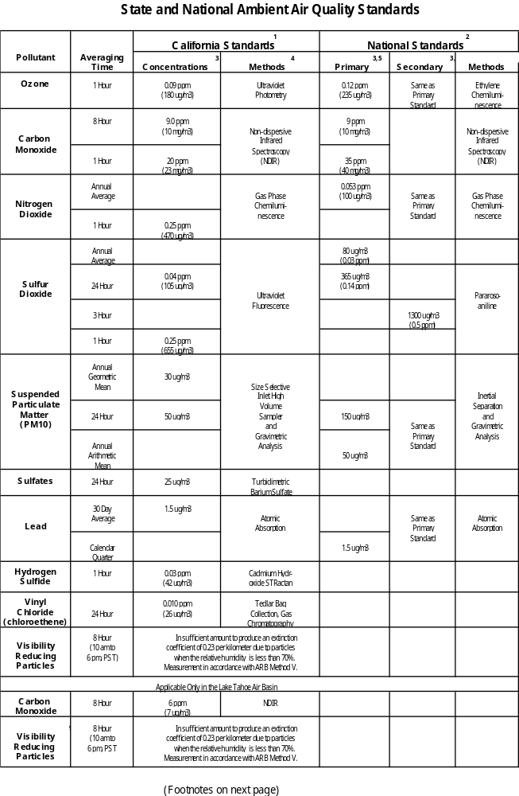

NOTES FROM AMBIENT AIR QUALITY STANDARDS TABLE

1. State standards for ozone, carbon monoxide (except the Lake Tahoe Air Basin), sulfur dioxide, nitrogen dioxide, suspended particulate matter (PM10), and visibility reducing particles are values that are not to be exceeded. The State standards for sulfates, Lake Tahoe Air Basin carbon monoxide, lead, hydrogen sulfide, and vinyl chloride are not to be equaled or exceeded.

2. National standards, other than ozone and those based on annual averages or annual arithmetic means, are not to be exceeded more than once a year. The ozone standard is attained when the expected number of days per calendar year with maximum hourly average concentrations above the standard is equal to or less than one.

3. Concentration expressed first in units in which it was promulgated. Equivalent units, given in parentheses, are based upon a reference temperature of 25 degrees C and a reference pressure of 760 mm of mercury. All measurements of air quality are to be corrected to a reference temperature of 25 degrees C and a reference pressure of 760 mm of mercury (1013.2 millibar); ppm (parts per million) in this table refers to ppm by volume, or micro moles of pollutant per mole of gas.

4. Any equivalent procedure which can be shown to the satisfaction of the Air Resources Board to give equivalent results at or near the level of the air quality standard may be used.

5. National Primary Standards: The level of air quality necessary, with an adequate margin of safety, to protect public health. Each State must attain the primary standards no later than three years after that State's implementation plan is approved by the U.S. Environmental Protection Agency (U.S. EPA).

6. National Secondary Standards: The level of air quality necessary to protect the public welfare from any known or anticipated adverse effects of a pollutant. Each State must attain the secondary standards within a reasonable time" after the State's implementation plan is approved by the U.S. EPA.

7. Reference method as describe by the U.S. EPA. An equivalent method of measurement may be used but must have a consistent relationship to the reference method and must be approved by the U.S. EPA.

8. This standard is intended to limit the frequency and severity of visibility impairment due to regional haze and is equivalent to a 10-mile nominal visual range when the relative humidity is less than 70 percent.

9. This standard is equivalent to a 30-mile nominal visual range when the relative humidity is less than 70 percent.

2. Area Designations for the State Ambient Air Quality Standards

This section contains a description of the area designations for each pollutant for which there is a State ambient air quality standard listed in the California Code of Regulations, Title 17, section 70200. The information presented reflects the proposed amendments to the area designations that the Board will consider in November 1996.

The area designations for each pollutant are presented in the form of a map and also, a summary table. Areas are identified as attainment, nonattainment, nonattainment-transitional, or unclassified for each pollutant, as shown, below:

Attainment A
Nonattainment N
Nonattainment-Transitional T
Unclassified U
Generally, the Board designates areas by air basin or county. However, when there are areas of an air basin or county with distinctly different air quality deriving from sources and conditions not affecting the entire air basin or county, the Board may designate a smaller area. Generally, when the boundaries of the designated area differ from the air basin or county boundaries, the description of the specific area is referenced at the bottom of the summary table.

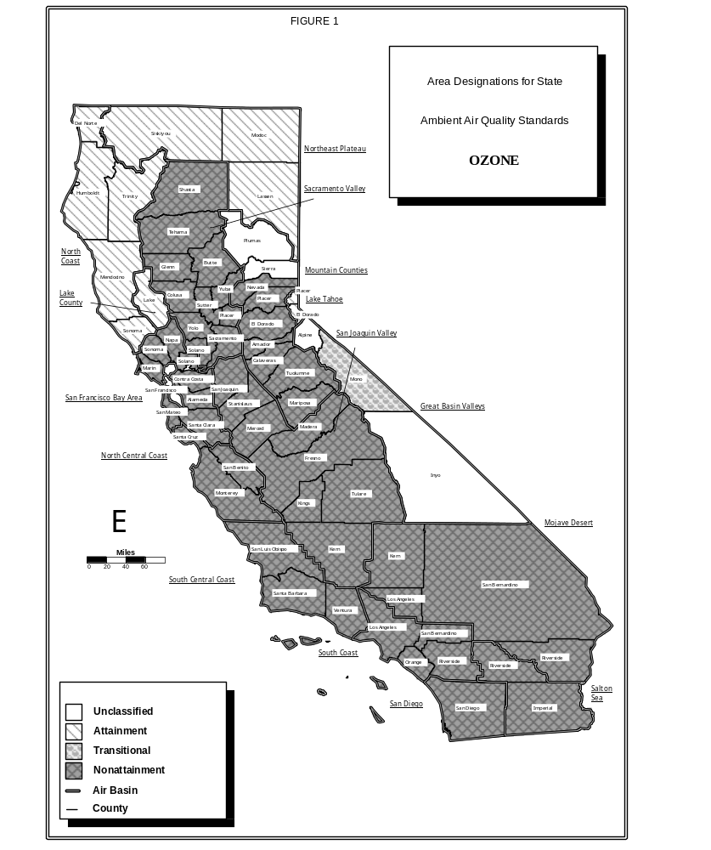

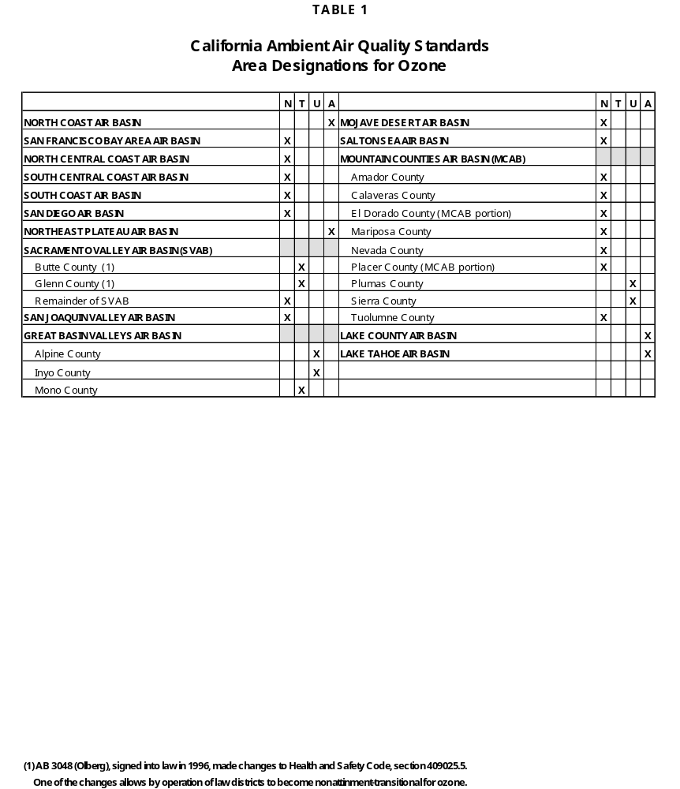

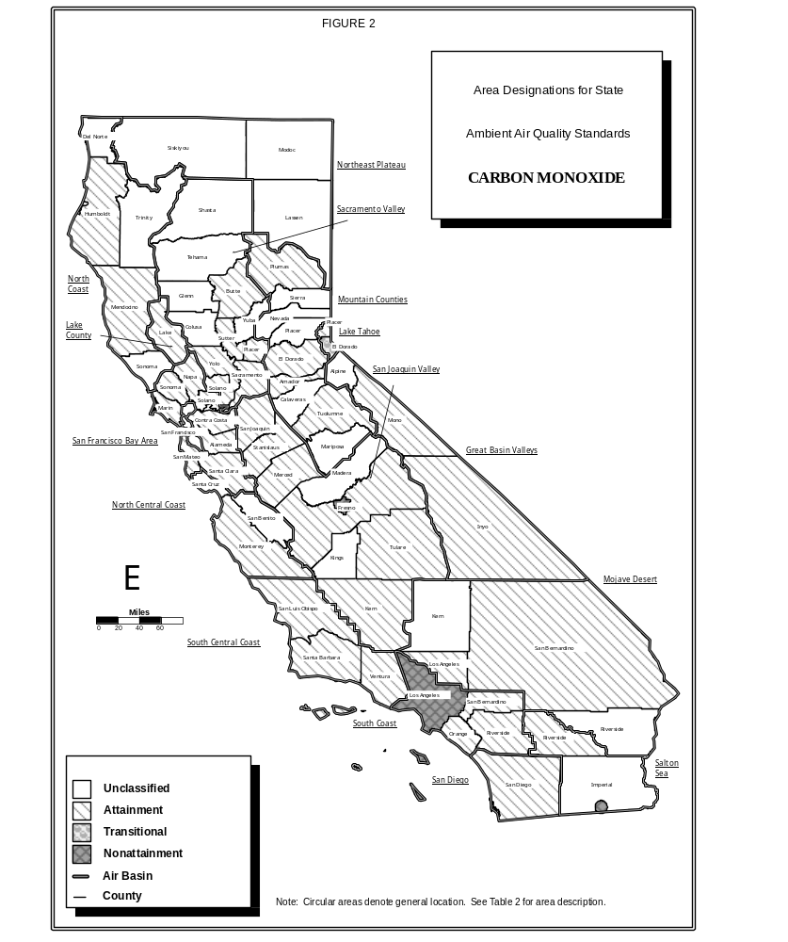

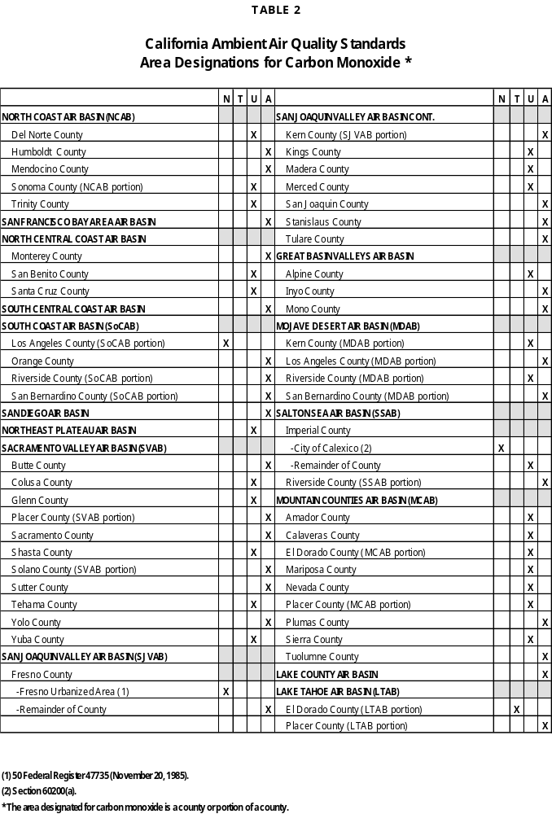
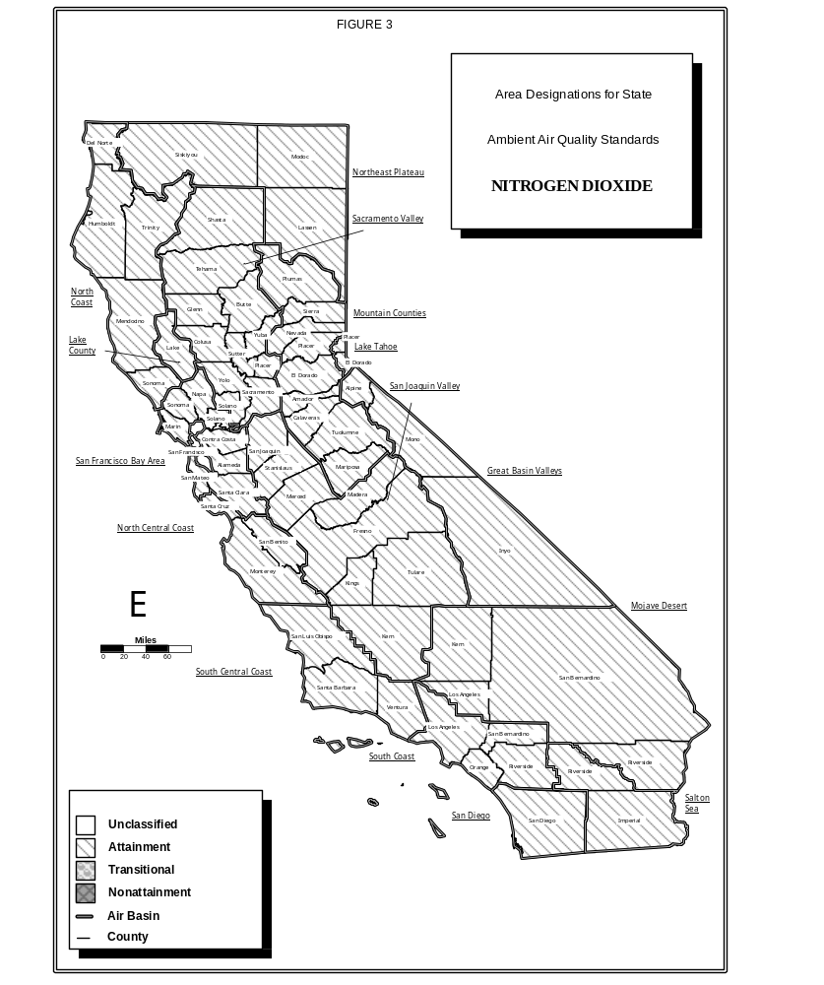

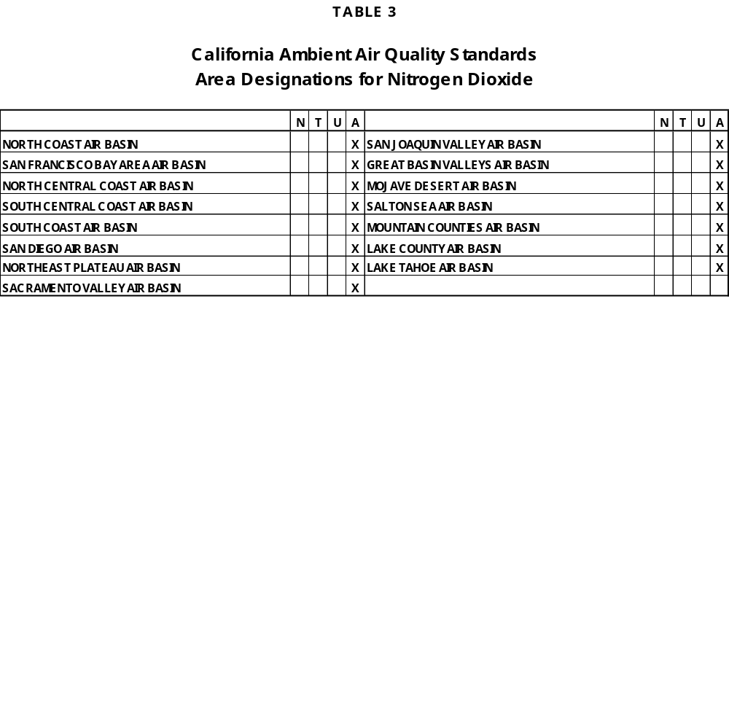

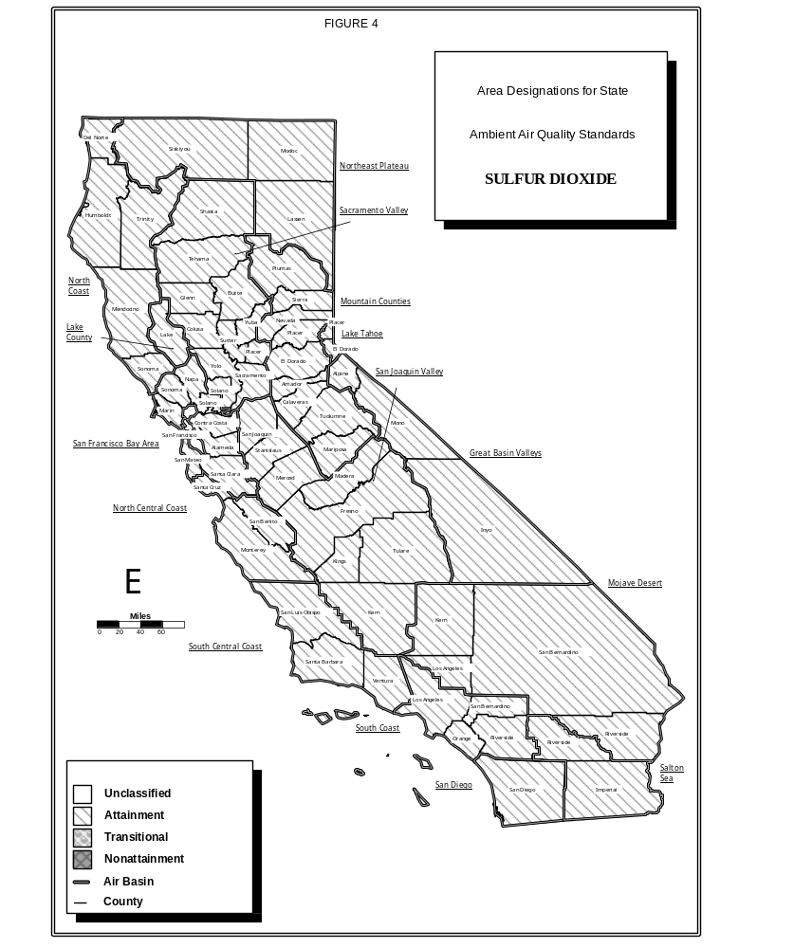

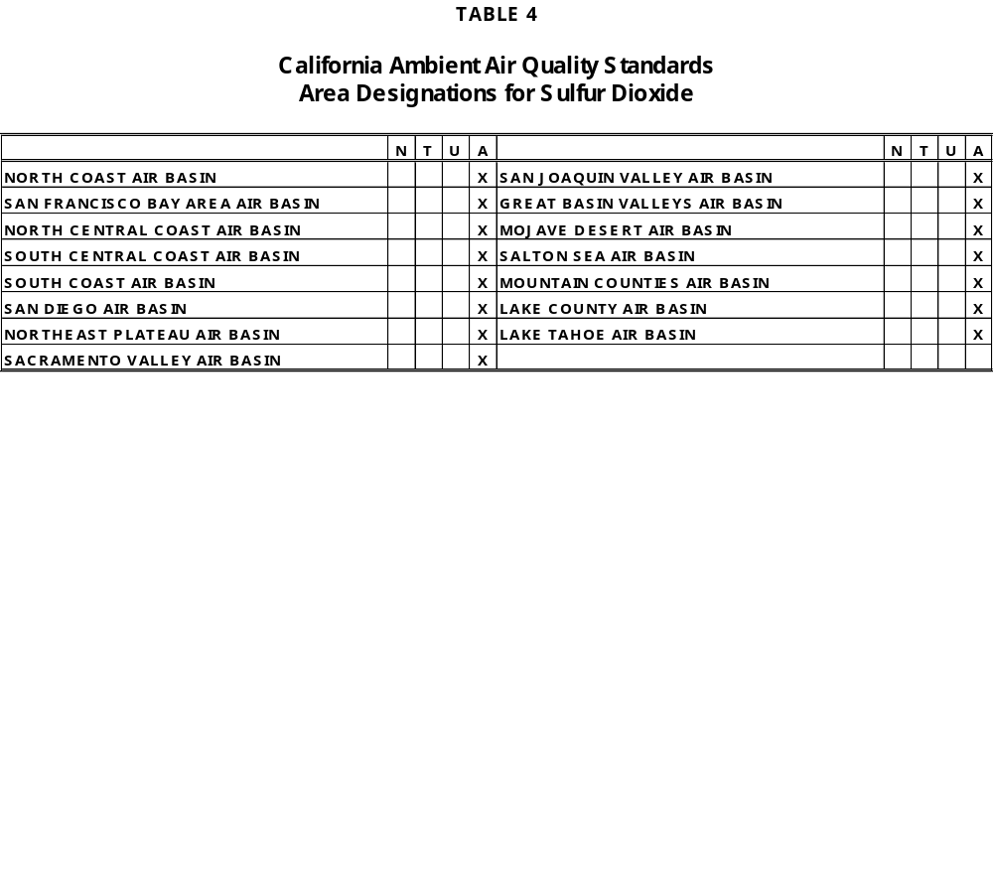

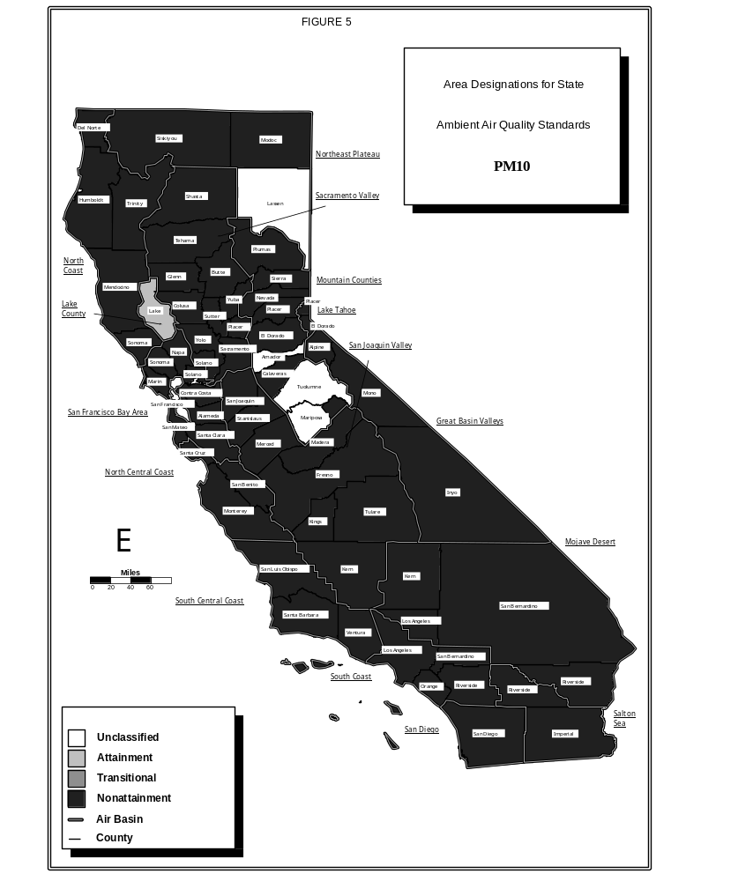

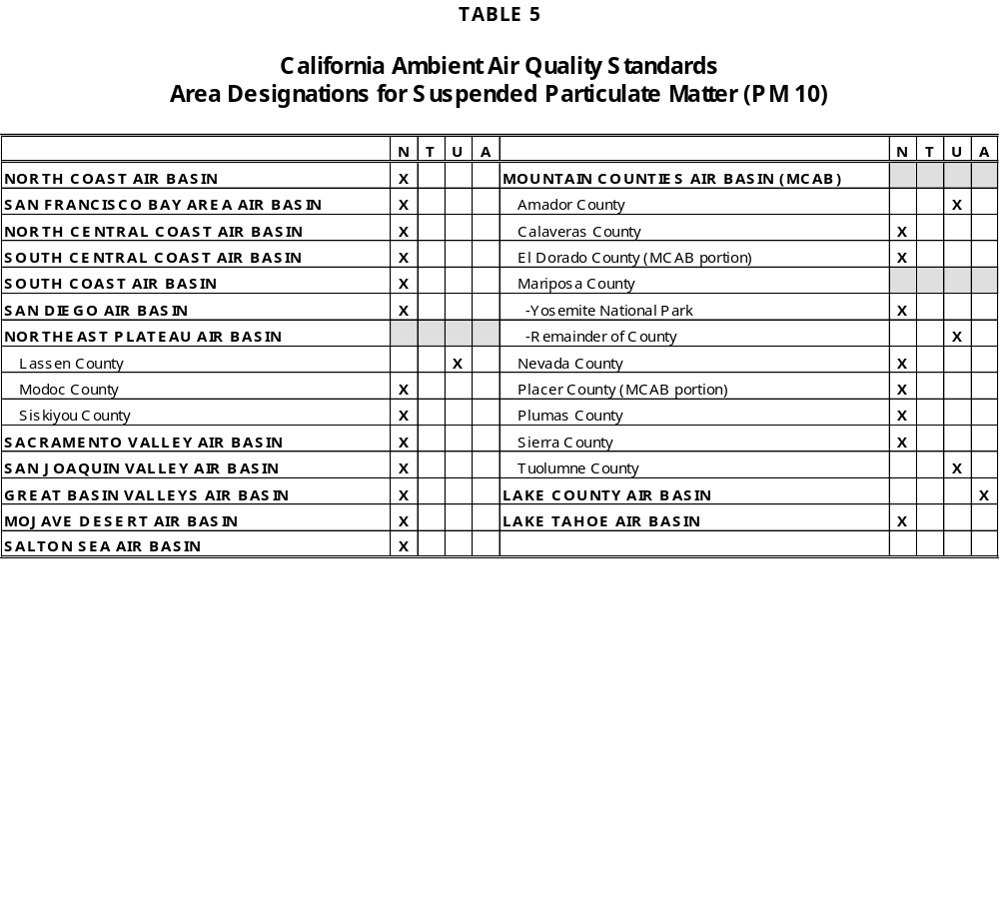

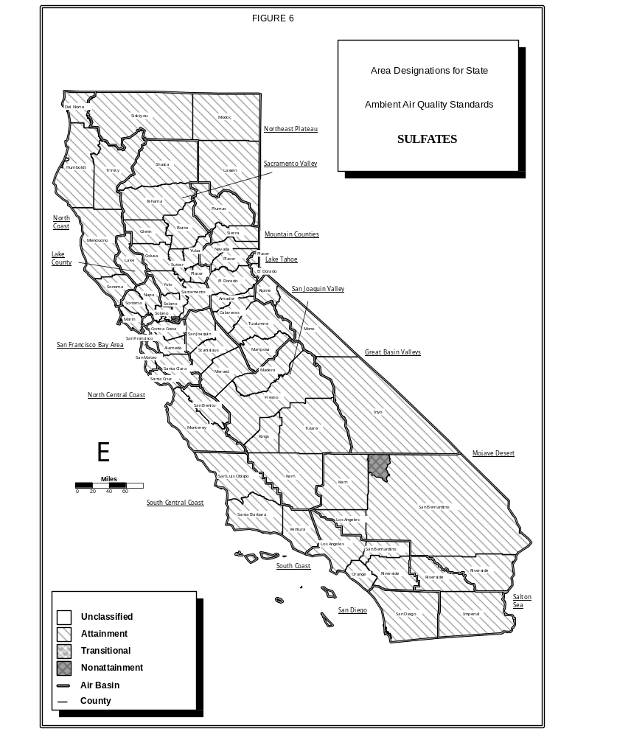

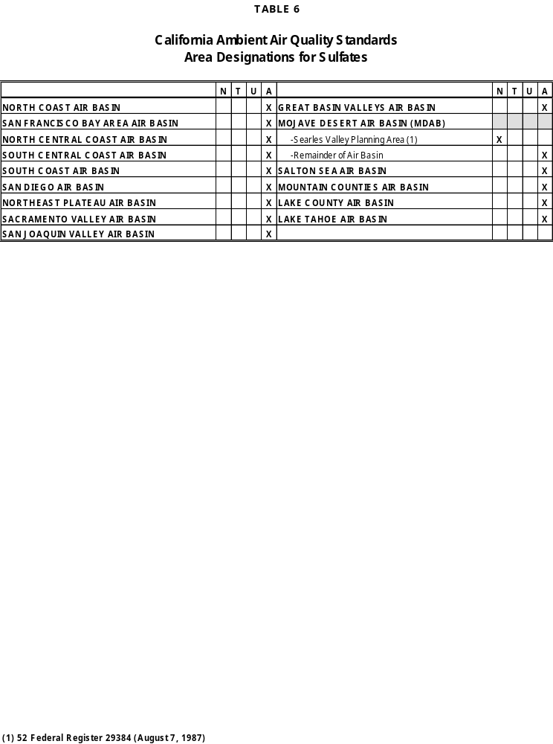
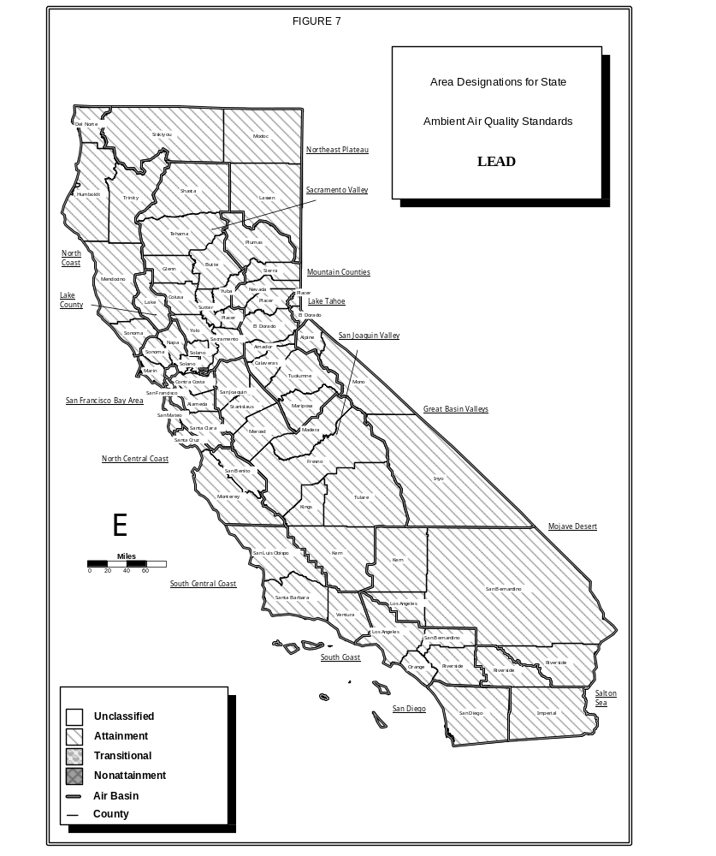

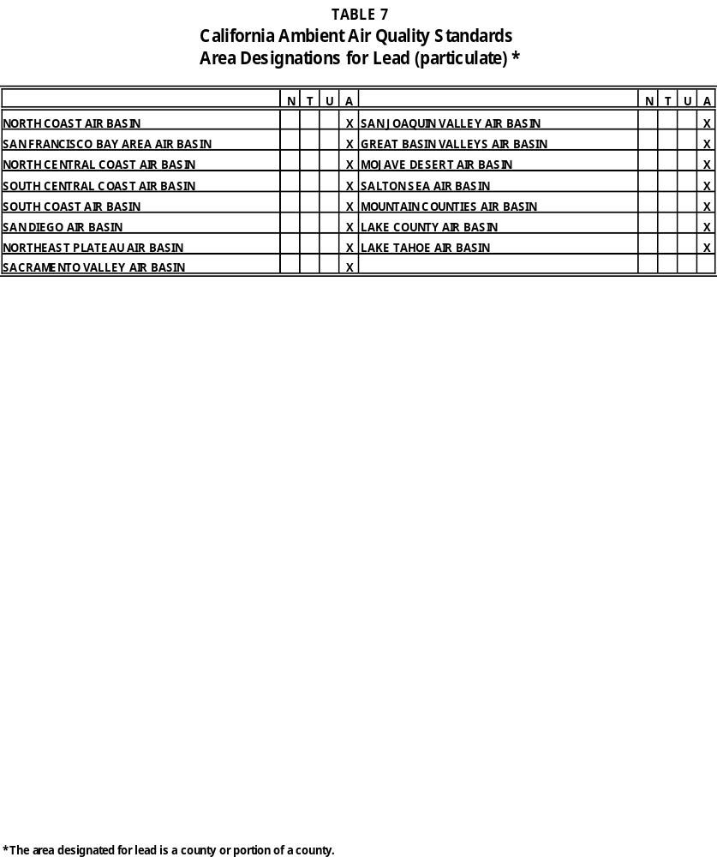

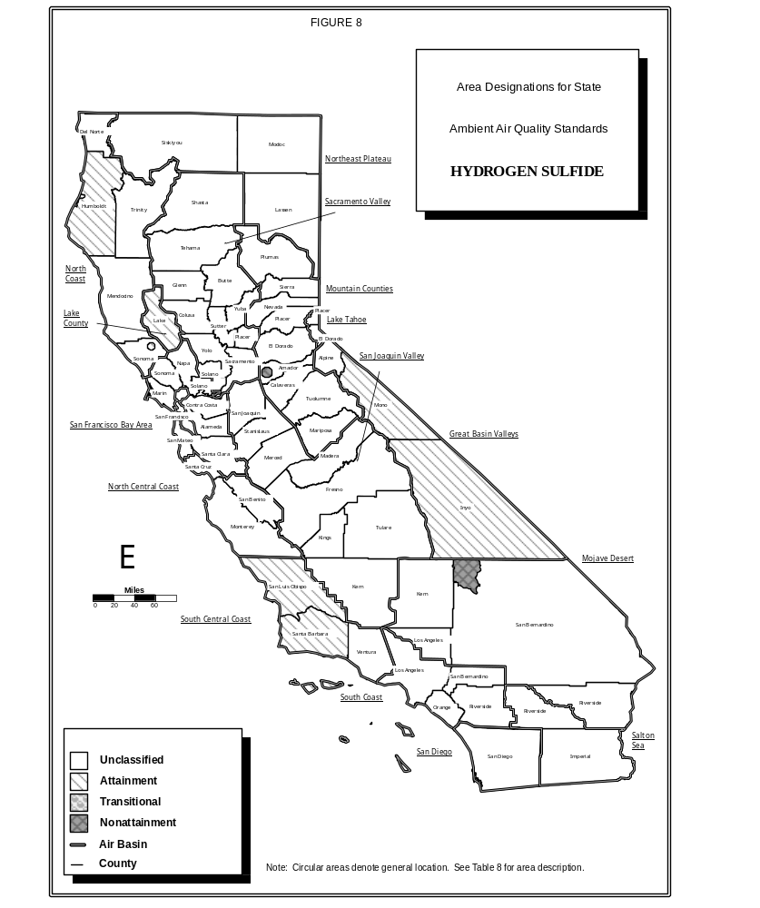

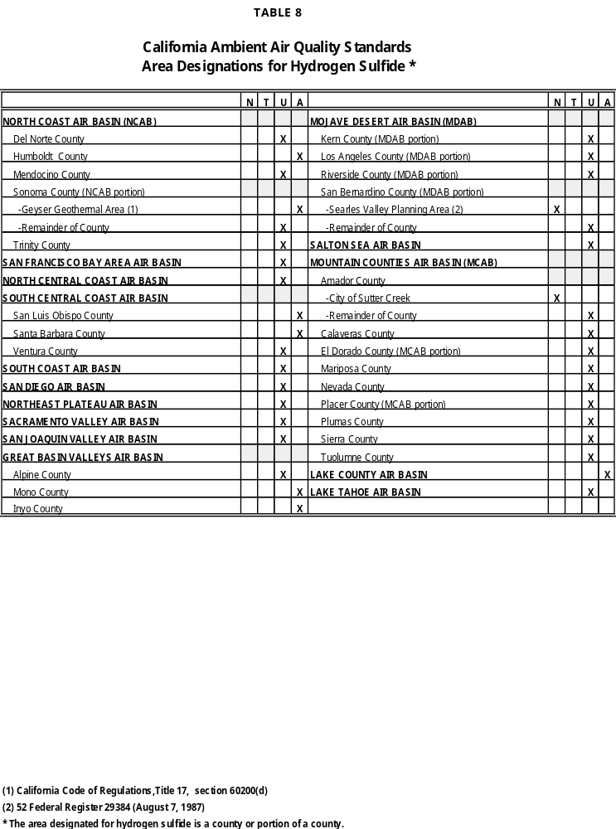
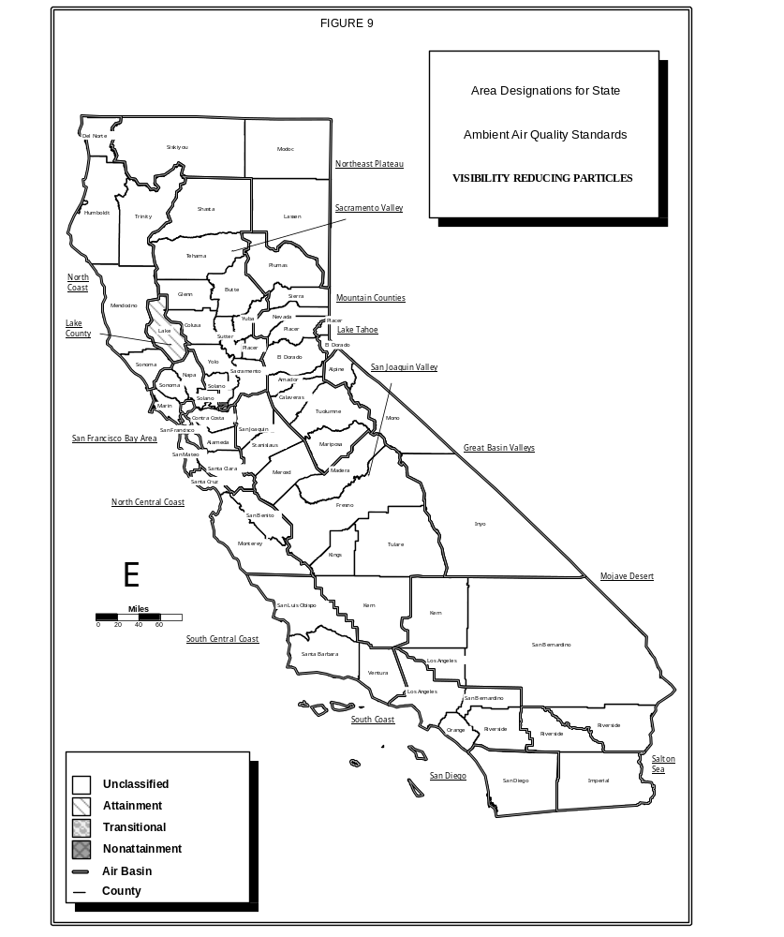

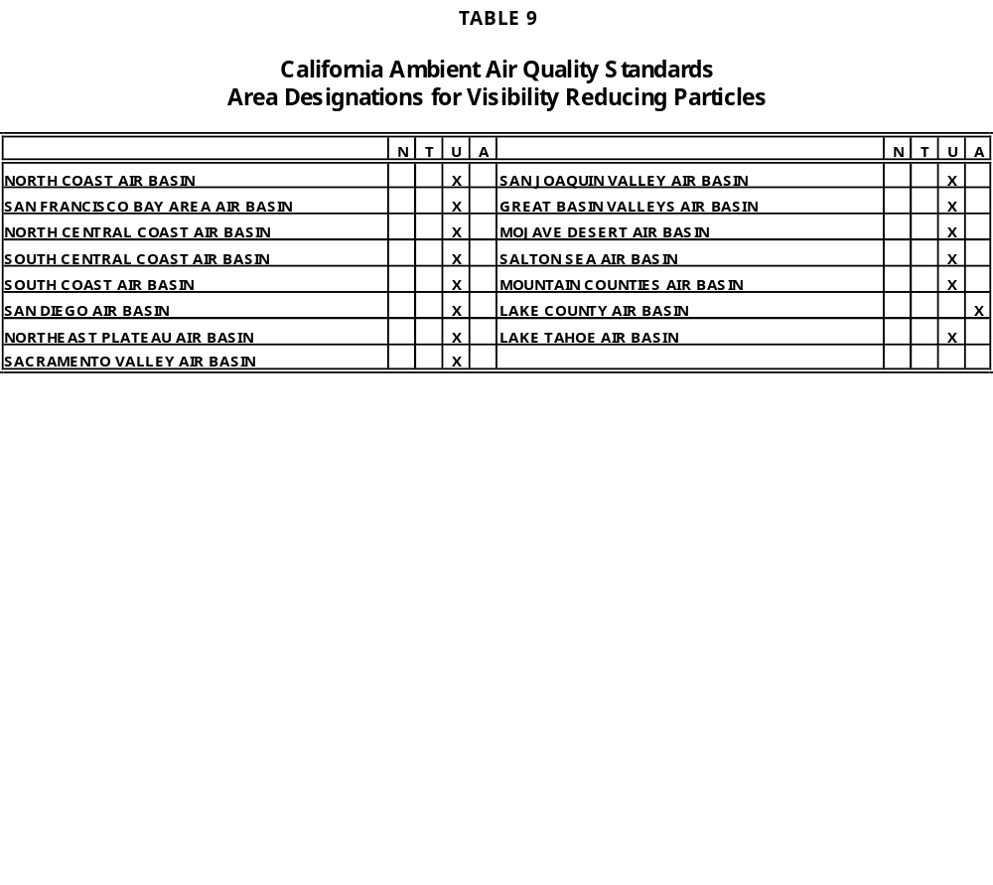

3. Area Designations for the National Ambient Air Quality Standards

This section contains a description of the area designations for each pollutant for which there is a national ambient air quality standard, except lead. The national lead standard was promulgated after the Federal Clean Air Act was amended in 1977, and in promulgating the national lead standard, the United States Environmental Protection Agency (U.S. EPA) did not require areas to be designated in a manner similar to other pollutants. The area designations for each pollutant are presented in the form of a map and also, a summary table.

The U.S. EPA uses two categories to designate areas with respect to ozone, carbon monoxide, and nitrogen dioxide. These designation categories are:

o Does not meet primary standards, and
o Cannot be classified or better than national standards.

Areas that do not meet the primary national standards for these pollutants are indicated on the following maps and summary tables as N for nonattainment. Areas that cannot be classified or are better than the national standards are indicated as UA" for unclassified/attainment.

The U.S. EPA uses four categories to designate areas with respect to sulfur dioxide. These designation categories are:

o Does not meet the primary standards,
o Does not meet the secondary standards,
o Cannot be classified, and
o Better than the national standards.

In California, the first two designation categories listed above do not apply. The map and summary table for sulfur dioxide show areas that cannot be classified as U for unclassifiable and areas that are better than the national standards as A for attainment.

Finally, the U.S. EPA uses two categories to designate areas with respect to suspended particulate matter (PM10). These designation categories are:

o Nonattainment, and
o Unclassifiable.

The map and summary table for the national PM10 standards indicate N for areas designated as nonattainment and U for areas that cannot be classified.

From time to time, the boundaries of the California air basins have been changed to facilitate the planning process. The Board generally initiates these changes, and they are not always reflected in the U.S. EPA area designations. For purposes of consistency with Section 2 of this attachment, all of the maps in the following section reflect the current air basin boundaries as adopted by the Board. Specifically, the maps show the western portion of Placer County as being in the Sacramento Valley Air Basin while the national area designations identify the western portion of Placer County as being in the Mountain Counties Air Basin. Also, while the national area designations reflect the former Southeast Desert Air Basin, the maps in this section show the new Mojave Desert and Salton Sea Air Basin boundaries. Nevertheless, the summary tables in this section reflect the area designations as promulgated by the U.S. EPA.

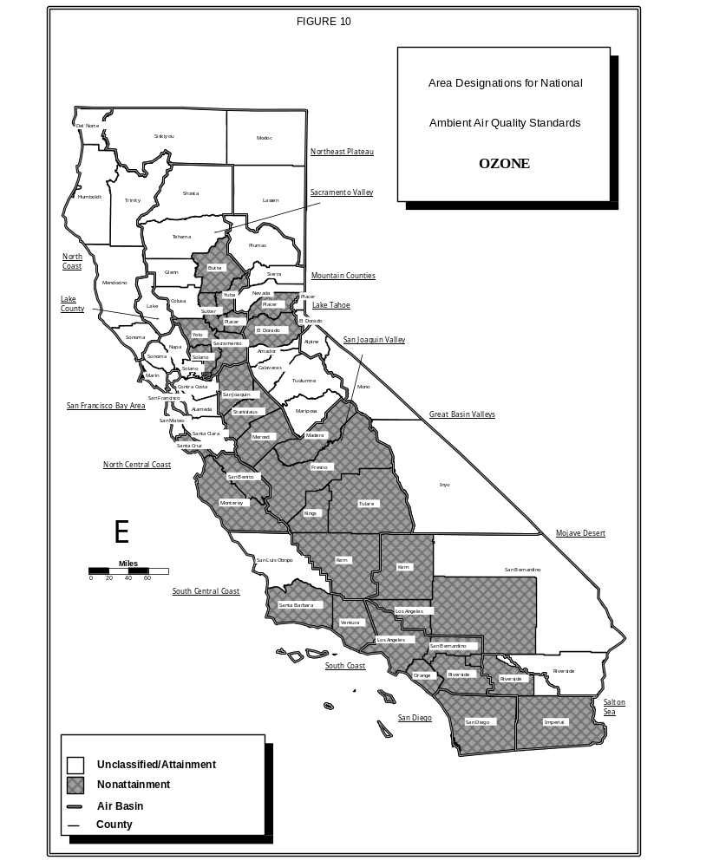

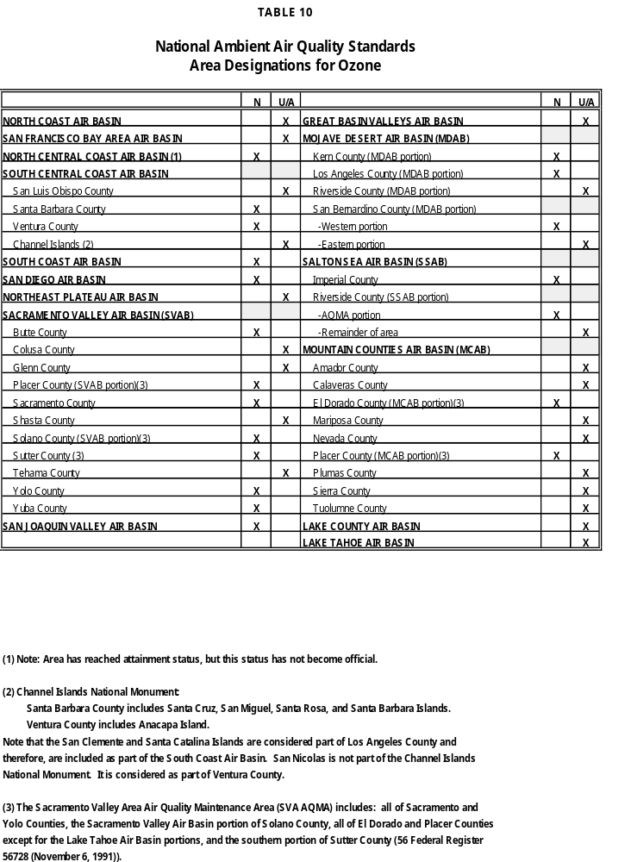

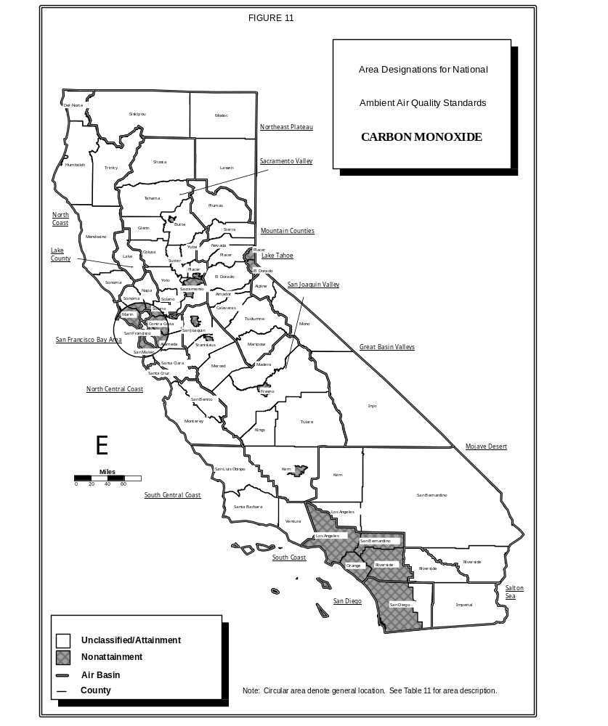

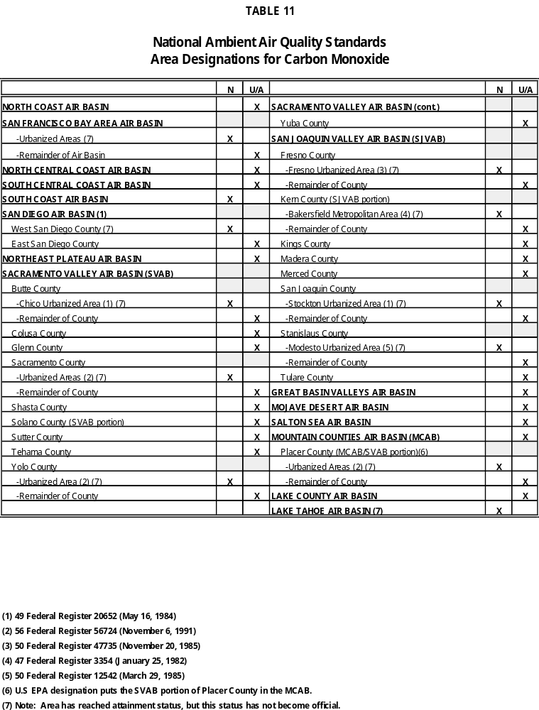
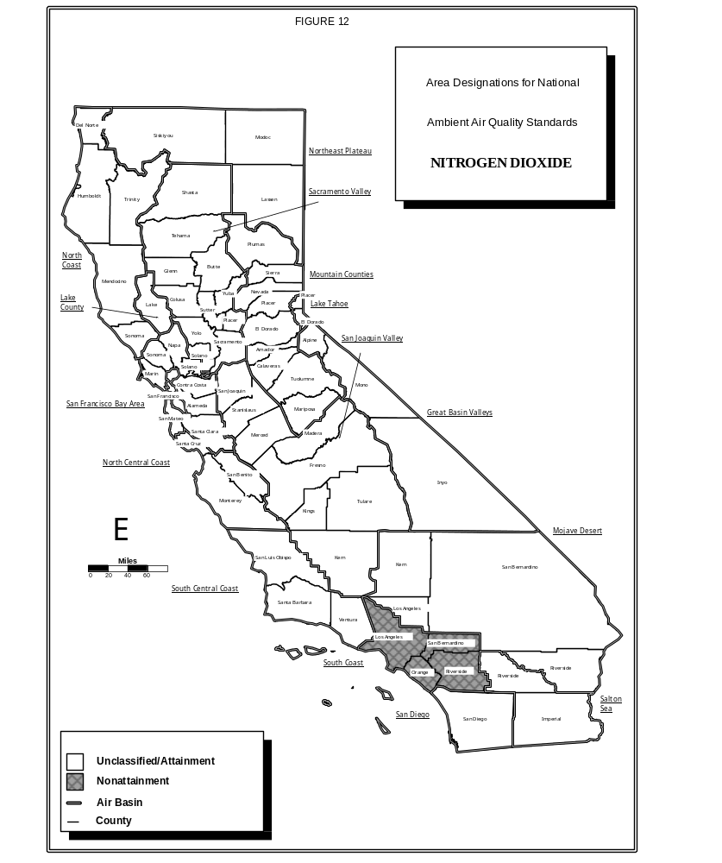

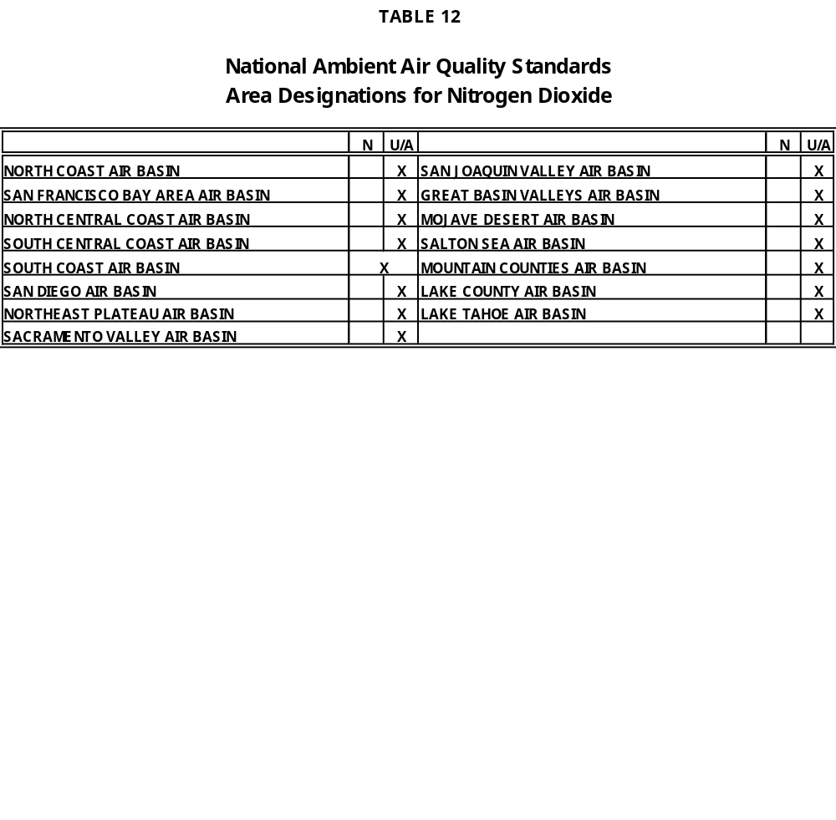

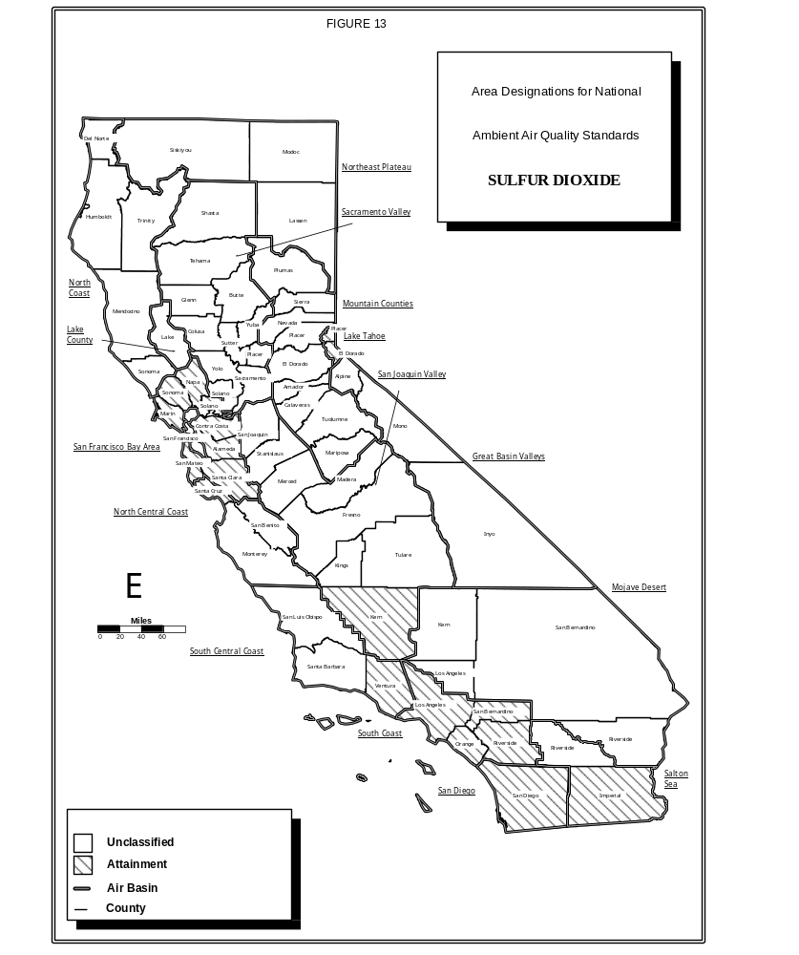

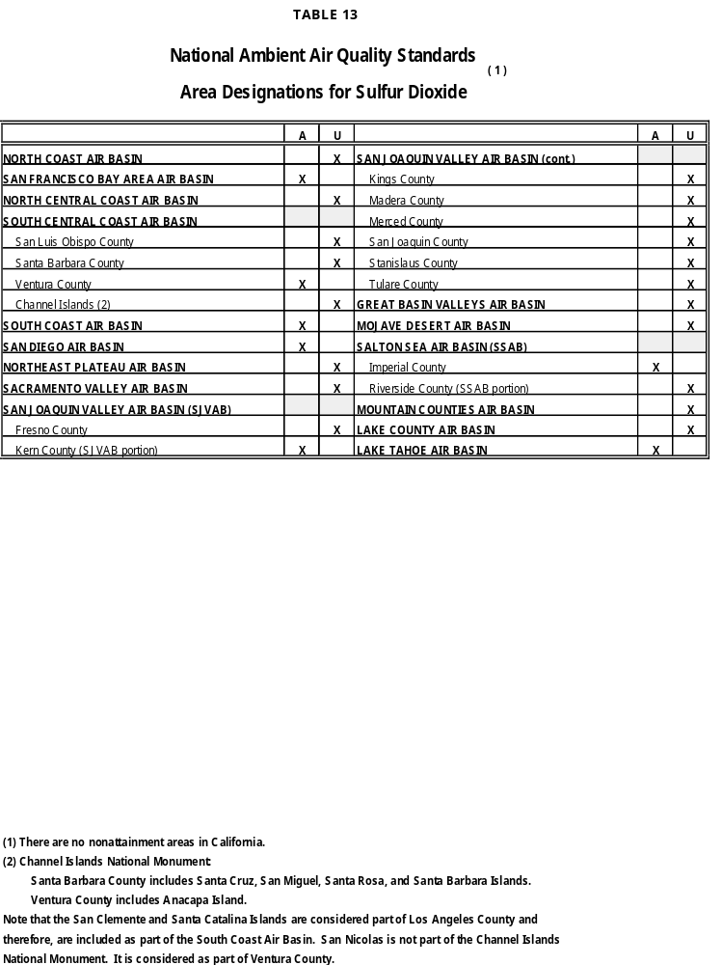
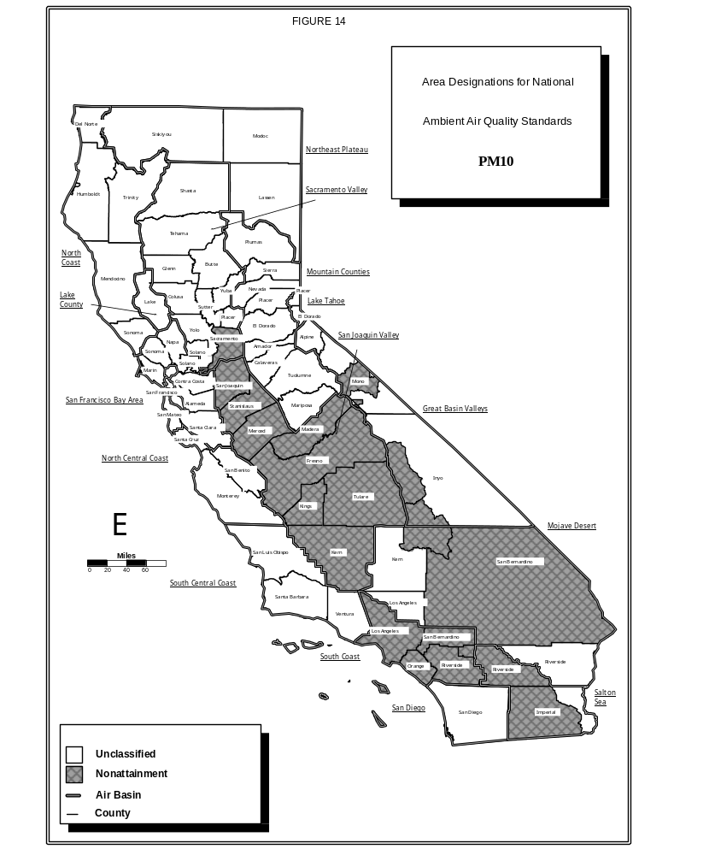

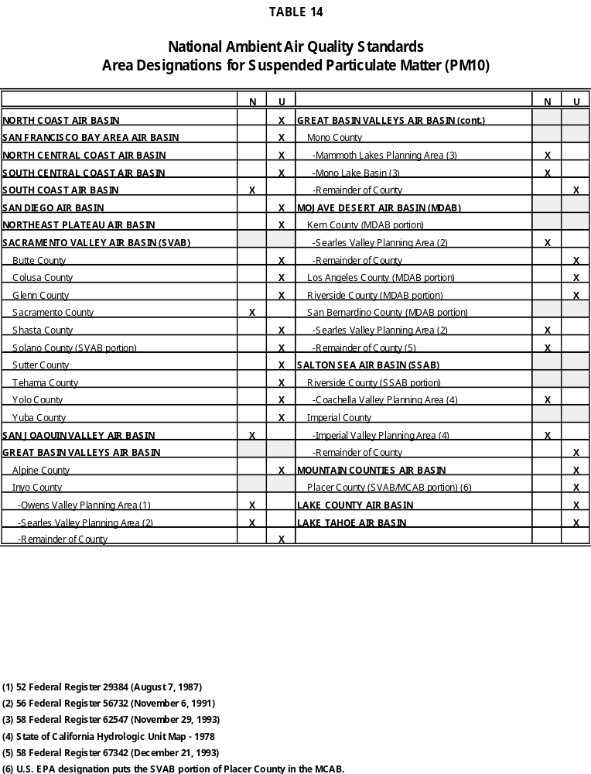

ATTACHMENT C

TEXT OF THE DESIGNATION CRITERIA

ATTACHMENT C

TEXT OF THE DESIGNATION CRITERIA
CALIFORNIA CODE OF REGULATIONS, TITLE 17,
SECTIONS 70300 THROUGH 70306, AND APPENDICES 1 THROUGH 4, THEREOF

70300. General Statement of Purpose

The objective of these criteria is to guide the state board in making designations of air basins as attainment, nonattainment, or unclassified for each of the pollutants for which state ambient air quality standards have been established in Section 70200.

NOTE: Authority Cited: sections 39600, 39601, 39607, and 39608, Health and Safety Code. Reference: sections 39607 and 39608, Health and Safety Code.

70301. Air Quality Data Used for Designations

(a) Except as otherwise provided in this article, designations shall be based on data for record. "Data for record" are those data collected by or under the auspices of the state board or the districts for the purpose of measuring ambient air quality, and which the executive officer has determined comply with the siting and quality assurance procedures established in Part 58, Title 40, Code of Federal Regulations, as they existed on July 1, 1987, or other equivalent procedures. The executive officer shall also determine within 90 days of submittal of complete supporting documentation whether any other data which are provided by a district or by any other person comply with the siting and quality assurance procedures and shall be data for record. If the executive officer finds there is good cause that 90 days is insufficient time to make a determination, he/she may after notification of the person requesting the data review extend the deadline for completion of the data review.

(b) Except as otherwise provided in this article, designations and reviews of designations shall be based on data for record for the three calendar years prior to the year in which the designation is made or the annual review of the designation is conducted.

NOTE: Authority Cited: sections 39600, 39601, 39607, and 39608, Health and Safety Code. Reference: sections 39607 and 39608, Health and Safety Code.

70302. Geographic Extent of Designations

(a) An air basin shall be the area designated for ozone, nitrogen dioxide, suspended particulate matter (PM10), sulfates, and visibility reducing particles. Provided, however, if the state board finds (based on air quality data, meteorology, topography, or the distribution of population and emissions) that there are areas within an air basin with distinctly different air quality deriving from sources and conditions not affecting the entire air basin, the state board may designate an area smaller than an air basin using political boundary lines to the extent practicable. In designating an area smaller than an air basin as nonattainment, the state board shall include within the area those sources whose emissions contribute to a violation of a

standard for that pollutant. Contiguous areas which would have the same designation within an air basin shall be one designated area.

(b) A county or the portion of a county which is located within an air basin shall be the area designated for carbon monoxide, sulfur dioxide, lead (particulate), and hydrogen sulfide. Provided, however, if the state board finds (based on air quality data, meteorology, topography, or the distribution of population and emissions) that there are areas within the county with distinctly different air quality, it may designate a smaller area. In designating an area smaller than a county as nonattainment, the state board shall include within the area those sources whose emissions contribute to a violation of a standard for that pollutant.

NOTE: Authority Cited: sections 39600, 39601, 39607, and 39608, Health and Safety Code. Reference: sections 39607 and 38608, Health and Safety Code.

70303. Criteria for Designating an Area as Nonattainment

(a) The state board shall designate an area as nonattainment for a pollutant if:

(1) Data for record show at least one violation of a state standard for that pollutant in the area, and the measurement of the violation meets the representativeness criteria set forth in "Criteria for Determining Data Representativeness" contained in Appendix 1 to this article; or

(2) Limited or no air quality data were collected in the area, but the state board finds, based on meteorology, topography, and air quality data for an adjacent nonattainment area, that there has been at least one violation of a state standard for that pollutant in the area being designated.

(b) An area shall not be designated as nonattainment if the only recorded exceedance(s) of that standard were based solely on data for record determined to be affected by a highly irregular or infrequent event. Data affected by a highly irregular or infrequent event will be identified as such by the executive officer in accordance with the "Air Resources Board Procedure for Reviewing Air Quality Data Possibly Affected by a Highly Irregular or Infrequent Event," set forth in Appendix 2 to this article.

(c) The state board shall, if requested by a district no later than May 1 of each year pursuant to section 70306, identify that portion of a designated area within the district as nonattainment-transitional for a pollutant other than ozone with a standard averaging time less than or equal to 24 hours and for which samples are routinely collected every day if it finds that:

(1) Data for record for the previous calendar year are consistent with the criteria established in section 70304(a)(2) and show two or fewer days at each site in the area with violations of a state standard for that pollutant (not including exceedances found to be affected by a highly irregular or infrequent event under the procedure set forth in Appendix 2);

(2) Evaluation of multi-year air quality, meteorological and emission data indicates that ambient air quality either has stabilized or is improving and that every site in the area is expected to reach attainment within three years; and

(3) The geographic extent of the area is consistent with the criteria established in section 70302.

(d) An area designated as nonattainment-transitional for a pollutant is close to attaining the standard(s) for that pollutant. The nonattainment-transitional designation provides an opportunity for a district to review and potentially to modify its attainment plan. Any modification to an attainment plan must be consistent with state and federal regulations and statutes.

NOTE: Authority Cited: sections 39600, 39601, 39607, 39608, and 40925.5, Health and Safety Code. Reference: sections 39607, 39608, and 40925.5, Health and Safety Code.

70303.5. Requirements for Ozone Nonattainment-Transitional

In evaluating whether a district meets the requirements of HSC 40925.5, the state board shall use the following guidelines:

(1) Data for record for the previous calendar year must be consistent with the criteria established in section 70304(a)(2) to ensure that no more than three exceedances have occurred;

(2) All data collected during the previous calendar year will be considered in the evaluation, including data possibly affected by a highly irregular or infrequent event under the procedure set forth in Appendix 2;

(3) Each day with concentration(s) that exceed the state ozone standard will be counted as one exceedance day; and

(4) No monitoring location may have more than three exceedance days during the previous calendar year.

NOTE: Authority Cited: sections 39600, 39601, 39607, and 40925.5, Health and Safety Code. Reference: sections 39607 and 40925.5, Health and Safety Code.

70304. Criteria for Designating an Area as Attainment

(a) The state board shall designate an area as attainment for a pollutant if:
(1) Data for record show that no state standard for that pollutant was violated at any site in the area; and

(2) Data for record meet representativeness and completeness criteria for a location at which the pollutant concentrations are expected to be high based on the spatial distribution of emission sources in the area and the relationship of emissions to air quality. Data representativeness criteria are set forth in "Criteria for Determining Data Representativeness" contained in Appendix 1 to this article. Data completeness criteria are set forth in "Criteria for Determining Data Completeness" contained in Appendix 3 to this article.

(b) Where there are limited or no air quality data for an area, the state board shall designate the area as attainment for a pollutant if it finds that no state standard for that pollutant has been violated in that area based on:

(1) Air quality data collected in the area during the most recent period since 1980 which meet the conditions in (a) above;

(2) Emissions of that pollutant or its precursors in the area have not increased since that period to a level at which the standard might be exceeded; and

(3) Air quality data collected in the area since the time period in (1) above do not show a violation of the state standard.

(c) Where an area has limited or no air quality data for nitrogen dioxide, sulfur dioxide, sulfates, and lead (particulate), the state board shall designate that area attainment for a pollutant if it finds that no state standard for that pollutant has been violated in that area based on the "Screening Procedure for Determining Attainment Designations for Areas with Incomplete Air Quality Data" set forth in Appendix 4 to this article.

(d) A nonattainment area shall not be redesignated as attainment for a pollutant if:

(1) Data for record for the monitoring site showing the greatest violation of a state standard for that pollutant no longer are available; and

(2) No other site has been identified as equivalent by the executive officer.

NOTE: Authority Cited: sections 39600, 39601, 39607, and 39608, Health and Safety Code. Reference: sections 39607 and 39608, Health and Safety Code.

70305. Criteria for Designating an Area as Unclassified

The state board shall designate an area as unclassified for a pollutant if it finds that, except as otherwise provided in this article, the data do not support a designation of attainment or nonattainment.

NOTE: Authority Cited: sections 39600, 39601, 39607, and 39608, Health and Safety Code. Reference: sections 39607 and 39608, Health and Safety Code.

70306. Annual Review of Designations

(a) The executive officer shall conduct annual reviews of all designations and shall propose revisions to the designations as necessary to the state board. The executive officer shall complete the annual reviews by November 15.

(b) Any request for a change in a designation and any submittal of information for purposes of the executive officer's consideration in the annual review of a designation shall be provided in writing to the executive officer no later than May 1 of each year.

NOTE: Authority Cited: sections 39600, 39601, 39607, and 39608, Health and Safety Code. Reference: sections 39607 and 39608, Health and Safety Code.

APPENDIX 1

CRITERIA FOR DETERMINING DATA REPRESENTATIVENESS

This Appendix describes the criteria to be used in determining data representativeness for the purpose of designating areas as described in Article 3, Subchapter 1.5, Chapter 1, Part III,
Title 17 (commencing with section 70300), California Code of Regulations. Representativeness, as used here, is only related to whether or not the amount of data reported is deemed sufficiently complete to characterize reliably air quality during the respective time period. No other kind of representativeness is implied. The criteria for representativeness are summarized in the accompanying table and discussed further, below.

Air quality statistics are usually computed from short term observed values. For example, an annual arithmetic mean is computed from all available hourly samples. If all the short term values for the statistical time period are available, the calculated statistic is representative. However, because all the short term values for a given period often are not available, a minimum number of observations are needed to provide reasonable assurance that the calculated value is a reliable estimate. In general, statistics are considered representative if 75 percent of the possible short term values are included and are distributed throughout the entire statistical time period.

To ensure that seasonal variations are accounted for, representative annual statistics are required to have four representative calendar quarters of data. For example, if an annual mean is based on 24-hour samples, such as that computed for suspended particulate matter (PM10) samples, three representative months are required for each calendar quarter. A 24-hour particulate sample is collected once every six days or a total of five samples per 3l-day month. Therefore, three or fewer samples (less than or equal to 60 percent data recovery) do not meet the criterion for a reliable estimate of the monthly mean concentration. The lack of representativeness of the monthly mean concentrations precludes a reliable estimate of a representative calendar quarter, which in turn precludes the representativeness of an annual statistic. Each level of criteria--hour, day, month, quarter, and year--must be met in order to make a representative annual statistic.

For observations made at less than 24-hour intervals, for example, hourly samples, representativeness depends on whether all the individual values are to be used or only a single daily value is to be used. In general, for representative statistics computed from all of the individual values, such as the mean of all hours, 75 percent of the values in the respective period are required. For representative statistics computed from daily values, such as the monthly mean of daily maximum hours, data from 75 percent of the days in the month are required and the data within those days must meet the relevant representativeness criteria.

CRITERIA FOR REPRESENTATIVENESS OF

AIR QUALITY MEASUREMENTS AND STATISTICS

Representative Sampling Number of
Calendar Time Basis of Statistic Representative Periods
Statistic Period or Requirement Required

Year Any 4 representative calendar quarters
_
| 24-hour Based on a daily sample 3 representative months
| _
Quarter < | Based on a daily 69 or more representative
| | statistic; or calendar days
| <24-hours <
| | Based on hourly samples 1,643 or more hours
_
| 24-hour Based on daily sample 4 or more 24-hour | samples
| _
| | Based on a daily 23 or more representative
| | statistic; or calendar days
| |
Month < | Based on all hourly 548 or more hours
| | samples; or
| <24-hours <
| | Based on all 2-hour 274 or more 2-hour
| | samples; or samples
| |
| | Based on all 3-hour 183 or more 3-hour
l l samples samples
_
| 1-hour 6 or more hours in each
| 1/3 day (hours 0 thru 7,
| 8 thru 15, 16 thru 23),
| and missing no more than | 2 consecutive hourly samples |
Day < 2-hour Based on all 2-hour 9 or more samples
| samples
|
| 3-hour Based on all 3-hour 6 or more samples
| samples
|
| 24-hour Based on daily sample 22 but not more than
| 26 hours of sampling

N Number of Samples Needed

24 18 or more hourly samples
Mean of 8 6 or more hourly samples
N Hour 6 5 or more hourly samples
Period 4 3 hourly sample

3 3 hourly samples 2 2 hourly samples

1 30 minutes or more of sampling

APPENDIX 2

AIR RESOURCES BOARD PROCEDURE FOR REVIEWING AIR QUALITY DATA
POSSIBLY AFFECTED BY A HIGHLY IRREGULAR OR INFREQUENT EVENT

This Appendix describes the procedures that the Air Resources Board will use for reviewing air quality data possibly affected by a highly irregular or infrequent event with regard to the state ambient air quality standards. All decisions regarding the identification of data as being affected by a highly irregular or infrequent event will be made by the executive officer.

The executive officer will review air quality data for possible identification as affected by a highly irregular or infrequent event if the data are the only exceedances of an air quality standard in the area or if such identification would otherwise affect the designation of the area.

Three types of highly irregular or infrequent events may be identified:

1. Exceptional Event.
2. Extreme Concentration Event.
3. Unusual Concentration Event.

Exceptional Events
An exceptional event is an event beyond reasonable regulatory control which causes an exceedance of a state standard. An exceptional event must be linked to a specific cause such as an act of nature or unusual human activity. As guidance to the states for determining exceptional events, the federal Environmental Protection Agency (EPA) has published Guideline on the Identification and Use of Air Quality Data Affected by Exceptional Events, (EPA-450/4-86-007), July 1986 (the EPA Guideline). The EPA Guideline provides overall criteria for determining whether an event is exceptional with regard to the national standards. The executive officer will use the EPA Guideline as a general basis for reviewing ambient data, but will not be bound by the specific definitions in the EPA Guideline for the various types of exceptional events because those definitions are made on a national basis. In addition, since what may be exceptional in one part of the state may be common in another, each possible event will be evaluated on a case-by-case basis.

The steps for identifying an exceptional event are:

1. A district (or the executive officer) identifies questionable data.

2. If a known exceptional event has occurred, the district gathers relevant data to document the occurrence.

3. If an exceptional event is only suspected, the district investigates available data for the possible event.

4. The district submits to the executive officer a request for identifying the data as affected by an exceptional event and also provides supporting documentation.

5. If the executive officer concurs with the district, he/she will identify the data as affected by an exceptional event.
6. If the district's request for identifying data as affected by an exceptional event cannot be supported, the district will be notified of the reasons. The executive officer will consider any additional data to support the request, but in the absence of any new evidence, will disapprove the request.

Extreme Concentration Events
An extreme concentration event is an event beyond reasonable regulatory control which causes an exceedance of a state standard but which does not qualify as an exceptional event. The causes of an extreme concentration event include but are not limited to unusual meteorology.

The steps for identifying an extreme concentration event are:

1. A district (or the executive officer) identifies questionable data.

2. If the event is not an exceptional event, with an identifiable cause, the executive officer will evaluate the data as affected by an extreme concentration event.

3. In evaluating a possible extreme concentration event, the executive officer shall use the data for the site at which the event is suspected to determine a limit for concentrations expected to recur no more frequently than once in one year. The limit shall be determined using the exponential tail method which is incorporated by reference herein and described in Part I section B.1. of the Supplement to the Technical Support Document for Proposed Amendments to the Criteria for Designating Areas of California as Nonattainment, Attainment, or Unclassified for State Ambient Air Quality Standards (May 1992). Using conventional rounding procedures, the limit shall be to be consistent with the level of precision in which the standard is expressed. If the possible extreme concentration exceeds the concentration expected to recur no more frequently than once in one year, the executive officer will consult with the district in identifying the data as affected by an extreme concentration event.

4. When an extreme concentration event is identified, the executive officer shall review other information, including but not limited to meteorological data, to determine whether air quality data for other sites in the area were affected by the extreme concentration event.

Unusual Concentration Events
An unusual concentration event is an event which causes an anomalous exceedance of a state standard and which does not qualify as an exceptional event or an extreme concentration event. An exceedance affected by an unusual concentration event may be identified only for an area designated as attainment or unclassified at the time of the exceedance.

The steps for identifying an unusual concentration event are:

1. A district (or the executive officer) identifies a questionable exceedance(s).

2. If the exceedance(s) has not been identified as having been affected by an exceptional event or an extreme concentration event, and if the area was designated as attainment or unclassified at the time of the exceedance(s), the executive officer will review the exceedance(s) to determine whether it was affected by an unusual concentration event.

3. In evaluating a possible unusual concentration event, the executive officer shall consider all relevant information, including but not limited to the amount and characteristics of air quality data, emission data, meteorological data, potential public health and welfare impacts, and any applicable state, district, and federal rules and regulations. To identify the exceedance(s) as affected by an unusual concentration event, the executive officer must find, based on the relevant information, that the impact of the exceedance(s) is limited to the local area, the exceedance(s) is not expected to recur, and that the data do not support a nonattainment designation.

4. If the exceedance(s) qualifies as possibly affected by an unusual concentration event, the executive officer will consult with the district in identifying the exceedance(s) as affected by an unusual concentration event.

5. An area may retain its attainment or unclassified designation based on the identification and exclusion of an exceedance(s) affected by an unusual concentration event for no more than three consecutive years. If the executive officer identifies an exceedance(s) affected by an unusual concentration event in the area in the fourth consecutive year, the area shall be redesignated as nonattainment.

NOTE: Authority Cited: sections 39600, 39601, 39607, and 39608, Health and Safety Code. Reference: sections 39607 and 39608, Health and Safety Code.

APPENDIX 3

CRITERIA FOR DETERMINING DATA COMPLETENESS

This Appendix describes the criteria to be used in determining data completeness for the purpose of designating areas as attainment or nonattainment-transitional as described in Article 3, Subchapter 1.5, Chapter 1, Part III, Title 17 (commencing with section 70300), California Code of Regulations. The purpose of these data completeness criteria is to specify the minimum data deemed necessary to assure that sampling occurred at times when a violation is most likely to occur.

Complete Data

Data for a site will be deemed complete if there are representative data (as determined in accordance with the Representativeness Criteria in Appendix 1) during the required hours (see below) of the day during the required months (see below) for the required years (see below).

Required Hours

The hours of potentially high concentration must be included. Unless a detailed evaluation determines different hours to be appropriate for a specific site, these hours are:

Pollutant Hours (PST)
Ozone 9 am - 5 pm
Carbon Monoxide 3 am - 9 am (next day)
Nitrogen Dioxide 8 am - 8 pm
Visibility Reducing Particles 10 am - 6 pm
Other Pollutants Throughout day

Required Months

The months of potentially high concentrations must be included. Unless a detailed evaluation determines different months to be appropriate for a specific site, these months are:

Pollutant Months
Ozone July - September
Carbon Monoxide January, November - December
Nitrogen Dioxide October - December
Sulfur Dioxide September - December
Sulfates January, June - December
Lead (Particulate) January, November - December
Other Pollutants January - December

Required Years

The number of years to be included is:
a) Three; or
b) Two, if during these years the maximum pollutant concentration (not including data found to be affected by a highly irregular or infrequent event under the procedure set forth in Appendix 2) is less than three-fourths the applicable state ambient air quality standard; or
c) One, if during this year the maximum pollutant concentration (not including data found to be affected by a highly irregular or infrequent event under the procedure set forth in Appendix 2) is less than one-half the applicable state ambient air quality standard.

APPENDIX 4

SCREENING PROCEDURE FOR DETERMINING ATTAINMENT DESIGNATIONS FOR AREAS WITH INCOMPLETE AIR QUALITY DATA

This Appendix describes the screening procedure that will serve as the basis for making a pollutant-specific finding under section 70304(c) that the state ambient air quality standard is being attained for areas with no or an incomplete air quality data record. The procedure is applicable only for nitrogen dioxide, sulfur dioxide, sulfates, and lead (particulate). For those areas with some air quality data for the prior three years, the screening procedure will be applied for a pollutant only if the maximum concentrations of that pollutant in the area did not exceed 75 percent of the state standard(s).

Pollutant Screening Parameters Screening Values

Nitrogen a) Basin Population 1,000,000 people
Dioxide
b) Total Annual NOx Emissions 40,000 tons/yr
in Air Basin

c) Total Annual Point Source NOx 2,100 tons/yr
Emissions in County

Sulfur a) Total Annual Point Source 1,700 tons/yr
Dioxide SOx emissions in County

b) Maximum Annual SOx Emissions 900 tons/yr
from Single Facility in County

Sulfates a) Total Annual SOx Emissions in 19,000 tons/yr
Air Basin

b) Total Annual Point Source 1,700 tons/yr
SOx Emissions in County

c) Maximum Annual SOx Emissions 900 tons/yr
from Single Facility in County

Lead a) County Population 600,000 people

b) Maximum Annual Lead Emissions 0.5 tons/yr
from Single Facility in County

For an area to which these values are applied, the local values of the applicable screening parameters will be compared to the respective screening values. The area will be presumed to be attainment if none of the applicable screening parameters for a pollutant exceed the associated screening values.

ATTACHMENT D

TEXT OF THE PROPOSED AMENDMENTS

TO THE AREA DESIGNATIONS

ATTACHMENT D

TEXT OF THE PROPOSED AMENDMENTS TO THE AREA DESIGNATIONS
CALIFORNIA CODE OF REGULATIONS, TITLE 17,
SECTIONS 60200 THROUGH 60209

(Additions are shown as underline italics and deletions as strikeout)

Note: Amendments to air basin boundaries were adopted by the Board on May 30, 1996 but have not yet been approved by the Office of Adimistrative Law.

60200. Description of Non-County Areas.
(a) City of Calexico as defined in the Imperial County Planning-Local Agency Formation Commission Manual.
(b) [Reserved]
(c) [Reserved]
(d) That portion of Lake County and portion of Sonoma County, referred to as the Geysers Geothermal Area, is described as follows:
Beginning at the northwest corner of T. 12 N, R. 9 W, Mount Diablo Base and Meridian; thence south along the range line common to R. 9 W and R. 10 W to the point of intersection with the Mendocino-Lake County border; thence east and south along the Mendocino-Lake County border to the point of intersection with the border of Sonoma County; thence west along the Mendocino-Sonoma County border to the point of intersection with the range line common to R. 10 W and R. 9 W; thence south along the range line common to R. 10 W and R. 9 W to the point of intersection with Big Sulfur Creek; thence southwest along Big Sulfur Creek to its confluence with Little Sulfur Creek; thence southeast, east, and northeast along Little Sulfur Creek to the point of intersection with the township line common to T. 10 N and T. 11 N; thence east along the township line common to T. 10 N and T. 11 N to the northeast corner of T. 10 N, R. 9 W; thence south along the range line common to R. 9 W and R. 8 W to the southwest corner of T. 10 N, R.8 W; thence east along the township line common to T. 9 N and T. 10 N to the point of intersection with the Sonoma-Napa County border; thence northwest along the Sonoma-Napa County border to the point of intersection with the Lake-Napa County border; thence northeast along the Lake-Napa County border to the point of intersection with State Highway 29 (SH-29); thence north and west along SH-29 to the point of intersection with the township line common to T. 12 N and T. 13 N; thence west along the township line common to T. 12 N and T. 13 N to the northwest corner of T. 12 N, R. 9 W, the point of beginning.

NOTE: Authority cited: sections 39600, 39601, and 39608, Health and Safety Code.
Reference: section 39608, Health and Safety Code.

60201. Table of Area Designations for Ozone
Area Designation

North Coast Air Basin Attainment
San Francisco Bay Area Air Basin Nonattainment
North Central Coast Air Basin Nonattainment
South Central Coast Air Basin Nonattainment
South Coast Air Basin Nonattainment
San Diego Air Basin Nonattainment
Northeast Plateau Air Basin Attainment
Sacramento Valley Air Basin Nonattainment
San Joaquin Valley Air Basin Nonattainment
Great Basin Valleys Air Basin
Alpine County Unclassified
Inyo County Unclassified
Mono County Nonattainment
Nonattainment-Transitional
Southeast Desert Air Basin Nonattainment
Mojave Desert Air Basin Nonattainment
Salton Sea Air Basin Nonattainment
Mountain Counties Air Basin
Amador, Calaveras, El Dorado, Nevada,
Placer, Mariposa, and Tuolumne Counties Nonattainment
Plumas and Sierra Counties Unclassified
Lake County Air Basin Attainment
Lake Tahoe Air Basin Attainment

NOTE: Authority cited: sections 39600, 39601, and 39608, Health and Safety Code.
Reference: sections 39608 and 40925.5(a), Health and Safety Code.

60202. Table of Area Designations for Carbon Monoxide
Area Designation

North Coast Air Basin
Del Norte County Unclassified
Humboldt County Attainment
Mendocino County Attainment
Sonoma County Unclassified
Trinity County Unclassified
San Francisco Bay Area Air Basin
Alameda County Attainment
Contra Costa County Attainment
Marin County Attainment
Napa County Attainment
San Francisco County Attainment
San Mateo County Attainment
Santa Clara County Attainment
Solano County Attainment
Sonoma County Attainment
North Central Coast Air Basin
Monterey County Attainment
San Benito County Unclassified
Santa Cruz County Unclassified
South Central Coast Air Basin
San Luis Obispo County Attainment
Santa Barbara County Attainment
Ventura County Attainment
South Coast Air Basin
Los Angeles County Nonattainment
Orange County Attainment
Riverside County Attainment
San Bernardino County Attainment
San Diego Air Basin Attainment
Northeast Plateau Air Basin
Lassen County Unclassified
Modoc County Unclassified
Siskiyou County Unclassified
60202. Table of Area Designations for Carbon Monoxide (continued)
Area Designation

Sacramento Valley Air Basin
Butte County Attainment
Chico Urbanized Area¹ Nonattainment
Remainder of County Unclassified
Colusa County Unclassified
Glenn County Unclassified
Placer County Unclassified
Attainment
Sacramento County Attainment
County Portion of Census Bureau
Urbanized Area³ Nonattainment-Transitional Remainder of County Attainment
Shasta County Unclassified
Solano County Attainment
Sutter County Attainment
Tehama County Unclassified
Yolo County Attainment
Yuba County Unclassified
San Joaquin Valley Air Basin

Fresno County
Fresno Urbanized Area² ¹ Nonattainment
Remainder of County Attainment
Kern County Attainment
Kings County Unclassified
Madera County Unclassified
Merced County Unclassified
San Joaquin County Attainment
Stanislaus County Attainment
Tulare County Attainment
Great Basin Valleys Air Basin
Alpine County Unclassified
Inyo County Attainment
Mono County Attainment
60202. Table of Area Designations for Carbon Monoxide (continued)
Area Designation

Southeast Desert Air Basin
Imperial County
City of Calexico⁴ Nonattainment
Remainder of County Unclassified
Kern County Unclassified
Los Angeles County Attainment
Riverside County Attainment
San Bernardino County Attainment

Mojave Desert Air Basin
Kern County Unclassified
Los Angeles County Attainment
Riverside County Unclassified
San Bernardino County Attainment

Salton Sea Air Basin

Imperial County
City of Calexico² Nonattainment
Remainder of County Unclassified
Riverside County Attainment
Mountain Counties Air Basin
Amador County Unclassified
Calaveras County Unclassified
El Dorado County Unclassified
Mariposa County Unclassified
Nevada County Unclassified
Placer County Unclassified
Plumas County Attainment
Sierra County Unclassified
Tuolumne County Unclassified
Attainment
60202. Table of Area Designations for Carbon Monoxide (continued)
Area Designation

Lake County Air Basin
Lake County Attainment

Lake Tahoe Air Basin
El Dorado County Nonattainment
Nonattainment-Transitional
Placer County Unclassified
Attainment

1. 49 Fed. Reg. 20652 (May 16, 1984); U.S. Department of Commerce, Bureau of the Census, Number of Inhabitants Report for California, 1980 U.S. Census 1982, page 6-56 (Chico).

2. 1. 50 Fed. Reg. 47735 (November 20, 1985); 45 Fed. Reg. 53149 (August 11, 1980); City of Fresno Department of Planning and Inspection, 1974 General Plan Report of the FCMA,
page 4.

3. 56 Fed. Reg. 56724 (November 6, 1991); U.S. Department of Commerce, Bureau of the Census, Number of Inhabitants Report for California, 1980 U.S. Census 1982, page 6-72.
4. 2. section 60200(a).

NOTE: Authority cited: sections 39600, 39601, and 39608, Health and Safety Code.
Reference: section 39608, Health and Safety Code.

60203. Table of Area Designations for Nitrogen Dioxide
Area Designation

North Coast Air Basin Attainment
San Francisco Bay Area Air Basin Attainment
North Central Coast Air Basin Attainment
South Central Coast Air Basin Attainment
South Coast Air Basin Attainment
San Diego Air Basin Attainment
Northeast Plateau Air Basin Attainment
Sacramento Valley Air Basin Attainment
San Joaquin Valley Air Basin Attainment
Great Basin Valleys Air Basin Attainment
Southeast Desert Air Basin Attainment
Mojave Desert Air Basin Attainment
Salton Sea Air Basin Attainment
Mountain Counties Air Basin Attainment
Lake County Air Basin Attainment
Lake Tahoe Air Basin Attainment

NOTE: Authority cited: sections 39600, 39601, and 39608, Health and Safety Code.
Reference: section 39608, Health and Safety Code.

60204. Table of Area Designations for Sulfur Dioxide
Area Designation

North Coast Air Basin Attainment
San Francisco Bay Area Air Basin
Alameda County Attainment
Contra Costa County Attainment
Marin County Attainment
Napa County Attainment
San Francisco County Attainment
San Mateo County Attainment
Santa Clara County Attainment
Solano County Attainment
Sonoma County Attainment
North Central Coast Air Basin
Monterey County Attainment
San Benito County Attainment
Santa Cruz County Attainment
South Central Coast Air Basin
San Luis Obispo County Attainment
Santa Barbara County Attainment
Ventura County Attainment
South Coast Air Basin
Los Angeles County Attainment
Orange County Attainment
Riverside County Attainment
San Bernardino County Attainment
San Diego Air Basin
San Diego County Attainment

Northeast Plateau Air Basin
Lassen County Attainment
Modoc County Attainment
Siskiyou County Attainment
60204. Table of Area Designations for Sulfur Dioxide (continued)
Area Designation

Sacramento Valley Air Basin
Butte County Attainment
Colusa County Attainment
Glenn County Attainment
Placer County Attainment
Sacramento County Attainment
Shasta County Attainment
Solano County Attainment
Sutter County Attainment
Tehama County Attainment
Yolo County Attainment
Yuba County Attainment
San Joaquin Valley Air Basin
Fresno County Attainment
Kern County Attainment
Kings County Attainment
Madera County Attainment
Merced County Attainment
San Joaquin County Attainment
Stanislaus County Attainment
Tulare County Attainment
Great Basin Valleys Air Basin
Alpine County Attainment
Inyo County Attainment
Mono County Attainment
Southeast Desert Air Basin
Imperial County Attainment
Kern County Attainment
Los Angeles County Attainment
Riverside County Attainment
San Bernardino County Attainment

Mojave Desert Air Basin
Kern County Attainment
Los Angeles County Attainment
Riverside County Attainment
San Bernardino County Attainment
60204. Table of Area Designations for Sulfur Dioxide (continued)
Area Designation

Salton Sea Air Basin
Imperial County Attainment
Riverside County Attainment
Mountain Counties Air Basin
Amador County Attainment
Calaveras County Attainment
El Dorado County Attainment
Mariposa County Attainment
Nevada County Attainment
Placer County Attainment
Plumas County Attainment
Sierra County Attainment
Tuolumne County Attainment
Lake County Air Basin
Lake County Attainment

Lake Tahoe Air Basin
El Dorado County Attainment
Placer County Attainment

NOTE: Authority cited: sections 39600, 39601, and 39608, Health and Safety Code.
Reference: section 39608, Health and Safety Code.

60205. Table of Area Designations for Suspended Particulate Matter (PM10)
Area Designation

North Coast Air Basin Nonattainment
San Francisco Bay Area Air Basin Nonattainment
North Central Coast Air Basin Nonattainment
South Central Coast Air Basin Nonattainment
South Coast Air Basin Nonattainment
San Diego Air Basin Nonattainment
Northeast Plateau Air Basin
Modoc and Siskiyou Counties Nonattainment
Lassen County Unclassified
Sacramento Valley Air Basin Nonattainment
San Joaquin Valley Air Basin Nonattainment
Great Basin Valleys Air Basin Nonattainment
Southeast Desert Air Basin Nonattainment
Mojave Desert Air Basin Nonattainment
Salton Sea Air Basin Nonattainment
Mountain Counties Air Basin

Amador, Calaveras, Remainder of
Mariposa, and Tuolumne Counties Unclassified
Amador County Unclassified
Calaveras County Nonattainment
El Dorado County Nonattainment

Mariposa County

Mariposa County Portion of
Yosemite National Park Nonattainment
Remainder of County Unclassified
El Dorado, Nevada, Placer,
Plumas, and Sierra Counties Nonattainment
Nevada County Nonattainment
Placer County Nonattainment
Plumas County Nonattainment
Sierra County Nonattainment
Tuolumne County Unclassified
Lake County Air Basin Attainment
Lake Tahoe Air Basin Nonattainment

NOTE: Authority cited: sections 39600, 39601, and 39608, Health and Safety Code.
Reference: section 39608, Health and Safety Code

60206. Table of Area Designations for Sulfates
Area Designation

North Coast Air Basin Attainment
San Francisco Bay Area Air Basin Attainment
North Central Coast Air Basin Attainment
South Central Coast Air Basin Attainment
South Coast Air Basin Attainment
San Diego Air Basin Attainment
Northeast Plateau Air Basin Attainment
Sacramento Valley Air Basin Attainment
San Joaquin Valley Air Basin Unclassified
Attainment
Great Basin Valleys Air Basin Attainment
Southeast Desert Air Basin

San Bernardino County Portion
of Searles Valley Planning Area¹ Nonattainment
Remainder of Air Basin Attainment

Mojave Desert Air Basin

San Bernardino County Portion
of Searles Valley Planning Area¹ Nonattainment
Remainder of Air Basin Attainment
Salton Sea Air Basin Attainment
Mountain Counties Air Basin Attainment
Lake County Air Basin Attainment
Lake Tahoe Air Basin Attainment

1. 52 Fed. Reg. 29384 (August 7, 1987); U.S. Geological Survey 1974, Hydrologic Unit Map-State of California, Hydrological Unit #18090205.

NOTE: Authority cited: sections 39600, 39601, and 39608, Health and Safety Code.
Reference: section 39608, Health and Safety Code.

60207. Table of Area Designations for Lead (Particulate)
Area Designation

North Coast Air Basin
Del Norte County Attainment
Humboldt County Attainment
Mendocino County Attainment
Sonoma County Attainment
Trinity County Attainment
San Francisco Bay Area Air Basin
Alameda County Attainment
Contra Costa County Attainment
Marin County Attainment
Napa County Attainment
San Francisco County Attainment
San Mateo County Attainment
Santa Clara County Attainment
Solano County Attainment
Sonoma County Attainment
North Central Coast Air Basin
Monterey County Attainment
San Benito County Attainment
Santa Cruz County Attainment
South Central Coast Air Basin
San Luis Obispo County Attainment
Santa Barbara County Attainment
Ventura County Attainment
South Coast Air Basin
Los Angeles County Attainment
Orange County Attainment
Riverside County Attainment
San Bernardino County Attainment
San Diego Air Basin
San Diego County Attainment
Northeast Plateau Air Basin
Lassen County Attainment
Modoc County Attainment
Siskiyou County Attainment
60207. Table of Area Designations for Lead (Particulate) (continued)
Area Designation

Sacramento Valley Air Basin
Butte County Attainment
Colusa County Attainment
Glenn County Attainment
Placer County Attainment
Sacramento County Attainment
Shasta County Attainment
Solano County Attainment
Sutter County Attainment
Tehama County Attainment
Yolo County Attainment
Yuba County Attainment
San Joaquin Valley Air Basin
Fresno County Attainment
Kern County Attainment
Kings County Attainment
Madera County Attainment
Merced County Attainment
San Joaquin County Attainment
Stanislaus County Attainment
Tulare County Attainment
Great Basin Valleys Air Basin
Alpine County Attainment
Inyo County Attainment
Mono County Attainment
Southeast Desert Air Basin
Imperial County Attainment
Kern County Attainment
Los Angeles County Attainment
Riverside County Attainment
San Bernardino County Attainment

60207. Table of Area Designations for Lead (Particulate) (continued)
Area Designation

Mojave Desert Air Basin
Kern County Attainment
Los Angeles County Attainment
Riverside County Attainment
San Bernardino County Attainment

Salton Sea Air Basin
Imperial County Attainment
Riverside County Attainment
Mountain Counties Air Basin
Amador County Attainment
Calaveras County Attainment
El Dorado County Attainment
Mariposa County Attainment
Nevada County Attainment
Placer County Attainment
Plumas County Attainment
Sierra County Attainment
Tuolumne County Attainment
Lake County Air Basin
Lake County Attainment
Lake Tahoe Air Basin
El Dorado County Attainment
Placer County Attainment

NOTE: Authority cited: sections 39600, 39601, and 39608, Health and Safety Code.
Reference: section 39608, Health and Safety Code.

60208. Table of Area Designations for Hydrogen Sulfide
Area Designation

North Coast Air Basin
Del Norte County Unclassified
Humboldt County Attainment
Mendocino County Unclassified
Sonoma County
Geyser Geothermal Area² ¹ Attainment
Remainder of County Unclassified
Trinity County Unclassified
San Francisco Bay Area Air Basin
Alameda County Unclassified
Contra Costa County Unclassified
Marin County Unclassified
Napa County Unclassified
San Francisco County Unclassified
San Mateo County Unclassified
Santa Clara County Unclassified
Solano County Unclassified
Sonoma County Unclassified
North Central Coast Air Basin
Monterey County Unclassified
San Benito County Unclassified
Santa Cruz County Unclassified
South Central Coast Air Basin
San Luis Obispo County Attainment
Santa Barbara County Attainment
Ventura County Unclassified
South Coast Air Basin
Los Angeles County Unclassified
Orange County Unclassified
Riverside County Unclassified
San Bernardino County Unclassified
San Diego Air Basin
San Diego County Unclassified
Northeast Plateau Air Basin
Lassen County Unclassified
Modoc County Unclassified
Siskiyou County Unclassified
60208. Table of Area Designations for Hydrogen Sulfide (continued)
Area Designation

Sacramento Valley Air Basin
Butte County Unclassified
Colusa County Unclassified
Glenn County Unclassified
Placer County Unclassified
Sacramento County Unclassified
Shasta County Unclassified
Solano County Unclassified
Sutter County Unclassified
Tehama County Unclassified
Yolo County Unclassified
Yuba County Unclassified
San Joaquin Valley Air Basin
Fresno County Unclassified
Kern County Unclassified
Kings County Unclassified
Madera County Unclassified
Merced County Unclassified
San Joaquin County Unclassified
Stanislaus County Unclassified
Tulare County Unclassified
Great Basin Valleys Air Basin
Alpine County Unclassified
Inyo County Attainment
Mono County Attainment
Southeast Desert Air Basin
Imperial County Unclassified
Kern County Unclassified
Los Angeles County Unclassified
Riverside County Unclassified
San Bernardino County
County Portion of
Searles Valley Planning Area¹ Nonattainment
Remainder of County Unclassified
60208. Table of Area Designations for Hydrogen Sulfide (continued)
Area Designation

Mojave Desert Air Basin
Kern County Unclassified
Los Angeles County Unclassified
Riverside County Unclassified

San Bernardino County
County Portion of Searles Valley Planning Area² Nonattainment
Remainder of County Unclassified

Salton Sea Air Basin
Imperial County Unclassified
Riverside County Unclassified
Mountain Counties Air Basin
Amador County
City of Sutter Creek Nonattainment
Remainder of County Unclassified
Calaveras County Unclassified
El Dorado County Unclassified
Mariposa County Unclassified
Nevada County Unclassified
Placer County Unclassified
Plumas County Unclassified
Sierra County Unclassified
Tuolumne County Unclassified
Lake County Air Basin
Lake County Attainment
Lake Tahoe Air Basin
El Dorado County Unclassified
Placer County Unclassified

2. 1. section 60200(d).
1. 2. 52 Fed. Reg. 29384 (August 7, 1987); U.S. Geological Survey 1974, Hydrologic Unit Map-State of California, Hydrological Unit #18090205.

NOTE: Authority cited: sections 39600, 39601, and 39608, Health and Safety Code.
Reference: section 39608, Health and Safety Code.

60209. Table of Area Designations for Visibility Reducing Particles
Area Designation

North Coast Air Basin Unclassified
San Francisco Bay Area Air Basin Unclassified
North Central Coast Air Basin Unclassified
South Central Coast Air Basin Unclassified
South Coast Air Basin Unclassified
San Diego Air Basin Unclassified
Northeast Plateau Air Basin Unclassified
Sacramento Valley Air Basin Unclassified
San Joaquin Valley Air Basin Unclassified
Great Basin Valleys Air Basin Unclassified
Southeast Desert Air Basin Unclassified
Mojave Desert Air Basin Unclassified
Salton Sea Air Basin Unclassified
Mountain Counties Air Basin Unclassified
Lake County Air Basin Attainment
Lake Tahoe Air Basin Unclassified

NOTE: Authority cited: sections 39600, 39601, and 39608, Health and Safety Code.
Reference: section 39608, Health and Safety Code.

ATTACHMENT E

EXPECTED PEAK DAY CONCENTRATIONS

AND DESIGNATION VALUES

ATTACHMENT F

SUPPORTING DOCUMENTS FOR

AREA DESIGNATIONS

CARBON MONOXIDE NONATTAINMENT-TRANSITIONAL ANALYSIS OF
EL DORADO COUNTY IN THE LAKE TAHOE AIR BASIN

Currently, El Dorado County in the Lake Tahoe Air Basin (LTAB) is designated as nonattainment for the State 8-hour average carbon monoxide (CO) standard of 6 ppm, not to be equaled or exceeded. Under the designation criteria, this portion of El Dorado County qualifies for redesignation as nonattainment-transitional.

The designation criteria specify two conditions related to air quality that an area must meet in order to be designated as nonattainment-transitional for a pollutant other than ozone. First, each site in the area must show no more than two days with violations during the previous calendar year. Of the two sites in this area only South Lake Tahoe (SLT)-Stateline site has exceedances during 1993-1995. During 1995, there was only one violation of the State CO standards at this site. Therefore, the first condition is satisfied.

The second condition states that an evaluation of multiple years of data must show that air quality has stabilized or is improving, and every site in the area is expected to reach attainment within three years. In other words, staff expects El Dorado County in the LTAB to reach attainment by the year 1998. The high site of the this area, and the only one with exceedances through out this designation three year period of 1993-1995, is SLT-Stateline site. The designation value for this three year period for the 8-hour State standard was 7.5 ppm. The countywide CO on-road motor vehicle emissions contributing to the 8-hour designation value are estimated at 62.32 tons per day (t/d). The following table shows the results of a rollback analysis for 1993 through the year 2000, using the designation value for the three year period, which reflects the highest value after excluding extreme concentration events. The designation value occurred during 1993; therefore, we used the projected annual countywide CO emissions starting with the year 1993. The rollback analysis shows that the maximum CO concentration for El Dorado County in the LTAB is expected to be below the level of the State 8-hour CO standard by 1998. Because countywide CO emissions are projected to continue to decline, the maximum concentration is expected to continue to decrease. In addition, the Graph 1 shows, through the Expected Peak Day Concentrations, that air quality has been improving at SLT-Stateline site since 1984. These results satisfy the second condition specified in the designation criteria. Therefore, the area qualifies for redesignation as nonattainment-transitional for the State 8-hour average CO standard.

RESULTS OF CO ROLLBACK ANALYSIS FOR THE EL DORADO COUNTY
IN THE LAKE TAHOE AIR BASIN

ROLLBACK ANALYSIS
Year | Countywide On-road MV Emissions (t/d) | Expected Maximum CO Concentration (ppm)
1993 | 62.38 | 7.5*
1994 | 60.32 | 7.3
1995 | 55.17 | 6.6
1996 | 53.34 | 6.4
1997 | 50.96 | 6.1
1998 | 46.33 | 5.6**
1999 | 43.90 | 5.3
2000 | 41.38 | 5.0

* Designation Value.
** Projected year of attainment for the State 8-hour standard.

ATTACHMENT G

SUPPORTING DOCUMENTATION FOR PROPOSED AREA DESIGNATIONS

DUE TO CHANGES IN AIR BASIN BOUNDARIES

