Instructions for Running RV2018

- Click RV-VBA-Model-RV2018_final1.accdb
- Under Forms, click ModelGUI. This will bring up the graphical user interface.
- For baseline runs, click Baseline Runs. This will use files like baseline emission factor files with labels EF_ and Emitest.
- For scenario runs (used in calculating differences with the baseline runs), click Scenario Runs. Scenario runs use files for emission factors that have Rule_ label.
- Here’s is a sample GUI :
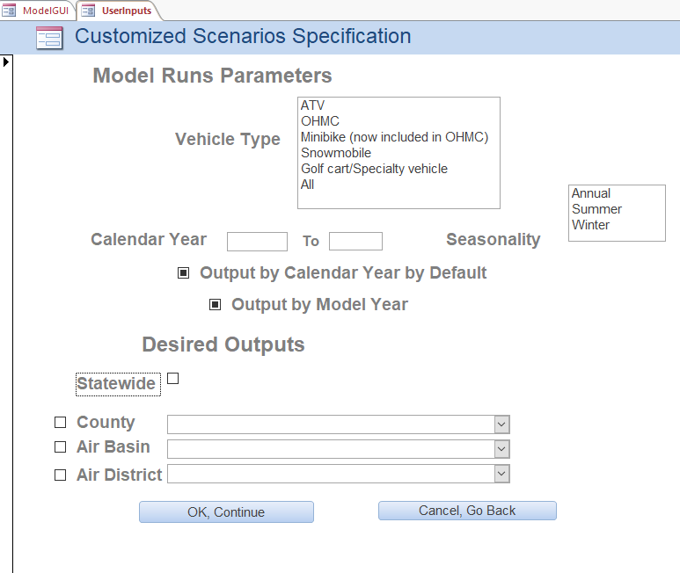

- For Vehicle Type, choose ATV, OHMC, Snowmobile, Golf, or All
- For Calendar Year, the years are between 1990 and 2050.
- For Seasonality, choose Annual, Summer, or Winter. Only one season can be ran at a time.
- For output, default will be by Calendar Year. If you want the output also by model year, click by model year. If you don’t click any of the output button, it will default to by Calendar Year. Warning : by Model Year output can get very big. Do not attempt by Model Year for more than a few years.
- Check either Statewide or by County/Air Basin/Air District. The default is by Statewide if no button is checked.
- Click Ok, Continue button.

