Public Review Draft

September 24 1999

Appendix 1B

Organic Gas Profiles

The ARB staff has presented a methodology for developing speciation for both exhaust and evaporative organic gas emissions from motor vehicles for 3 MTBE free gasolines:

- Unoxygenated
- 2.0% oxygen ethanol
- 3.5% oxygen ethanol

ARB staff relied on results from earlier test programs and ARB’s Predictive Model to estimate how the speciation of organic gas emissions will change relative to the baseline MTBE gasoline and comments received by Dr. Rob Harley of UC Berkeley (see ?). A basic assumption is that all 3 MTBE free gasolines will comply with ARB’s regulations.

In addition to the organic gas species profiles developed by ARB staff for 2.0% and 3.5% oxygen ethanol gasolines, Dr. Harley has suggested that the headspace evaporative organic gas emissions profiles (used to represent diurnal evaporative emissions), developed by ARB staff for the 2 ethanol gasolines, may be too high in ethanol emissions and as a result too low in emissions of other species. Also, he suggested that the liquid gasoline composition be used as an alternate representation for hot soak vapors.

Photochemical grid model simulations were performed for both the ARB evaporative profiles as well as those recommended by Dr. Harley. Summaries of several important characteristics of the emission profiles are shown in Tables 1 through 7. (Harley’s recommended profiles are designated with a trailing “H”.) Tables 1 through 6 compare the weight percent of six selected organic gas species for all categories and gasolines used in the airshed modeling. The six species are: ethanol, benzene, formaldehyde, acetaldehyde, 1,3-butadiene, and methane.

Table 1 shows the weight percent of ethanol in the motor vehicle emission categories. Note that ARB and Dr. Harley’s estimates for hot soak and headspace vapors are very different for the two ethanol gasolines. The use of the two estimates of evaporative emissions does lead to a large range in expected ethanol emissions.

Table 2 shows the estimated benzene weight percents for the emission categories. Since there is no difference expected in the benzene content in any of the gasolines, there is not much difference in the expected benzene in any of the emission categories. Dr. Harley’s headspace profiles contain twice the benzene (0.80% vs. 0.36%) content as ARB’s estimates, but since the weight percents are very low in the headspace vapors, the overall benzene inventory will not be very different.

Tables 3 through 6 show acetaldehyde, formaldehyde, 1,3-butadiene, and methane. These compounds are not found in the gasoline nor in the evaporative emissions so only the exhaust comparisons are shown. Since acetaldehyde is a product of ethanol combustion, it is expected to be higher as the ethanol content of gasoline increases. As seen in Table 3, acetaldehyde emissions are expected to be highest for the ethanol blends.

Exhaust emissions of 1,3-butadiene, formaldehyde, and methane are expected to be similar for all 4 gasolines.

Table 7 shows the specific reactivity (SR) for all emission categories. The maximum incremental reactivity (MIR) values used to calculate the specific reactivity for each category are the same as those adopted for use in ARB’s Low Emission Vehicle program.
Note that the unoxygenated gasoline SRs are highest for all source categories. This is due to the replacement of lower reactivity oxygenates with higher reactivity alkanes or aromatics.

Figures 1 through 11 show a more complete comparison of the species profiles for each emission category. There are about 180 organic species identified if motor vehicle emissions. These figures contain 7 categories of “lumped” species (butanes, pentanes, C6+ alkanes, etc) and 11 explicit species.

Figures 1 through 3 show the profiles for the liquid gasoline, hot soak, and headspace vapors. The unoxygenated gasoline has the highest alkane emissions; the evaporative emissions are also the highest in aromatic content.

Figures 4 through 7 show how ARB’s evaporative emission profiles compare to those suggested for use by Dr. Harley. Replacing the ARB hot soak emission profiles with the liquid profile results in large speciation differences for both the 2.0% and 3.5% oxygen ethanol gasolines. The liquid gasoline has much higher alkane content then ARB’s hot soak emissions. This also results in lower content of all other gasoline components including ethanol, especially toluene and ethanol. Dr. Harley’s headspace estimated are lower in ethanol content especially for the 3.5% oxygen ethanol gasoline. The biggest change in using Dr. Harley’s profile is to reduce the amount of ethanol emissions.

The remaining figures are for catalyst and non-catalyst vehicle exhaust emissions. There are no large differences in exhaust gas composition for any of the 4 gasolines. The removal of MTBE and ethanol lead to slightly higher alkane and aromatic emissions, while acetaldehyde is expected to increase as the ethanol content in the gasoline increases.

Tables 8 through 15 at the end of this appendix display the complete speciation profiles for all fuels used in the airshed simulations.

Table 1
Organic Gas Emission Comparison by Source Category
Ethanol (Weight percent)

ETHANOL | Liquid | Hot Soak | Headspace | Catalyst  Start  Exhaust | Catalyst  Hot  Exhaust | Non-cat Start  Exhaust | Non-cat Hot  Exhaust
MTBE | 0.00 | 0.00 | 0.00 | 1.74 | 1.64 | 1.69 | 1.31
No-oxygen | 0.00 | 0.00 | 0.00 | 1.85 | 1.72 | 1.80 | 1.38
EtOH 2% | 5.75 | 18.00 | 11.00 | 1.79 | 1.68 | 1.74 | 1.34
EtOH 3.5% | 10.10 | 31.00 | 19.00 | 1.71 | 1.64 | 1.69 | 1.31
EtOH 2% H | 5.75 | 5.75 | 9.35 | 1.79 | 1.68 | 1.74 | 1.34
EtOH 3.5% H | 10.10 | 10.10 | 9.56 | 1.71 | 1.64 | 1.69 | 1.31

Table 2
Organic Gas Emission Comparison by Source Category
Benzene (Weight percent)

BENZENE | Liquid | Hot Soak | Headspace | Catalyst  Start  Exhaust | Catalyst  Hot  Exhaust | Non-cat Start  Exhaust | Non-cat Hot  Exhaust
MTBE | 1.00 | 3.43 | 0.36 | 2.47 | 2.73 | 2.75 | 3.44
No-oxygen | 1.00 | 3.64 | 0.36 | 2.32 | 2.52 | 2.58 | 3.19
EtOH 2% | 1.00 | 3.43 | 0.36 | 2.43 | 2.68 | 2.71 | 3.38
EtOH 3.5% | 1.00 | 3.64 | 0.36 | 2.43 | 2.73 | 2.74 | 3.45
EtOH 2% H | 1.00 | 1.00 | 0.80 | 2.43 | 2.68 | 2.71 | 3.38
EtOH 3.5% H | 1.00 | 1.00 | 0.80 | 2.43 | 2.73 | 2.74 | 3.45

Table 3
Organic Gas Emission Comparison by Source Category
Acetaldehyde (Weight percent)

ACETALDEHYDE | Catalyst  Start  Exhaust | Catalyst  Hot  Exhaust | Non-cat Start  Exhaust | Non-cat Hot  Exhaust
MTBE | 0.40 | 0.25 | 0.35 | 0.75
No-oxygen | 0.40 | 0.25 | 0.35 | 0.75
EtOH 2% | 0.52 | 0.32 | 0.44 | 0.98
EtOH 3.5% | 0.91 | 0.58 | 0.81 | 1.74

Table 4
Organic Gas Emission Comparison by Source Category
Formaldehyde (Weight percent)

FORMALDEHYDE | Catalyst  Start  Exhaust | Catalyst  Hot  Exhaust | Non-cat Start  Exhaust | Non-cat Hot  Exhaust
MTBE | 1.31 | 1.76 | 1.46 | 3.12
No-oxygen | 1.24 | 1.64 | 1.38 | 2.93
EtOH 2% | 1.26 | 1.69 | 1.36 | 3.01
EtOH 3.5% | 1.30 | 1.77 | 1.46 | 3.15

Table 5
Organic Gas Emission Comparison by Source Category
1,3-Butadiene (Weight percent)

1,3-BUTADIENE | Catalyst  Start  Exhaust | Catalyst  Hot  Exhaust | Non-cat Start  Exhaust | Non-cat Hot  Exhaust
MTBE | 0.70 | 0.57 | 0.78 | 0.83
No-oxygen | 0.73 | 0.59 | 0.81 | 0.86
EtOH 2% | 0.70 | 0.57 | 0.79 | 0.83
EtOH 3.5% | 0.68 | 0.57 | 0.77 | 0.82

Table 6
Organic Gas Emission Comparison by Source Category
Methane (Weight percent)

METHANE | Catalyst  Start  Exhaust | Catalyst  Hot  Exhaust | Non-cat Start  Exhaust | Non-cat Hot  Exhaust
MTBE | 5.28 | 15.82 | 6.53 | 5.58
No-oxygen | 5.63 | 16.60 | 6.96 | 5.89
EtOH 2% | 5.42 | 16.16 | 6.71 | 5.72
EtOH 3.5% | 5.20 | 15.85 | 6.52 | 5.60

Table 7
Organic Gas Emission Comparison by Source Category
Specific Reactivity

Specific Reactivity | Liquid | Hot Soak | Headspace | Catalyst  Start  Exhaust | Catalyst  Hot  Exhaust | Non-cat Start  Exhaust | Non-cat Hot  Exhaust
MTBE | 2.53 | 2.89 | 1.58 | 3.61 | 3.54 | 3.51 | 3.97
No-oxygen | 2.14 | 3.20 | 1.78 | 3.74 | 3.60 | 3.65 | 4.04
EtOH 2% | 2.29 | 2.86 | 1.73 | 3.65 | 3.53 | 3.56 | 3.98
EtOH 3.5% | 2.24 | 2.62 | 1.70 | 3.61 | 3.49 | 3.51 | 3.95
EtOH 2% H | 2.29 | 2.29 | 1.64 | 3.65 | 3.53 | 3.56 | 3.98
EtOH 3.5% H | 2.24 | 2.24 | 1.63 | 3.61 | 3.49 | 3.51 | 3.95

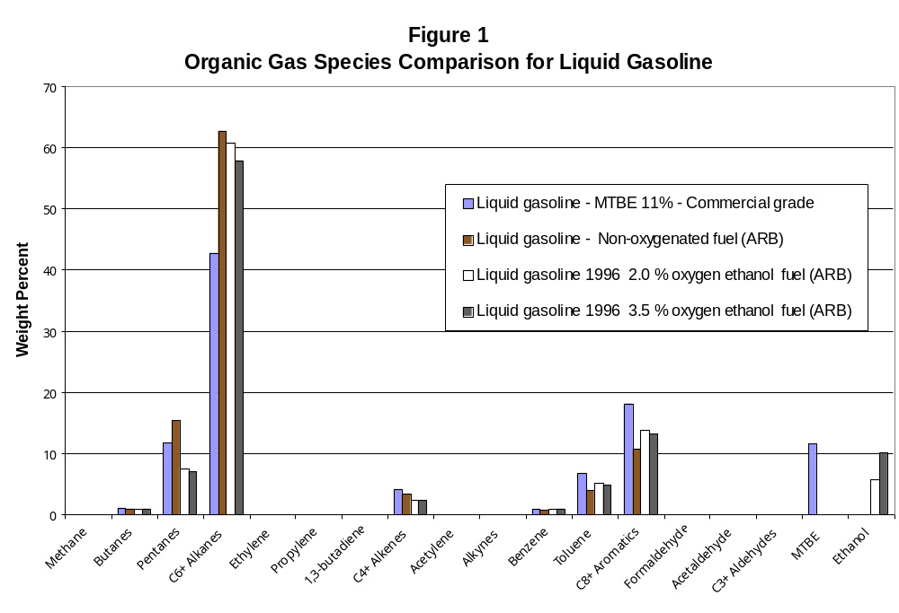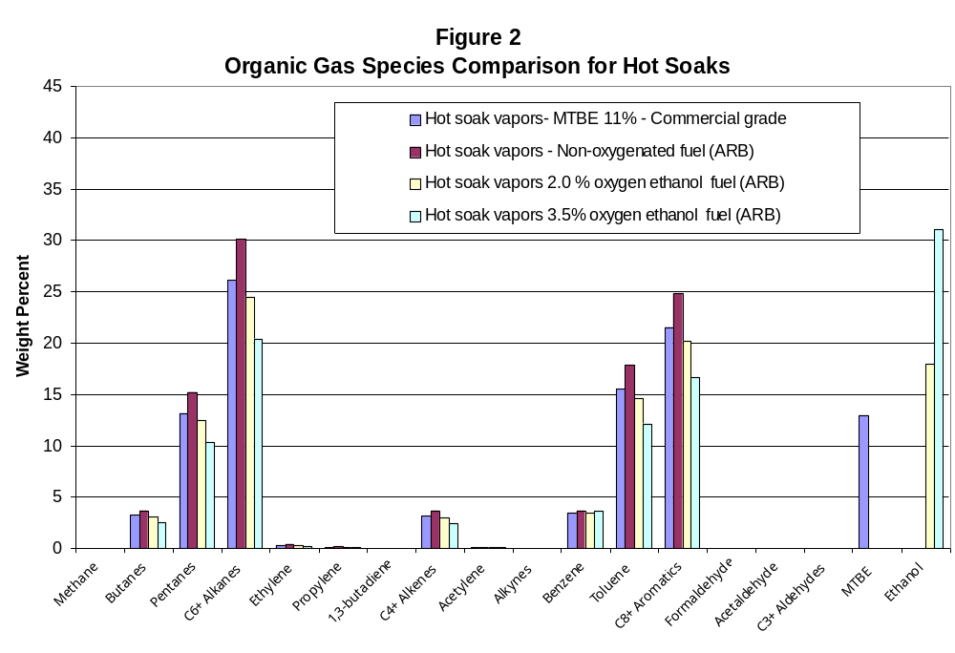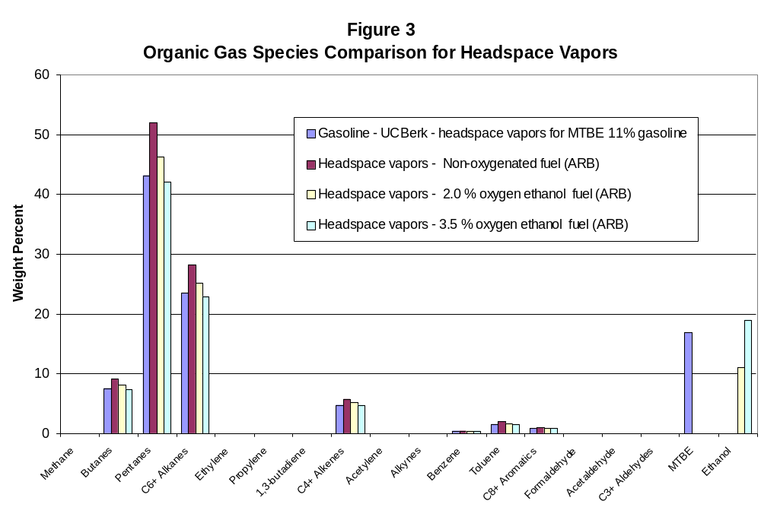
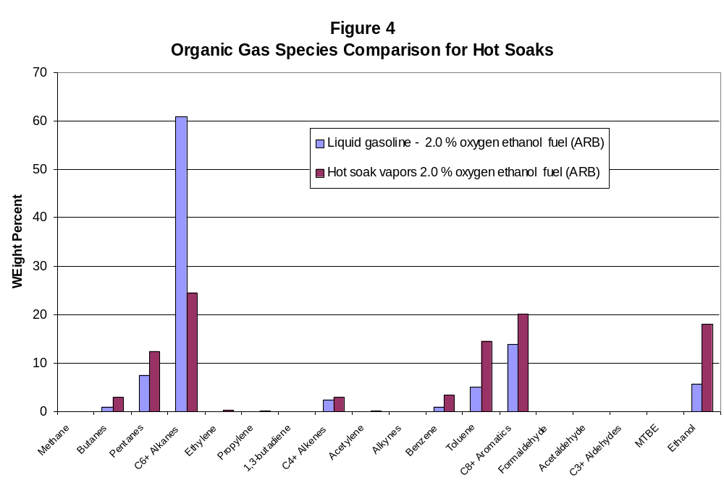

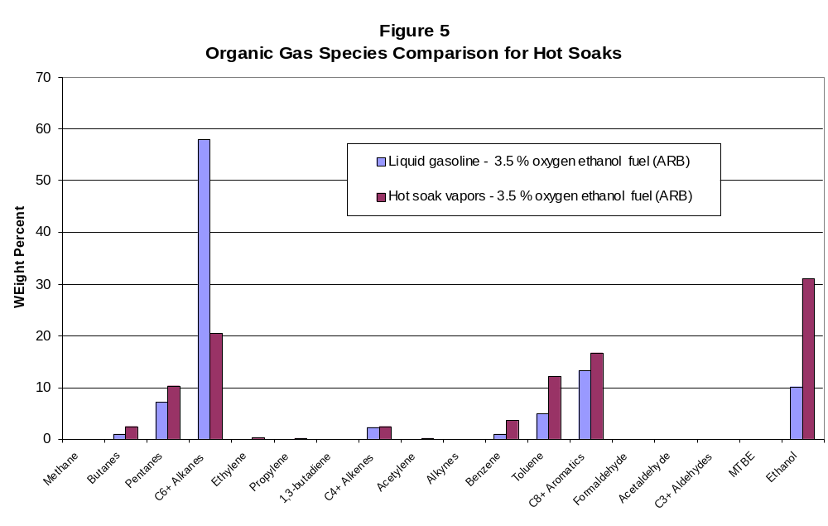

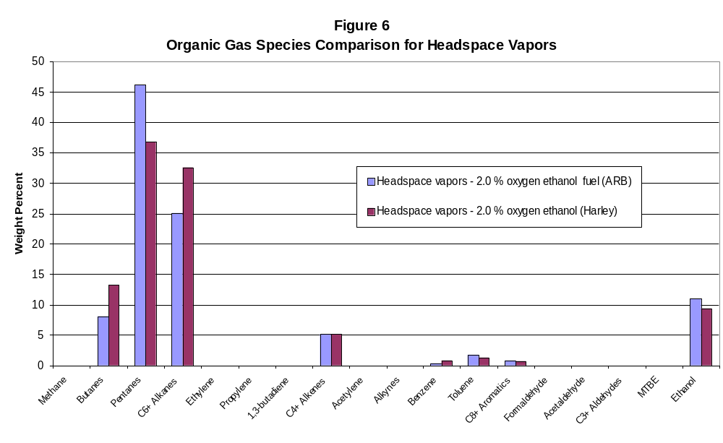
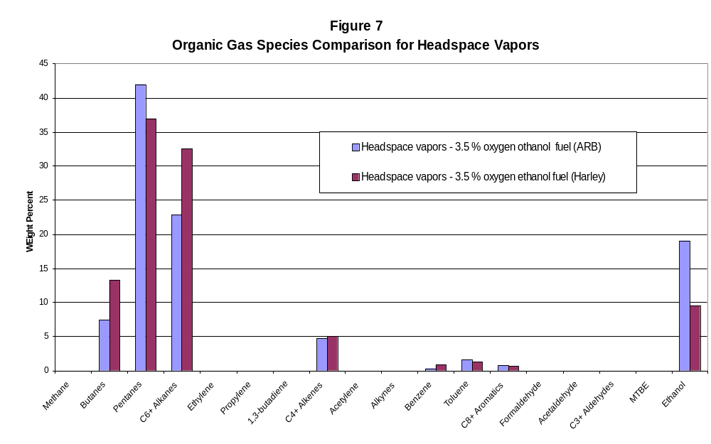3

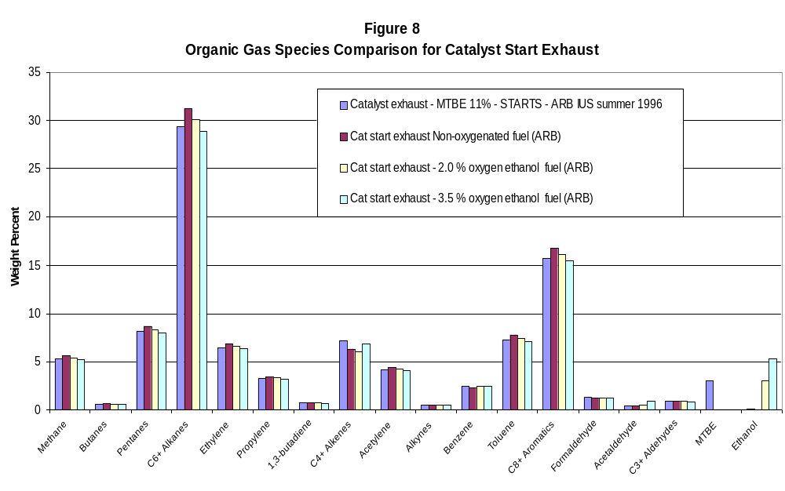
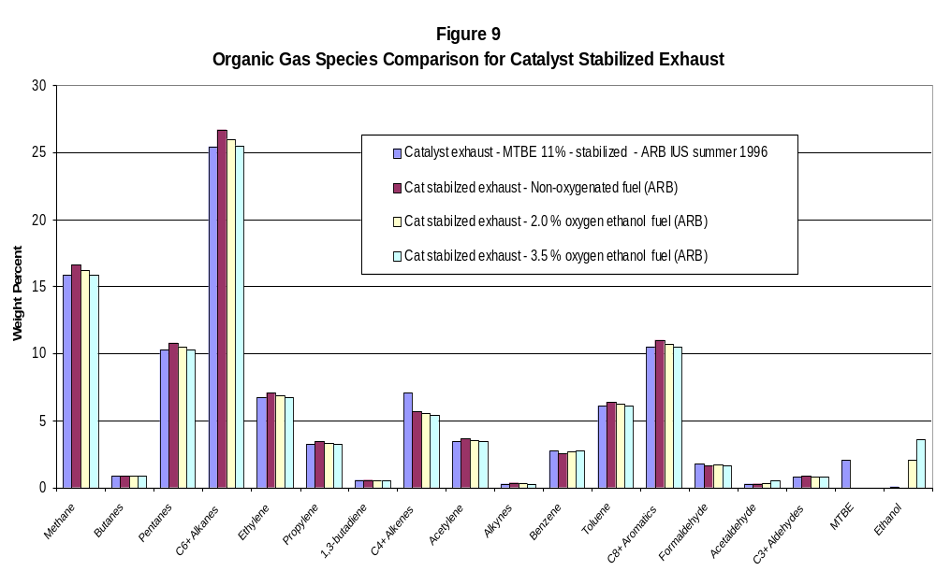
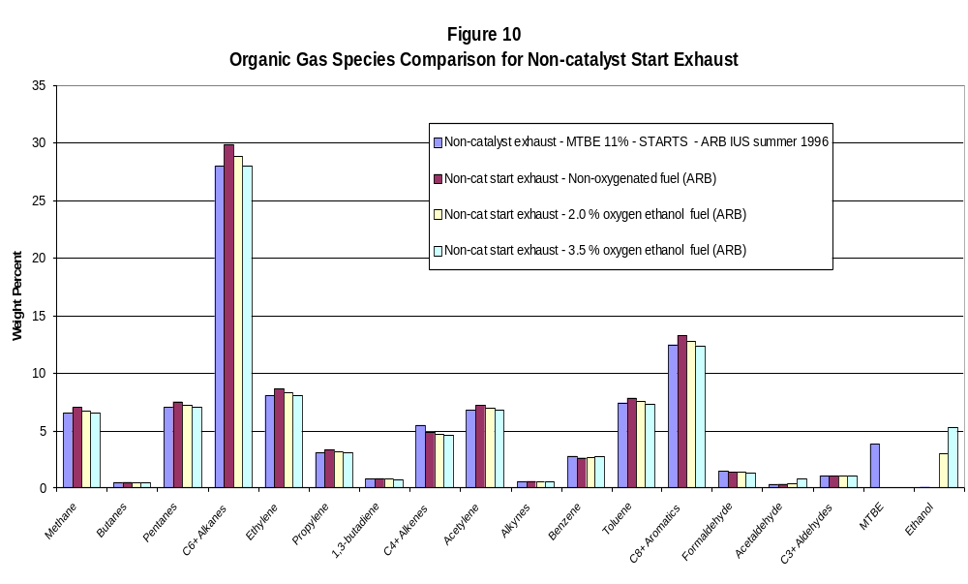
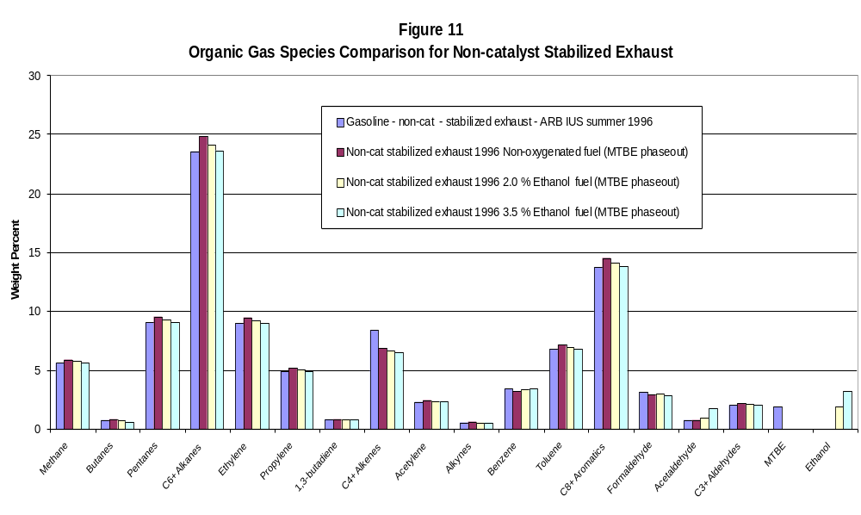

PAGE 1

TABLE 8

LIQUID GASOLINE ORGANIC GAS SPECIES
(WEIGHT PERCENT)

FUEL
CURRENT MTBE UNOXYGENATED 2.0% O ETOH 3.5% O ETOH
CNUM CHEMNAME
-----------------------------------------------------------------------------------------------------------
1.00 methyl alcohol .01 .00 .01 .01
2.00 ethyl alcohol .00 .00 5.75 10.10
3.00 n-propyl alcohol .02 .00 .02 .02
4.00 cis-2-butene .01 .01 .01 .01
isobutane .17 .14 .16 .15
n-butane 1.01 .81 .80 .76
trans-2-butene .01 .01 .01 .01
1-butene .01 .01 .01 .01
5.00 cis-2-pentene .22 .18 .13 .13
cyclopentane .14 .18 .09 .08
cyclopentene .07 .06 .04 .04
isopentane 9.80 12.84 6.26 5.97
isoprene .01 .01 .01 .01
methyl t-butyl ether (MTBE) 11.55 .00 .00 .00
n-pentane 1.81 2.37 1.16 1.10
trans-1,3-pentadiene .03 .02 .02 .02
trans-2-pentene .40 .32 .24 .23
1-pentene .12 .10 .07 .07
1,3-cyclopentadiene .01 .01 .01 .01
2-methyl-1-butene .23 .18 .14 .13
2-methyl-2-butene .61 .49 .37 .35
2,2-dimethylpropane .01 .01 .01 .01
3-methyl-1-butene .02 .02 .01 .01
6.00 benzene 1.00 .80 1.00 1.00
cis-2-hexene .09 .07 .05 .05
cis-3-hexene .03 .02 .02 .02
cyclohexane .22 .29 .14 .13
cyclohexene .03 .02 .02 .02
methylcyclopentane 1.54 2.02 .98 .94
n-hexane 1.19 1.56 .76 .72
trans-2-hexene .17 .14 .10 .10
trans-3-hexene .09 .07 .05 .05
PAGE 2

TABLE 8

LIQUID GASOLINE ORGANIC GAS SPECIES
(WEIGHT PERCENT)

FUEL
CURRENT MTBE UNOXYGENATED 2.0% O ETOH 3.5% O ETOH
CNUM CHEMNAME
-----------------------------------------------------------------------------------------------------------
6.00 1-hexene .06 .05 .04 .03
1-methylcyclopentene .17 .14 .10 .10
2-methyl-1-pentene .11 .09 .07 .06
2-methyl-2-pentene .19 .15 .11 .11
2-methylpentane 4.17 5.47 2.66 2.54
2,2-dimethylbutane .24 .31 .15 .15
2,3-dimethyl-1-butene .01 .01 .01 .01
2,3-dimethylbutane 1.31 1.72 .84 .80
3-methyl-cis-2-pentene .04 .03 .02 .02
3-methyl-1-pentene .02 .02 .01 .01
3-methylcyclopentene .11 .09 .07 .06
3-methylpentane 2.33 3.05 1.49 1.42
4-methyl-trans-2-pentene .07 .06 .04 .04
4-methyl-1-pentene .03 .02 .02 .02
7.00 cis-2-heptene .06 .05 .04 .03
dimethylcyclopentane .06 .09 .11 .10
ethylcyclopentane .21 .33 .37 .35
methylcyclohexane .75 1.19 1.32 1.26
n-heptane 1.64 1.31 1.56 1.49
toluene 6.69 3.96 5.10 4.87
trans-2-heptene .06 .05 .04 .03
trans-3-heptene .13 .10 .08 .07
1-c-2-dimethylcyclopentane .17 .27 .30 .29
1-c-3-dimethylcyclopentane .49 .78 .86 .82
1-t-2-dimethylcyclopentane .36 .57 .63 .60
1-t-3-dimethylcyclopentane .45 .72 .79 .76
2-methyl-trans-3-hexene .03 .02 .02 .02
2-methylhexane 2.61 4.15 4.60 4.39
2,2-dimethylpentane .01 .02 .02 .02
2,2,3-trimethylbutane .04 .06 .07 .04
2,3-dimethylpentane 2.78 4.42 4.90 4.68
2,4-dimethyl-1-pentene .01 .01 .01 .01
PAGE 3

TABLE 8

LIQUID GASOLINE ORGANIC GAS SPECIES
(WEIGHT PERCENT)

FUEL
CURRENT MTBE UNOXYGENATED 2.0% O ETOH 3.5% O ETOH
CNUM CHEMNAME
-----------------------------------------------------------------------------------------------------------
7.00 2,4-dimethylpentane 1.72 2.73 3.03 2.89
3-ethyl-2-pentene .03 .02 .02 .02
3-ethylpentane .28 .44 .49 .47
3-methyl-cis-2-hexene .16 .13 .10 .09
3-methyl-cis-3-hexene .04 .03 .02 .02
3-methyl-trans-2-hexene .14 .11 .08 .08
3-methyl-trans-3-hexene .05 .04 .03 .03
3-methylhexane 2.86 4.55 5.04 4.81
3,3-dimethyl-1-pentene .18 .14 .11 .10
3,3-dimethylpentane .16 .25 .28 .27
3,4-dimethyl-2-pentene .02 .02 .01 .01
4-methyl-trans-2-hexene .05 .04 .03 .03
4-methyl-1-hexene .02 .02 .01 .01
4,4-dimethyl-2-pentene .07 .06 .04 .04
5-methyl-cis-2-hexene .01 .01 .01 .01
5-methyl-1-hexene .01 .01 .01 .01
8.00 c-1,2-dimethylcyclohexane .03 .05 .05 .05
cis-1,3-dimethylcyclohexane .07 .11 .12 .12
cis-2-octene .01 .01 .01 .01
c8 cycloparaffins .21 .33 .37 .35
ethylbenzene 2.15 1.27 1.64 1.56
m-xylene 3.53 2.09 2.69 2.57
n-octane .63 .50 .60 .57
o-xylene 2.10 1.24 1.60 1.53
p-xylene 1.82 1.08 1.39 1.32
propylcyclopentane .04 .06 .07 .07
t-1,2-dimethylcyclohexane .07 .11 .12 .12
t-2-ethylmethylcyclopentane .06 .09 .11 .10
trans-1,3-dimethylcyclohexane .02 .03 .03 .03
trans-1,4-dimethylcyclohexane .07 .11 .12 .12
trans-2-octene .03 .02 .02 .02
trans-4-octene .01 .01 .01 .01
PAGE 4

TABLE 8

LIQUID GASOLINE ORGANIC GAS SPECIES
(WEIGHT PERCENT)

FUEL
CURRENT MTBE UNOXYGENATED 2.0% O ETOH 3.5% O ETOH
CNUM CHEMNAME
-----------------------------------------------------------------------------------------------------------
8.00 unidentified 2.67 2.13 2.54 2.43
1,1-dimethylcyclohexane .01 .02 .02 .02
1,1-methylethylcyclopentane .01 .02 .02 .02
1,1,2-trimethylcyclopentane .02 .03 .03 .03
1c,2c,3-trimethylcyclopentane .07 .11 .12 .12
1c,2t,3-trimethylcyclopentane .30 .48 .53 .50
1c,2t,4-trimethylcyclopentane .17 .27 .30 .29
1t,2c,3-trimethylcyclopentane .09 .14 .16 .15
2-methyl-3-ethylpentane .05 .08 .09 .08
2-methylheptane .69 1.10 1.22 1.16
2,2-dimethylhexane .14 .22 .25 .23
2,2,3-trimethylpentane .13 .21 .23 .22
2,2,4-trimethylpentane 5.45 8.67 9.61 9.17
2,3-dimethylhexane .60 .95 1.06 1.01
2,3,3-trimethylpentane 1.05 1.67 1.85 1.77
2,3,4-trimethylpentane 1.42 2.26 2.50 2.39
2,4-dimethylhexane .85 1.35 1.50 1.43
2,5-dimethylhexane .62 .99 1.09 1.04
3-ethylhexane .06 .09 .11 .10
3-methyl-3-ethylpentane .08 .13 .14 .13
3-methylheptane .74 1.18 1.30 1.24
3,3-dimethylhexane .05 .08 .09 .08
3,4-dimethylhexane .08 .13 .14 .13
4-methylheptane .29 .46 .51 .49
9.00 c-1,c-3,5-trimethylcyclohexane .03 .05 .05 .05
cis-3-nonene .02 .02 .01 .01
c1,t2,t4-trimethylcyclohexane .02 .03 .03 .03
i-butylcyclopentane .14 .22 .25 .23
indan .17 .10 .13 .12
isopropylbenzene (cumene) .06 .03 .05 .04
n-butylcyclopentane .02 .03 .03 .03
n-nonane .16 .13 .15 .14
PAGE 5

TABLE 8

LIQUID GASOLINE ORGANIC GAS SPECIES
(WEIGHT PERCENT)

FUEL
CURRENT MTBE UNOXYGENATED 2.0% O ETOH 3.5% O ETOH
CNUM CHEMNAME
-----------------------------------------------------------------------------------------------------------
9.00 n-propylbenzene .38 .22 .29 .28
propylcyclohexane .01 .02 .02 .02
trans-3-nonene .01 .01 .01 .01
trimethylcyclohexane .01 .02 .02 .02
1-methyl-2-ethylbenzene .37 .22 .28 .27
1-methyl-3-ethylbenzene 1.34 .79 1.02 .97
1-methyl-4-ethylbenzene .57 .34 .43 .41
1-nonene .01 .01 .01 .01
1,1-methylethylcyclohexane .03 .05 .05 .05
1,1,2-trimethylcyclohexane .01 .02 .02 .02
1,1,3-trimethylcyclohexane .01 .02 .02 .02
1,1,4-trimethylcyclohexane .10 .16 .18 .17
1,2,3-trimethylbenzene .32 .19 .24 .23
1,2,4-trimethylbenzene 1.87 1.11 1.43 1.36
1,3,5-trimethylbenzene .68 .40 .52 .49
2-methyl-1-octene .01 .01 .01 .01
2-methyloctane .21 .33 .37 .35
2,2,3,trimethylhexane .07 .11 .12 .12
2,2,4-trimethylhexane .02 .03 .03 .03
2,2,5-trimethylhexane .69 1.10 1.22 1.16
2,3-dimethylheptane .08 .13 .14 .13
2,3,4-trimethylhexane .11 .17 .19 .18
2,3,5-trimethylhexane .08 .13 .14 .13
2,4-dimethylheptane .01 .02 .02 .02
2,4,4-trimethylhexane .01 .02 .02 .02
2,5-dimethylheptane .15 .24 .26 .25
3-ethylheptane .05 .08 .09 .08
3-methyloctane .23 .37 .41 .39
3,3-dimethylheptane .05 .08 .09 .08
3,4-dimethylheptane .05 .08 .09 .08
3,5-dimethylheptane .02 .03 .03 .03
4-methyloctane .16 .25 .28 .27
PAGE 6

TABLE 8

LIQUID GASOLINE ORGANIC GAS SPECIES
(WEIGHT PERCENT)

FUEL
CURRENT MTBE UNOXYGENATED 2.0% O ETOH 3.5% O ETOH
CNUM CHEMNAME
-----------------------------------------------------------------------------------------------------------
9.00 4,4-dimethylheptane .03 .05 .05 .05
10.00 butylcyclohexane .01 .01 .01 .01
dihydronaphthalene .01 .01 .01 .01
isobutylbenzene .04 .02 .03 .03
n-butylbenzene .06 .03 .05 .04
n-decane .06 .05 .06 .05
naphthalene .18 .11 .14 .13
sec-butylbenzene .03 .02 .02 .02
1-methyl-2-isopropylbenzene .02 .01 .01 .01
1-methyl-3-isopropylbenzene .03 .02 .02 .02
1-methyl-3n-propylbenzene .24 .14 .18 .17
1-methyl-4-isopropylbenzene .01 .01 .01 .01
1-methyl-4n-propylbenzene .13 .08 .10 .09
1,2-diethylbenzene (ortho) .02 .01 .01 .01
1,2-dimethyl-3-ethylbenzene .05 .03 .04 .04
1,2-dimethyl-4-ethylbenzene .28 .17 .21 .20
1,2,3,5-tetramethylbenzene .15 .09 .11 .11
1,2,4,5-tetramethylbenzene .11 .06 .08 .08
1,3-diethylbenzene (meta) .11 .06 .08 .08
1,3-dimethyl-2-ethylbenzene .01 .01 .01 .01
1,3-dimethyl-4-ethylbenzene .14 .08 .11 .10
1,3-dimethyl-5-ethylbenzene .22 .13 .17 .16
1,4-dimethyl-2-ethylbenzene .15 .09 .11 .11
2-methylindan .13 .08 .10 .09
2-methylnonane .07 .06 .07 .06
2,2-dimethyloctane .01 .01 .01 .01
2,3-dimethyl-2-octene .01 .01 .01 .01
2,4-dimethyloctane .03 .02 .03 .03
2,5-dimethyloctane .05 .04 .05 .04
2,6-dimethyloctane .02 .02 .02 .02
3-ethyloctane .01 .01 .01 .01
3-methylnonane .07 .06 .07 .06
PAGE 7

TABLE 8

LIQUID GASOLINE ORGANIC GAS SPECIES
(WEIGHT PERCENT)

FUEL
CURRENT MTBE UNOXYGENATED 2.0% O ETOH 3.5% O ETOH
CNUM CHEMNAME
-----------------------------------------------------------------------------------------------------------
10.00 3,3-dimethyloctane .04 .03 .04 .04
3,6-dimethyloctane .01 .01 .01 .01
4-methylindan .03 .02 .02 .02
5-methylindan .12 .07 .09 .09
5-methylnonane .03 .02 .03 .03
11.00 c11 dialkyl benzenes .03 .02 .02 .02
n-undecane .03 .02 .03 .03
pentamethylbenzene .02 .01 .01 .01
s-pentylbenzene .03 .02 .02 .02
1-ethyl-2n-propylbenzene .05 .03 .04 .04
1-methyl-4-t-butylbenzene .02 .01 .01 .01
1-methylnaphthalene .06 .03 .05 .04
2-methylnaphthalene .14 .08 .11 .10
3-ethylnonane .01 .01 .01 .01
12.00 c12 dialkyl benzenes .01 .01 .01 .01
n-dodecane .03 .02 .03 .03
n-hexylbenzene .01 .01 .01 .01
1-methyl-4-n-pentylbenzene .04 .02 .03 .03
1,2-isodipropylbenzene .04 .02 .03 .03
1,2,4-triethylbenzene .01 .01 .01 .01
1,3-dipropylbenzene .04 .02 .03 .03
1,3-n-dipropylbenzene .03 .02 .02 .02
1,3,5-triethylbenzene .01 .01 .01 .01

TOTAL 100.00 100.01 100.01 100.00
PAGE 1

TABLE 9

HOT SOAK EVAPORATIVE ORGANIC GAS SPECIES
(WEIGHT PERCENT)

FUEL
CURRENT MTBE UNOXYGENATED 2.0% O ETOH 3.5% O ETOH
CNUM CHEMNAME
-----------------------------------------------------------------------------------------------------------
2.00 acetylene .13 .15 .13 .10
ethane .08 .09 .08 .06
ethyl alcohol .00 .00 18.00 31.00
ethylene .32 .37 .30 .25
3.00 propane .19 .22 .18 .15
propylene .15 .18 .14 .12
4.00 cis-2-butene .02 .02 .02 .02
isobutane .23 .26 .21 .18
isobutylene .24 .27 .22 .18
n-butane 2.99 3.45 2.81 2.34
trans-2-butene .02 .02 .02 .02
5.00 cis-2-pentene .18 .21 .17 .14
cyclopentane .19 .22 .18 .15
cyclopentene .07 .08 .07 .06
isopentane 9.48 10.93 8.91 7.41
methyl t-butyl ether (MTBE) 12.97 .00 .00 .00
n-pentane 3.51 4.05 3.30 2.75
trans-2-pentene .69 .79 .65 .54
1-pentene .09 .11 .09 .07
2-methyl-1-butene .21 .24 .19 .16
2-methyl-2-butene 1.17 1.35 1.10 .92
6.00 benzene 3.43 3.64 3.43 3.64
cis-2-hexene .02 .02 .02 .02
cyclohexane .53 .62 .50 .42
methylcyclopentane 2.36 2.72 2.22 1.85
n-hexane 2.38 2.75 2.24 1.86
trans-2-hexene .12 .14 .12 .10
trans-3-hexene .07 .08 .07 .06
2-methyl-1-pentene .03 .04 .03 .02
2-methyl-2-pentene .11 .13 .11 .09
2-methylpentane 3.96 4.56 3.72 3.09
2,2-dimethylbutane .22 .25 .20 .17
PAGE 2

TABLE 9

HOT SOAK EVAPORATIVE ORGANIC GAS SPECIES
(WEIGHT PERCENT)

FUEL
CURRENT MTBE UNOXYGENATED 2.0% O ETOH 3.5% O ETOH
CNUM CHEMNAME
-----------------------------------------------------------------------------------------------------------
6.00 2,3-dimethylbutane 1.04 1.20 .97 .81
3-methylcyclopentene .04 .05 .04 .03
3-methylpentane 2.22 2.56 2.09 1.73
4-methyl-trans-2-pentene .01 .01 .01 .01
7.00 ethylcyclopentane .07 .08 .07 .06
methylcyclohexane .92 1.07 .87 .72
n-heptane 1.23 1.42 1.16 .96
toluene 15.51 17.87 14.57 12.12
1-c-3-dimethylcyclopentane .18 .21 .17 .14
1-t-2-dimethylcyclopentane .01 .01 .01 .01
1-t-3-dimethylcyclopentane .25 .28 .23 .19
2-methyl-2-hexene .10 .12 .10 .08
2-methylhexane .57 .66 .54 .45
2,3-dimethylpentane 2.52 2.90 2.37 1.97
2,4-dimethylpentane .96 1.10 .90 .75
3-ethylpentane .18 .21 .17 .14
3-methylhexane 1.90 2.19 1.79 1.49
8.00 cis-1,3-dimethylcyclohexane .01 .01 .01 .01
ethylbenzene 3.02 3.48 2.84 2.36
m-xylene 9.08 10.47 8.54 7.10
n-octane .19 .22 .18 .15
o-xylene 2.93 3.38 2.75 2.29
styrene .01 .01 .01 .01
trans-1,2-cis-4-tm-cyclopentane .01 .01 .01 .01
trans-1,4-dimethylcyclohexane .10 .12 .10 .08
2-methylheptane .25 .28 .23 .19
2,2,4-trimethylpentane 2.17 2.50 2.04 1.69
2,3-dimethylhexane .09 .11 .09 .07
2,3,4-trimethylpentane .54 .63 .51 .43
2,4-dimethylhexane .16 .19 .15 .13
2,5-dimethylhexane .23 .26 .21 .18
3-methylheptane .52 .60 .49 .41
PAGE 3

TABLE 9

HOT SOAK EVAPORATIVE ORGANIC GAS SPECIES
(WEIGHT PERCENT)

FUEL
CURRENT MTBE UNOXYGENATED 2.0% O ETOH 3.5% O ETOH
CNUM CHEMNAME
-----------------------------------------------------------------------------------------------------------
8.00 4-methylheptane .03 .04 .03 .02
9.00 indan .10 .12 .10 .08
n-nonane .02 .02 .02 .02
n-propylbenzene .19 .22 .18 .15
propylbenzene .19 .22 .18 .15
1-methyl-2-ethylbenzene .53 .62 .50 .42
1-methyl-3-ethylbenzene 1.61 1.86 1.52 1.26
1-methyl-4-ethylbenzene .61 .70 .57 .47
1,2,3-trimethylbenzene .14 .17 .13 .11
1,2,4-trimethylbenzene 1.93 2.23 1.81 1.51
1,3,5-trimethylbenzene .65 .75 .61 .51
2,2,5-trimethylhexane .14 .17 .13 .11
4-methyloctane .05 .06 .05 .04
10.00 n-decane .05 .06 .05 .04
1-methyl-2-isopropylbenzene .08 .09 .08 .06
1-methyl-3n-propylbenzene .03 .04 .03 .02
1,2-dimethyl-4-ethylbenzene .03 .04 .03 .02
1,3-dimethyl-5-ethylbenzene .06 .07 .06 .05
12.00 n-dodecane .01 .01 .01 .01
t-1-butyl-3,5-dimethylbenzene .13 .15 .13 .00
1-(1,1-dme)-3,5-dmbenzene .13 .15 .13 .10

TOTAL 100.00 100.00 100.00 99.89
PAGE 1

TABLE 10

HEADSPACE EVAPORATIVE ORGANIC GAS SPECIES
(WEIGHT PERCENT)

FUEL
CURRENT MTBE UNOXYGENATED 2.0% O ETOH 3.5% O ETOH
CNUM CHEMNAME
-----------------------------------------------------------------------------------------------------------
2.00 ethyl alcohol .00 .00 11.00 19.00
3.00 propane .28 .34 .30 .27
4.00 cis-2-butene .34 .41 .36 .33
isobutane 1.30 1.56 1.39 1.27
isobutylene .16 .19 .17 .16
n-butane 6.29 7.57 6.73 6.13
trans-2-butene .59 .71 .63 .57
1-butene .12 .14 .13 .12
5.00 cis-2-pentene .30 .36 .32 .29
cyclopentane .98 1.18 1.05 .95
cyclopentene .09 .11 .10 .09
isopentane 34.88 41.97 37.34 33.97
methyl t-butyl ether (MTBE) 16.83 .00 .00 .00
n-pentane 7.28 8.76 7.79 7.09
trans-2-pentene .73 .88 .78 .71
1-pentene .22 .26 .23 .21
2-methyl-1-butene .41 .49 .44 .40
2-methyl-2-butene 1.02 1.23 1.09 .99
3-methyl-1-butene .08 .10 .09 .08
6.00 benzene .36 .36 .36 .36
cis-2-hexene .04 .05 .04 .04
cis-3-hexene .05 .06 .05 .05
cyclohexane .96 1.15 1.03 .93
methylcyclopentane 2.64 3.18 2.83 2.57
n-hexane 1.44 1.73 1.54 1.40
t-amylmethylether (TAME) .01 .01 .01 .01
trans-2-hexene .09 .11 .10 .09
1-hexene .03 .04 .03 .03
2-ethyl-1-butene .02 .02 .02 .02
2-hexenes .03 .04 .03 .03
2-methyl-1-pentene .06 .07 .06 .06
2-methyl-2-pentene .18 .22 .19 .17
PAGE 2

TABLE 10

HEADSPACE EVAPORATIVE ORGANIC GAS SPECIES
(WEIGHT PERCENT)

FUEL
CURRENT MTBE UNOXYGENATED 2.0% O ETOH 3.5% O ETOH
CNUM CHEMNAME
-----------------------------------------------------------------------------------------------------------
6.00 2-methylpentane 5.57 6.70 5.96 5.42
2,2-dimethylbutane 1.55 1.86 1.66 1.51
2,3-dimethylbutane 1.95 2.35 2.09 1.90
3-methyl-cis-2-pentene .04 .05 .04 .04
3-methyl-trans-2-pentene .06 .07 .06 .06
3-methylpentane 3.06 3.68 3.27 2.98
4-methyl-cis-2-pentene .02 .02 .02 .02
4-methyl-trans-2-pentene .10 .12 .11 .10
4-methyl-1-pentene .03 .04 .03 .03
7.00 methylcyclohexane .38 .46 .41 .37
n-heptane .39 .47 .42 .38
toluene 1.59 1.91 1.70 1.55
2-methylhexane .67 .81 .72 .65
2,2-dimethylpentane .06 .07 .06 .06
2,3-dimethylpentane .65 .78 .70 .63
2,4-dimethylpentane .51 .61 .55 .50
3-ethylpentane .04 .05 .04 .04
3-methylhexane .74 .89 .79 .72
8.00 c-1,2-dimethylcyclohexane .01 .01 .01 .01
ethylbenzene .11 .13 .12 .11
ethylcyclohexane .07 .08 .07 .07
m-xylene .32 .38 .34 .31
n-octane .05 .06 .05 .05
o-xylene .12 .14 .13 .12
p-xylene .10 .12 .11 .10
unidentified 1.16 1.40 1.24 1.13
2-methyl-3-ethylpentane .09 .11 .10 .09
2-methylheptane .12 .14 .13 .12
2,2-dimethylhexane .01 .01 .01 .01
2,2,3-trimethylpentane .04 .05 .04 .04
2,2,4-trimethylpentane 1.21 1.46 1.29 1.18
2,3-dimethylhexane .01 .01 .01 .01
PAGE 3

TABLE 10

HEADSPACE EVAPORATIVE ORGANIC GAS SPECIES
(WEIGHT PERCENT)

FUEL
CURRENT MTBE UNOXYGENATED 2.0% O ETOH 3.5% O ETOH
CNUM CHEMNAME
-----------------------------------------------------------------------------------------------------------
8.00 2,3,3-trimethylpentane .31 .37 .33 .30
2,3,4-trimethylpentane .31 .37 .33 .30
2,4-dimethylhexane .13 .16 .14 .13
2,5-dimethylhexane .12 .14 .13 .12
3-methylheptane .12 .14 .13 .12
3,3-dimethylhexane .01 .01 .01 .01
4-methylheptane .06 .07 .06 .06
9.00 isopropylbenzene (cumene) .01 .01 .01 .01
m-ethyltoluene (99912) .04 .05 .04 .04
n-nonane .01 .01 .01 .01
o-ethyltoluene (99915) .01 .01 .01 .01
p-ethyltoluene (99914) .02 .02 .02 .02
1,2,3-trimethylbenzene .01 .01 .01 .01
2,2,5-trimethylhexane .14 .17 .15 .14
12.00 1,2,4-triethylbenzene .04 .05 .04 .04
1,3,5-triethylbenzene .02 .02 .02 .02

TOTAL 100.00 99.99 100.00 100.00
PAGE 1

TABLE 11

CATALYST START EXHAUST ORGANIC GAS SPECIES
(WEIGHT PERCENT)

FUEL
CURRENT MTBE UNOXYGENATED 2.0% O ETOH 3.5% O ETOH
CNUM CHEMNAME
-----------------------------------------------------------------------------------------------------------
1.00 formaldehyde 1.31 1.24 1.26 1.19
methane 5.28 5.63 5.42 5.20
methyl alcohol 1.23 .00 .29 .28
2.00 acetaldehyde .40 .40 .52 .91
acetylene 4.13 4.40 4.24 4.07
ethane .74 .79 .76 .73
ethyl alcohol .09 .00 3.00 5.28
ethylene 6.45 6.87 6.62 6.36
3.00 acetone .34 .36 .35 .33
acrolein (2-propenal) .11 .12 .11 .11
propane .07 .07 .07 .07
propionaldehyde .06 .06 .06 .06
propylene 3.25 3.46 3.33 3.20
1-propyne .32 .34 .33 .31
1,2-propadiene .23 .24 .24 .23
4.00 butyraldehyde .06 .06 .06 .06
cis-2-butene .22 .23 .23 .22
crotonaldehyde .05 .05 .05 .05
isobutane .02 .02 .02 .02
isobutylene 2.86 1.61 1.56 2.82
methyl ethyl ketone (MEK) .06 .06 .06 .06
n-butane .56 .60 .57 .55
trans-2-butene .24 .26 .25 .24
vinylacetylene .12 .13 .12 .12
1-butene .53 .56 .54 .28
1,2-butadiene .03 .03 .03 .03
1,3-butadiene .70 .73 .70 .68
1,3-butadiyne .02 .02 .02 .02
2-methyl-2-propenal .10 .11 .10 .10
5.00 cis-2-pentene .12 .13 .12 .12
cyclopentane .41 .44 .42 .40
cyclopentene .22 .23 .23 .22
PAGE 2

TABLE 11

CATALYST START EXHAUST ORGANIC GAS SPECIES
(WEIGHT PERCENT)

FUEL
CURRENT MTBE UNOXYGENATED 2.0% O ETOH 3.5% O ETOH
CNUM CHEMNAME
-----------------------------------------------------------------------------------------------------------
5.00 isopentane 5.36 5.71 5.50 5.28
isoprene .21 .22 .22 .21
isovaleraldehyde .03 .03 .03 .03
methyl t-butyl ether (MTBE) 3.02 .00 .00 .00
n-pentane 2.38 2.54 2.44 2.35
trans-1,3-pentadiene .03 .03 .03 .03
trans-2-pentene .26 .28 .27 .26
1-pentene .14 .15 .14 .14
2-methyl-1-butene .28 .30 .29 .28
2-methyl-2-butene .44 .47 .45 .43
3-methyl-1-butene .22 .23 .23 .22
6.00 benzene 2.47 2.32 2.43 2.43
cis-2-hexene .06 .06 .06 .06
cyclohexane .74 .79 .76 .73
cyclohexene .07 .07 .07 .07
hexanal .02 .02 .02 .02
methylcyclopentane 2.92 3.11 3.00 2.88
n-hexane 1.74 1.85 1.79 1.71
trans-2-hexene .18 .19 .18 .18
trans-3-hexene .07 .07 .07 .07
1-hexene .10 .11 .10 .10
2-methyl-1-pentene .06 .06 .06 .06
2-methyl-2-pentene .10 .11 .10 .10
2-methylpentane 3.68 3.92 3.78 3.63
2,2-dimethylbutane .56 .60 .57 .55
2,3-dimethyl-1-butene .01 .01 .01 .01
2,3-dimethylbutane .98 1.04 1.01 .97
3-methyl-trans-2-pentene .01 .01 .01 .01
3-methyl-1-pentene .08 .08 .08 .08
3-methylcyclopentene .10 .11 .10 .10
3-methylpentane 2.23 2.38 2.29 2.20
3,3-dimethyl-1-butene .02 .02 .02 .02
PAGE 3

TABLE 11

CATALYST START EXHAUST ORGANIC GAS SPECIES
(WEIGHT PERCENT)

FUEL
CURRENT MTBE UNOXYGENATED 2.0% O ETOH 3.5% O ETOH
CNUM CHEMNAME
-----------------------------------------------------------------------------------------------------------
6.00 4-methyl-trans-2-pentene .06 .06 .06 .06
4-methyl-1-pentene .03 .03 .03 .03
7.00 benzaldehyde .23 .24 .24 .23
cis-2-heptene .04 .04 .04 .04
ethylcyclopentane .22 .23 .23 .22
methylcyclohexane .79 .84 .81 .78
n-heptane .66 .70 .68 .65
toluene 7.25 7.73 7.44 7.14
trans-2-heptene .04 .04 .04 .04
trans-3-heptene .06 .06 .06 .06
1-c-3-dimethylcyclopentane .30 .32 .31 .30
1-t-3-dimethylcyclopentane .33 .35 .34 .32
2-methyl-trans-3-hexene .01 .01 .01 .01
2-methyl-2-hexene .04 .04 .04 .04
2-methylhexane .03 .03 .03 .03
2,2,3-trimethylbutane .02 .02 .02 .02
2,3-dimethyl-2-pentene .02 .02 .02 .02
2,3-dimethylpentane 1.72 1.83 1.76 1.69
2,4-dimethyl-1-pentene .01 .01 .01 .01
2,4-dimethyl-2-pentene .05 .05 .05 .05
2,4-dimethylpentane .54 .57 .55 .53
3-ethylpentane .33 .35 .34 .32
3-methyl-cis-2-hexene .04 .04 .04 .04
3-methyl-trans-3-hexene .01 .01 .01 .01
3-methylhexane .92 .98 .94 .91
3,3-dimethylpentane .02 .02 .02 .02
3,4-dimethyl-1-pentene .01 .01 .01 .01
4-methyl-trans-2-hexene .02 .02 .02 .02
8.00 c-1-methyl-3-ethylcyclopentane .09 .10 .09 .09
c-1,2-dimethylcyclohexane .01 .01 .01 .01
cis-1,3-dimethylcyclohexane .05 .05 .05 .05
cis-2-octene .01 .01 .01 .01
PAGE 4

TABLE 11

CATALYST START EXHAUST ORGANIC GAS SPECIES
(WEIGHT PERCENT)

FUEL
CURRENT MTBE UNOXYGENATED 2.0% O ETOH 3.5% O ETOH
CNUM CHEMNAME
-----------------------------------------------------------------------------------------------------------
8.00 ethylbenzene 1.54 1.64 1.58 1.52
ethylcyclohexane .02 .02 .02 .02
m-xylene 5.17 5.51 5.31 5.09
n-octane .55 .59 .56 .54
o-xylene 1.78 1.90 1.83 1.75
styrene .25 .27 .26 .25
t-1-methyl-3-ethylcyclopentane .16 .17 .16 .16
tolualdehyde .20 .21 .20 .20
trans-1,3-dimethylcyclohexane .07 .07 .07 .07
trans-1,4-dimethylcyclohexane .14 .15 .14 .14
trans-2-octene .01 .01 .01 .01
unidentified .45 .48 .46 .44
1-octene .02 .02 .02 .02
1,2,4-trimethylcyclopentene .21 .22 .22 .21
1c,2t,3-trimethylcyclopentane .09 .10 .09 .09
2-methylheptane .48 .51 .49 .47
2,2-dimethylhexane .10 .11 .10 .10
2,2,4-trimethylpentane 1.92 2.05 1.97 1.89
2,3-dimethylhexane .38 .40 .39 .38
2,3,4-trimethylpentane .77 .82 .79 .76
2,4-dimethylhexane .38 .40 .39 .38
2,5-dimethylhexane .43 .46 .44 .42
3-methylheptane .82 .87 .84 .81
3,3-dimethylhexane .01 .01 .01 .01
4-methylheptane .27 .29 .28 .27
9.00 indan .15 .16 .15 .15
isopropylbenzene (cumene) .06 .06 .06 .06
n-nonane .29 .31 .30 .29
n-propylbenzene .38 .40 .39 .38
1-methyl-2-ethylbenzene .45 .48 .46 .44
1-methyl-3-ethylbenzene 1.23 1.31 1.26 1.21
1-methyl-4-ethylbenzene .53 .56 .54 .52
PAGE 5

TABLE 11

CATALYST START EXHAUST ORGANIC GAS SPECIES
(WEIGHT PERCENT)

FUEL
CURRENT MTBE UNOXYGENATED 2.0% O ETOH 3.5% O ETOH
CNUM CHEMNAME
-----------------------------------------------------------------------------------------------------------
9.00 1-methyl-4-ethylcyclohexane .06 .06 .06 .06
1-nonene .06 .06 .06 .06
1,2,3-trimethylbenzene .29 .31 .30 .29
1,2,4-trimethylbenzene 1.52 1.62 1.56 1.50
1,3,5-trimethylbenzene .61 .65 .63 .60
1,3,5-trimethylcyclohexane .11 .12 .11 .11
2-methyloctane .05 .05 .05 .05
2,2,4-trimethylhexane .11 .12 .11 .11
2,2,5-trimethylhexane .39 .42 .40 .38
2,3-dimethylheptane .02 .02 .02 .02
2,3,5-trimethylhexane .06 .06 .06 .06
2,4-dimethylheptane .12 .13 .12 .12
2,4,4-trimethylhexane .02 .02 .02 .02
2,6-dimethylheptane .29 .31 .30 .29
3-methyloctane .40 .43 .41 .39
3,4-dimethylheptane .09 .10 .09 .09
3,5-dimethylheptane .22 .23 .23 .22
4-methyloctane .34 .36 .35 .33
10.00 isobutylbenzene .03 .03 .03 .03
n-decane .13 .14 .13 .13
naphthalene .07 .07 .07 .07
1-methyl-2-isopropylbenzene .09 .10 .09 .09
1-methyl-2n-propylbenzene .06 .06 .06 .06
1-methyl-3-isopropylbenzene .07 .07 .07 .07
1-methyl-3n-propylbenzene .22 .23 .23 .22
1-methyl-4-isopropylbenzene .02 .02 .02 .02
1,2-diethylbenzene (ortho) .02 .02 .02 .02
1,2-dimethyl-3-ethylbenzene .04 .04 .04 .04
1,2-dimethyl-4-ethylbenzene .17 .18 .17 .17
1,2,3,4-tetramethylbenzene .05 .05 .05 .05
1,2,3,5-tetramethylbenzene .08 .08 .08 .08
1,2,4,5-tetramethylbenzene .06 .06 .06 .06
PAGE 6

TABLE 11

CATALYST START EXHAUST ORGANIC GAS SPECIES
(WEIGHT PERCENT)

FUEL
CURRENT MTBE UNOXYGENATED 2.0% O ETOH 3.5% O ETOH
CNUM CHEMNAME
-----------------------------------------------------------------------------------------------------------
10.00 1,3-diethylbenzene (meta) .11 .12 .11 .11
1,3-dimethyl-2-ethylbenzene .03 .03 .03 .03
1,3-dimethyl-4-ethylbenzene .13 .14 .13 .13
1,3-dimethyl-5-ethylbenzene .18 .19 .18 .18
1,4-diethylbenzene (para) .13 .14 .13 .13
1,4-dimethyl-2-ethylbenzene .12 .13 .12 .12
2-methylindan .08 .08 .08 .08
2-methylnonane .18 .19 .18 .18
2,2-dimethyloctane .04 .04 .04 .04
2,2,4-trimethylheptane .12 .13 .12 .12
2,3-dimethyloctane .05 .05 .05 .05
2,4-dimethyloctane .06 .06 .06 .06
2,5-dimethyloctane .07 .07 .07 .07
2,6-dimethyloctane .09 .10 .09 .09
3,3-dimethyloctane .08 .08 .08 .08
4-methylindan .02 .02 .02 .02
5-methylindan .07 .07 .07 .07
11.00 n-pentylbenzene .04 .04 .04 .04
n-undecane .07 .07 .07 .07
1-ethyl-2n-propylbenzene .02 .02 .02 .02
1-methyl-2-n-butylbenzene .03 .03 .03 .03
1-methyl-2-t-butylbenzene .01 .01 .01 .01
12.00 n-dodecane .02 .02 .02 .02
t-1-butyl-3,5-dimethylbenzene .03 .03 .03 .03
1,3-dipropylbenzene .02 .02 .02 .02
13.00 2,2,5-triethylheptane .16 .17 .16 .16

TOTAL 100.00 100.01 100.01 100.01
PAGE 1

TABLE 12

CATALYST STABILIZED EXHAUST ORGANIC GAS SPECIES
(WEIGHT PERCENT)

FUEL
CURRENT MTBE UNOXYGENATED 2.0% O ETOH 3.5% O ETOH
CNUM CHEMNAME
-----------------------------------------------------------------------------------------------------------
1.00 formaldehyde 1.76 1.64 1.69 1.62
methane 15.82 16.59 16.16 15.85
methyl alcohol .42 .00 .21 .21
2.00 acetaldehyde .25 .25 .32 .58
acetylene 3.44 3.61 3.51 3.45
ethane 1.09 1.14 1.11 1.09
ethyl alcohol .07 .00 2.01 3.58
ethylene 6.73 7.06 6.88 6.74
3.00 acetone .17 .18 .17 .17
acrolein (2-propenal) .14 .15 .14 .14
propane .06 .06 .06 .06
propionaldehyde .04 .04 .04 .04
propylene 3.24 3.40 3.31 3.24
1-propyne .24 .25 .24 .24
1,2-propadiene .15 .16 .15 .15
4.00 butyraldehyde .02 .02 .02 .02
cis-2-butene .18 .19 .18 .18
crotonaldehyde .03 .03 .03 .03
isobutane .02 .02 .02 .02
isobutylene 3.46 1.92 1.87 1.84
methyl ethyl ketone (MEK) .02 .02 .02 .02
n-butane .81 .85 .83 .81
trans-2-butene .25 .26 .25 .25
vinylacetylene .07 .07 .07 .07
1-butene .44 .46 .45 .44
1,2-butadiene .01 .01 .01 .01
1,3-butadiene .57 .59 .57 .56
2-methyl-2-propenal .09 .09 .09 .09
5.00 cis-2-pentene .12 .13 .12 .12
cyclopentane .37 .39 .38 .37
cyclopentene .20 .21 .20 .20
isopentane 7.08 7.43 7.23 7.09
PAGE 2

TABLE 12

CATALYST STABILIZED EXHAUST ORGANIC GAS SPECIES
(WEIGHT PERCENT)

FUEL
CURRENT MTBE UNOXYGENATED 2.0% O ETOH 3.5% O ETOH
CNUM CHEMNAME
-----------------------------------------------------------------------------------------------------------
5.00 isoprene .15 .16 .15 .15
isovaleraldehyde .04 .04 .04 .04
methyl t-butyl ether (MTBE) 2.01 .00 .00 .00
n-pentane 2.86 3.00 2.92 2.86
trans-2-pentene .22 .23 .22 .22
1-pentene .14 .15 .14 .14
2-methyl-1-butene .30 .31 .31 .30
2-methyl-2-butene .43 .45 .44 .43
3-methyl-1-butene .24 .25 .24 .24
6.00 benzene 2.73 2.52 2.68 2.73
cis-2-hexene .04 .04 .04 .04
cyclohexane .63 .66 .64 .63
cyclohexene .09 .09 .09 .09
hexanal .02 .02 .02 .02
methylcyclopentane 2.86 3.00 2.92 2.86
n-hexane 1.64 1.72 1.67 1.64
trans-2-hexene .13 .14 .13 .13
trans-3-hexene .05 .05 .05 .05
1-hexene .05 .05 .05 .05
2-methyl-1-pentene .07 .07 .07 .07
2-methyl-2-pentene .08 .08 .08 .08
2-methylpentane 3.85 4.04 3.93 3.86
2,2-dimethylbutane .66 .69 .67 .66
2,3-dimethyl-1-butene .01 .01 .01 .01
2,3-dimethylbutane 1.09 1.14 1.11 1.09
3-methyl-1-pentene .11 .11 .11 .11
3-methylcyclopentene .07 .07 .07 .07
3-methylpentane 2.26 2.37 2.31 2.26
4-methyl-trans-2-pentene .06 .06 .06 .06
4-methyl-1-pentene .01 .01 .01 .01
7.00 benzaldehyde .17 .18 .17 .17
cis-2-heptene .01 .01 .01 .01
PAGE 3

TABLE 12

CATALYST STABILIZED EXHAUST ORGANIC GAS SPECIES
(WEIGHT PERCENT)

FUEL
CURRENT MTBE UNOXYGENATED 2.0% O ETOH 3.5% O ETOH
CNUM CHEMNAME
-----------------------------------------------------------------------------------------------------------
7.00 ethylcyclopentane .15 .16 .15 .15
methylcyclohexane .63 .66 .64 .63
n-heptane .52 .54 .53 .52
toluene 6.09 6.39 6.22 6.10
trans-2-heptene .01 .01 .01 .01
trans-3-heptene .05 .05 .05 .05
1-c-3-dimethylcyclopentane .24 .25 .24 .24
1-t-3-dimethylcyclopentane .27 .28 .28 .27
2-methyl-trans-3-hexene .04 .04 .04 .04
2,2,3-trimethylbutane .01 .01 .01 .01
2,3-dimethylpentane 1.49 1.56 1.52 1.49
2,4-dimethyl-2-pentene .02 .02 .02 .02
2,4-dimethylpentane .45 .47 .46 .45
3-ethylpentane .27 .28 .28 .27
3-methyl-cis-2-hexene .01 .01 .01 .01
3-methylhexane .79 .83 .81 .79
3,3-dimethylpentane .01 .01 .01 .01
8.00 c-1-methyl-3-ethylcyclopentane .07 .07 .07 .07
c-1,2-dimethylcyclohexane .03 .03 .03 .03
cis-1,3-dimethylcyclohexane .08 .08 .08 .08
ethylbenzene 1.11 1.16 1.13 1.11
m-xylene 3.77 3.95 3.85 3.78
n-octane .40 .42 .41 .40
o-xylene 1.31 1.37 1.34 1.31
styrene .13 .14 .13 .13
t-1-methyl-3-ethylcyclopentane .11 .11 .11 .11
tolualdehyde .23 .24 .23 .23
trans-1,3-dimethylcyclohexane .04 .04 .04 .04
trans-1,4-dimethylcyclohexane .04 .04 .04 .04
1,2,4-trimethylcyclopentene .13 .14 .13 .13
1c,2t,3-trimethylcyclopentane .06 .06 .06 .06
2-methylheptane .35 .37 .36 .35
PAGE 4

TABLE 12

CATALYST STABILIZED EXHAUST ORGANIC GAS SPECIES
(WEIGHT PERCENT)

FUEL
CURRENT MTBE UNOXYGENATED 2.0% O ETOH 3.5% O ETOH
CNUM CHEMNAME
-----------------------------------------------------------------------------------------------------------
8.00 2,2-dimethylhexane .07 .07 .07 .07
2,2,4-trimethylpentane 1.78 1.87 1.82 1.78
2,3-dimethylhexane .25 .26 .25 .25
2,3,4-trimethylpentane .62 .65 .63 .62
2,4-dimethylhexane .28 .29 .29 .28
2,5-dimethylhexane .35 .37 .36 .35
3-methylheptane .62 .65 .63 .62
4-methylheptane .16 .17 .16 .16
9.00 indan .09 .09 .09 .09
isopropylbenzene (cumene) .01 .01 .01 .01
n-nonane .18 .19 .18 .18
n-propylbenzene .24 .25 .24 .24
1-methyl-2-ethylbenzene .29 .30 .30 .29
1-methyl-3-ethylbenzene .84 .88 .86 .84
1-methyl-4-ethylbenzene .35 .37 .36 .35
1-methyl-4-ethylcyclohexane .01 .01 .01 .01
1,2,3-trimethylbenzene .18 .19 .18 .18
1,2,4-trimethylbenzene 1.02 1.07 1.04 1.02
1,3,5-trimethylbenzene .41 .43 .42 .41
1,3,5-trimethylcyclohexane .07 .07 .07 .07
2-methyloctane .01 .01 .01 .01
2,2,4-trimethylhexane .08 .08 .08 .08
2,2,5-trimethylhexane .33 .35 .34 .33
2,3,5-trimethylhexane .02 .02 .02 .02
2,4-dimethylheptane .07 .07 .07 .07
2,6-dimethylheptane .18 .19 .18 .18
3-methyloctane .31 .32 .32 .31
3,4-dimethylheptane .04 .04 .04 .04
3,5-dimethylheptane .15 .16 .15 .15
4-methyloctane .24 .25 .24 .24
10.00 n-decane .16 .17 .16 .16
naphthalene .05 .05 .05 .05
PAGE 5

TABLE 12

CATALYST STABILIZED EXHAUST ORGANIC GAS SPECIES
(WEIGHT PERCENT)

FUEL
CURRENT MTBE UNOXYGENATED 2.0% O ETOH 3.5% O ETOH
CNUM CHEMNAME
-----------------------------------------------------------------------------------------------------------
10.00 1-methyl-2-isopropylbenzene .05 .05 .05 .05
1-methyl-2n-propylbenzene .01 .01 .01 .01
1-methyl-3-isopropylbenzene .03 .03 .03 .03
1-methyl-3n-propylbenzene .16 .17 .16 .16
1,2-dimethyl-3-ethylbenzene .01 .01 .01 .01
1,2-dimethyl-4-ethylbenzene .11 .11 .11 .11
1,2,3,4-tetramethylbenzene .02 .02 .02 .02
1,2,3,5-tetramethylbenzene .03 .03 .03 .03
1,2,4,5-tetramethylbenzene .02 .02 .02 .02
1,3-diethylbenzene (meta) .03 .03 .03 .03
1,3-dimethyl-4-ethylbenzene .05 .05 .05 .05
1,3-dimethyl-5-ethylbenzene .12 .13 .12 .12
1,4-diethylbenzene (para) .07 .07 .07 .07
1,4-dimethyl-2-ethylbenzene .05 .05 .05 .05
2-methylindan .02 .02 .02 .02
2-methylnonane .09 .09 .09 .09
2,2-dimethyloctane .01 .01 .01 .01
2,2,4-trimethylheptane .02 .02 .02 .02
2,3-dimethyloctane .01 .01 .01 .01
2,4-dimethyloctane .04 .04 .04 .04
2,5-dimethyloctane .04 .04 .04 .04
2,6-dimethyloctane .01 .01 .01 .01
3,3-dimethyloctane .04 .04 .04 .04
4-methylindan .01 .01 .01 .01
5-methylindan .02 .02 .02 .02
11.00 n-pentylbenzene .01 .01 .01 .01
n-undecane .01 .01 .01 .01
1-methyl-2-n-butylbenzene .01 .01 .01 .01
12.00 n-dodecane .01 .01 .01 .01
t-1-butyl-3,5-dimethylbenzene .01 .01 .01 .01
1,3-dipropylbenzene .01 .01 .01 .01
13.00 2,2,5-triethylheptane .06 .06 .06 .06
PAGE 6

TABLE 12

CATALYST STABILIZED EXHAUST ORGANIC GAS SPECIES
(WEIGHT PERCENT)

FUEL
CURRENT MTBE UNOXYGENATED 2.0% O ETOH 3.5% O ETOH
CNUM CHEMNAME
-----------------------------------------------------------------------------------------------------------
TOTAL 100.00 99.97 99.99 99.99
PAGE 1

TABLE 13

NON-CATALYST START EXHAUST ORGANIC GAS SPECIES
(WEIGHT PERCENT)

FUEL
CURRENT MTBE UNOXYGENATED 2.0% O ETOH 3.5% O ETOH
CNUM CHEMNAME
-----------------------------------------------------------------------------------------------------------
1.00 formaldehyde 1.46 1.38 1.36 1.34
methane 6.53 6.96 6.71 6.52
methyl alcohol .84 .00 .19 .19
2.00 acetaldehyde .35 .35 .44 .81
acetylene 6.73 7.17 6.92 6.72
ethane .74 .79 .76 .74
ethyl alcohol .06 .00 3.00 5.28
ethylene 8.06 8.59 8.29 8.04
3.00 acetone .28 .30 .29 .28
acrolein (2-propenal) .13 .14 .13 .13
propane .04 .04 .04 .04
propionaldehyde .07 .07 .07 .07
propylene 3.11 3.31 3.20 3.10
1-propyne .37 .39 .38 .37
1,2-propadiene .31 .33 .32 .31
4.00 butyraldehyde .07 .07 .07 .07
cis-2-butene .21 .22 .22 .21
crotonaldehyde .08 .08 .08 .08
isobutane .01 .01 .01 .01
isobutylene 1.97 1.11 1.03 1.04
methyl ethyl ketone (MEK) .10 .11 .10 .10
n-butane .48 .51 .49 .48
trans-2-butene .20 .21 .21 .20
vinylacetylene .16 .17 .16 .16
1-butene .44 .47 .45 .44
1,2-butadiene .02 .02 .02 .02
1,3-butadiene .78 .81 .79 .77
1,3-butadiyne .02 .02 .02 .02
2-methyl-2-propenal .10 .11 .10 .10
5.00 cis-2-pentene .07 .07 .07 .07
cyclopentane .49 .52 .50 .49
cyclopentene .15 .16 .15 .15
PAGE 2

TABLE 13

NON-CATALYST START EXHAUST ORGANIC GAS SPECIES
(WEIGHT PERCENT)

FUEL
CURRENT MTBE UNOXYGENATED 2.0% O ETOH 3.5% O ETOH
CNUM CHEMNAME
-----------------------------------------------------------------------------------------------------------
5.00 isopentane 4.55 4.85 4.68 4.54
isoprene .25 .27 .26 .25
isovaleraldehyde .02 .02 .02 .02
methyl t-butyl ether (MTBE) 3.80 .00 .00 .00
n-pentane 1.96 2.09 2.01 1.96
trans-1,3-pentadiene .04 .04 .04 .04
trans-2-pentene .33 .35 .34 .33
1-pentene .08 .08 .08 .08
2-methyl-1-butene .23 .24 .24 .23
2-methyl-2-butene .38 .40 .39 .38
3-methyl-1-butene .25 .27 .26 .25
6.00 benzene 2.75 2.58 2.71 2.74
cis-2-hexene .03 .03 .03 .03
cyclohexane .77 .82 .79 .77
cyclohexene .03 .03 .03 .03
hexanal .03 .03 .03 .03
methylcyclopentane 2.86 3.05 2.94 2.85
n-hexane 1.69 1.80 1.74 1.69
trans-2-hexene .17 .18 .17 .17
trans-3-hexene .04 .04 .04 .04
1-hexene .06 .06 .06 .06
2-methyl-1-pentene .04 .04 .04 .04
2-methyl-2-pentene .04 .04 .04 .04
2-methylpentane 3.50 3.73 3.60 3.49
2,2-dimethylbutane .47 .50 .48 .47
2,3-dimethylbutane .94 1.00 .97 .94
3-methyl-1-pentene .04 .04 .04 .04
3-methylcyclopentene .05 .05 .05 .05
3-methylpentane 2.16 2.30 2.22 2.16
4-methyl-trans-2-pentene .04 .04 .04 .04
4-methyl-1-pentene .02 .02 .02 .02
7.00 benzaldehyde .26 .28 .27 .26
PAGE 3

TABLE 13

NON-CATALYST START EXHAUST ORGANIC GAS SPECIES
(WEIGHT PERCENT)

FUEL
CURRENT MTBE UNOXYGENATED 2.0% O ETOH 3.5% O ETOH
CNUM CHEMNAME
-----------------------------------------------------------------------------------------------------------
7.00 cis-2-heptene .02 .02 .02 .02
ethylcyclopentane .30 .32 .31 .30
methylcyclohexane .83 .88 .85 .83
n-heptane .72 .77 .74 .72
toluene 7.37 7.85 7.58 7.35
trans-2-heptene .02 .02 .02 .02
trans-3-heptene .05 .05 .05 .05
1-c-3-dimethylcyclopentane .38 .40 .39 .38
1-t-3-dimethylcyclopentane .34 .36 .35 .34
2-methyl-2-hexene .02 .02 .02 .02
2,2,3-trimethylbutane .03 .03 .03 .03
2,3-dimethyl-2-pentene .02 .02 .02 .02
2,3-dimethylpentane 1.65 1.76 1.70 1.65
2,4-dimethyl-2-pentene .02 .02 .02 .02
2,4-dimethylpentane .59 .63 .61 .59
3-ethylpentane .40 .43 .41 .40
3-methyl-cis-2-hexene .02 .02 .02 .02
3-methyl-trans-3-hexene .01 .01 .01 .01
3-methylhexane .95 1.01 .98 .95
3,4-dimethyl-1-pentene .02 .02 .02 .02
4-methyl-trans-2-hexene .01 .01 .01 .01
8.00 c-1-methyl-3-ethylcyclopentane .07 .07 .07 .07
c-1,2-dimethylcyclohexane .05 .05 .05 .05
cis-1,3-dimethylcyclohexane .18 .19 .18 .18
ethylbenzene 1.39 1.48 1.43 1.39
m-xylene 4.75 5.06 4.88 4.74
n-octane .48 .51 .49 .48
o-xylene 1.62 1.73 1.67 1.62
styrene .14 .15 .14 .14
t-1-methyl-3-ethylcyclopentane .15 .16 .15 .15
tolualdehyde .26 .28 .27 .26
trans-1,3-dimethylcyclohexane .04 .04 .04 .04
PAGE 4

TABLE 13

NON-CATALYST START EXHAUST ORGANIC GAS SPECIES
(WEIGHT PERCENT)

FUEL
CURRENT MTBE UNOXYGENATED 2.0% O ETOH 3.5% O ETOH
CNUM CHEMNAME
-----------------------------------------------------------------------------------------------------------
8.00 trans-1,4-dimethylcyclohexane .15 .16 .15 .15
trans-2-octene .01 .01 .01 .01
unidentified 1.63 1.74 1.68 1.63
1-octene .01 .01 .01 .01
1,2,4-trimethylcyclopentene .29 .31 .30 .29
1c,2t,3-trimethylcyclopentane .05 .05 .05 .05
2-methylheptane .47 .50 .48 .47
2,2-dimethylhexane .05 .05 .05 .05
2,2,4-trimethylpentane 1.58 1.68 1.63 1.58
2,3-dimethylhexane .42 .45 .43 .42
2,3,4-trimethylpentane .68 .72 .70 .68
2,4-dimethylhexane .43 .46 .44 .43
2,5-dimethylhexane .46 .49 .47 .46
3-methylheptane .70 .75 .72 .70
3,3-dimethylhexane .01 .01 .01 .01
4-methylheptane .34 .36 .35 .34
9.00 indan .06 .06 .06 .06
isopropylbenzene (cumene) .03 .03 .03 .03
n-nonane .27 .29 .28 .27
n-propylbenzene .34 .36 .35 .34
1-methyl-2-ethylbenzene .29 .31 .30 .29
1-methyl-3-ethylbenzene .95 1.01 .98 .95
1-methyl-4-ethylbenzene .40 .43 .41 .40
1-methyl-4-ethylcyclohexane .03 .03 .03 .03
1-nonene .02 .02 .02 .02
1,2,3-trimethylbenzene .22 .23 .23 .22
1,2,4-trimethylbenzene 1.10 1.17 1.13 1.10
1,3,5-trimethylbenzene .48 .51 .49 .48
1,3,5-trimethylcyclohexane .07 .07 .07 .07
2-methyloctane .08 .08 .08 .08
2,2,4-trimethylhexane .06 .06 .06 .06
2,2,5-trimethylhexane .30 .32 .31 .30
PAGE 5

TABLE 13

NON-CATALYST START EXHAUST ORGANIC GAS SPECIES
(WEIGHT PERCENT)

FUEL
CURRENT MTBE UNOXYGENATED 2.0% O ETOH 3.5% O ETOH
CNUM CHEMNAME
-----------------------------------------------------------------------------------------------------------
9.00 2,3-dimethylheptane .01 .01 .01 .01
2,3,5-trimethylhexane .03 .03 .03 .03
2,4-dimethylheptane .04 .04 .04 .04
2,4,4-trimethylhexane .01 .01 .01 .01
2,6-dimethylheptane .32 .34 .33 .32
3-methyloctane .57 .61 .59 .57
3,4-dimethylheptane .05 .05 .05 .05
3,5-dimethylheptane .21 .22 .22 .21
4-methyloctane .29 .31 .30 .29
10.00 isobutylbenzene .01 .01 .01 .01
n-decane .06 .06 .06 .06
naphthalene .02 .02 .02 .02
1-methyl-2-isopropylbenzene .05 .05 .05 .05
1-methyl-2n-propylbenzene .02 .02 .02 .02
1-methyl-3-isopropylbenzene .05 .05 .05 .05
1-methyl-3n-propylbenzene .14 .15 .14 .14
1-methyl-4-isopropylbenzene .01 .01 .01 .01
1,2-dimethyl-3-ethylbenzene .01 .01 .01 .01
1,2-dimethyl-4-ethylbenzene .07 .07 .07 .07
1,2,3,4-tetramethylbenzene .02 .02 .02 .02
1,2,3,5-tetramethylbenzene .03 .03 .03 .03
1,2,4,5-tetramethylbenzene .02 .02 .02 .02
1,3-diethylbenzene (meta) .03 .03 .03 .03
1,3-dimethyl-2-ethylbenzene .01 .01 .01 .01
1,3-dimethyl-4-ethylbenzene .05 .05 .05 .05
1,3-dimethyl-5-ethylbenzene .07 .07 .07 .07
1,4-diethylbenzene (para) .05 .05 .05 .05
1,4-dimethyl-2-ethylbenzene .05 .05 .05 .05
2-methylindan .02 .02 .02 .02
2-methylnonane .12 .13 .12 .12
2,2-dimethyloctane .01 .01 .01 .01
2,2,4-trimethylheptane .04 .04 .04 .04
PAGE 6

TABLE 13

NON-CATALYST START EXHAUST ORGANIC GAS SPECIES
(WEIGHT PERCENT)

FUEL
CURRENT MTBE UNOXYGENATED 2.0% O ETOH 3.5% O ETOH
CNUM CHEMNAME
-----------------------------------------------------------------------------------------------------------
10.00 2,3-dimethyloctane .04 .04 .04 .04
2,4-dimethyloctane .02 .02 .02 .02
2,5-dimethyloctane .03 .03 .03 .03
2,6-dimethyloctane .04 .04 .04 .04
3,3-dimethyloctane .04 .04 .04 .04
5-methylindan .02 .02 .02 .02
11.00 n-pentylbenzene .01 .01 .01 .01
n-undecane .01 .01 .01 .01
1-ethyl-2n-propylbenzene .01 .01 .01 .01
1-methyl-2-n-butylbenzene .01 .01 .01 .01
12.00 t-1-butyl-3,5-dimethylbenzene .01 .01 .01 .01
13.00 2,2,5-triethylheptane .08 .08 .08 .08

TOTAL 100.00 100.00 100.00 100.00
PAGE 1

TABLE 14

NON-CATALYST START EXHAUST ORGANIC GAS SPECIES
(WEIGHT PERCENT)

FUEL
CURRENT MTBE UNOXYGENATED 2.0% O ETOH 3.5% O ETOH
CNUM CHEMNAME
-----------------------------------------------------------------------------------------------------------
1.00 formaldehyde 3.12 2.93 3.00 2.88
methane 5.58 5.89 5.72 5.59
methyl alcohol .70 .00 .35 .34
2.00 acetaldehyde .75 .75 .98 1.74
acetylene 2.34 2.47 2.40 2.35
ethane 1.77 1.87 1.81 1.77
ethyl alcohol .01 .00 1.86 3.24
ethylene 8.94 9.43 9.16 8.96
3.00 acetone .46 .48 .47 .46
acrolein (2-propenal) .18 .19 .18 .18
propane .09 .09 .09 .09
propionaldehyde .13 .14 .13 .13
propylene 4.90 5.17 5.02 4.91
1-propyne .43 .45 .44 .43
1,2-propadiene .33 .35 .34 .33
4.00 butyraldehyde .05 .05 .05 .05
cis-2-butene .25 .26 .26 .25
crotonaldehyde .13 .14 .13 .13
isobutane .02 .02 .02 .02
isobutylene 3.95 2.21 2.14 2.10
methyl ethyl ketone (MEK) .06 .06 .06 .06
n-butane .75 .79 .77 .60
trans-2-butene .35 .37 .36 .35
vinylacetylene .12 .13 .12 .12
1-butene .66 .70 .68 .66
1,2-butadiene .05 .05 .05 .05
1,3-butadiene .83 .86 .83 .82
1,3-butadiyne .01 .01 .01 .01
2-butyne .01 .01 .01 .01
2-methyl-2-propenal .20 .21 .20 .20
5.00 cis-2-pentene .11 .12 .11 .11
cyclopentane .28 .29 .29 .28
PAGE 2

TABLE 14

NON-CATALYST START EXHAUST ORGANIC GAS SPECIES
(WEIGHT PERCENT)

FUEL
CURRENT MTBE UNOXYGENATED 2.0% O ETOH 3.5% O ETOH
CNUM CHEMNAME
-----------------------------------------------------------------------------------------------------------
5.00 cyclopentene .18 .19 .18 .18
isopentane 6.56 6.92 6.72 6.58
isoprene .14 .15 .14 .14
isovaleraldehyde .08 .08 .08 .08
methyl t-butyl ether (MTBE) 1.86 .00 .00 .00
n-pentane 2.19 2.31 2.24 2.20
trans-1,3-pentadiene .03 .03 .03 .03
trans-2-pentene .19 .20 .19 .19
1-pentene .14 .15 .14 .14
2-methyl-1-butene .32 .34 .33 .32
2-methyl-2-butene .39 .41 .40 .39
3-methyl-1-butene .25 .26 .26 .25
6.00 benzene 3.44 3.19 3.38 3.45
cis-2-hexene .04 .04 .04 .04
cyclohexane .45 .47 .46 .45
cyclohexene .07 .07 .07 .07
hexanal .06 .06 .06 .06
methylcyclopentane 2.20 2.32 2.25 2.21
n-hexane 1.31 1.38 1.34 1.31
trans-2-hexene .13 .14 .13 .13
trans-3-hexene .05 .05 .05 .05
1-hexene .08 .08 .08 .08
2-methyl-1-pentene .06 .06 .06 .06
2-methyl-2-pentene .07 .07 .07 .07
2-methylpentane 3.21 3.39 3.29 3.22
2,2-dimethylbutane .51 .54 .52 .51
2,3-dimethyl-1-butene .02 .02 .02 .02
2,3-dimethylbutane .98 1.03 1.00 .98
3-methyl-trans-2-pentene .02 .02 .02 .02
3-methyl-1-pentene .10 .11 .10 .10
3-methylcyclopentene .07 .07 .07 .07
3-methylpentane 1.93 2.04 1.98 1.93
PAGE 3

TABLE 14

NON-CATALYST START EXHAUST ORGANIC GAS SPECIES
(WEIGHT PERCENT)

FUEL
CURRENT MTBE UNOXYGENATED 2.0% O ETOH 3.5% O ETOH
CNUM CHEMNAME
-----------------------------------------------------------------------------------------------------------
6.00 3,3-dimethyl-1-butene .01 .01 .01 .01
4-methyl-trans-2-pentene .06 .06 .06 .06
4-methyl-1-pentene .07 .07 .07 .07
7.00 benzaldehyde .61 .64 .63 .61
cis-2-heptene .03 .03 .03 .03
ethylcyclopentane .13 .14 .13 .13
methylcyclohexane .50 .53 .51 .50
n-heptane .49 .52 .50 .49
toluene 6.79 7.16 6.96 6.81
trans-2-heptene .03 .03 .03 .03
trans-3-heptene .04 .04 .04 .04
1-c-3-dimethylcyclopentane .20 .21 .20 .20
1-t-3-dimethylcyclopentane .23 .24 .24 .23
2-methyl-trans-3-hexene .05 .05 .05 .05
2-methyl-2-hexene .02 .02 .02 .02
2,2,3-trimethylbutane .03 .03 .03 .03
2,3-dimethyl-2-pentene .01 .01 .01 .01
2,3-dimethylpentane 1.69 1.78 1.73 1.69
2,4-dimethyl-1-pentene .01 .01 .01 .01
2,4-dimethyl-2-pentene .06 .06 .06 .06
2,4-dimethylpentane .53 .56 .54 .53
3-ethylpentane .24 .25 .25 .24
3-methyl-cis-2-hexene .03 .03 .03 .03
3-methyl-trans-3-hexene .01 .01 .01 .01
3-methylhexane .76 .80 .78 .76
3,3-dimethylpentane .02 .02 .02 .02
4-methyl-trans-2-hexene .01 .01 .01 .01
8.00 c-1-methyl-3-ethylcyclopentane .07 .07 .07 .07
c-1,2-dimethylcyclohexane .01 .01 .01 .01
cis-1,3-dimethylcyclohexane .05 .05 .05 .05
cis-2-octene .01 .01 .01 .01
ethylbenzene 1.50 1.58 1.54 1.50
PAGE 4

TABLE 14

NON-CATALYST START EXHAUST ORGANIC GAS SPECIES
(WEIGHT PERCENT)

FUEL
CURRENT MTBE UNOXYGENATED 2.0% O ETOH 3.5% O ETOH
CNUM CHEMNAME
-----------------------------------------------------------------------------------------------------------
8.00 ethylcyclohexane .02 .02 .02 .02
m-xylene 4.45 4.70 4.56 4.46
n-octane .35 .37 .36 .35
o-xylene 1.55 1.64 1.59 1.55
styrene .13 .14 .13 .13
t-1-methyl-3-ethylcyclopentane .09 .09 .09 .09
tolualdehyde .60 .63 .61 .60
trans-1,3-dimethylcyclohexane .05 .05 .05 .05
trans-1,4-dimethylcyclohexane .05 .05 .05 .05
1,2,4-trimethylcyclopentene .11 .12 .11 .11
1c,2t,3-trimethylcyclopentane .07 .07 .07 .07
2-methylheptane .33 .35 .34 .33
2,2-dimethylhexane .08 .08 .08 .08
2,2,4-trimethylpentane 1.99 2.10 2.04 1.99
2,3-dimethylhexane .28 .29 .29 .28
2,3,4-trimethylpentane .63 .66 .65 .63
2,4-dimethylhexane .29 .31 .30 .29
2,5-dimethylhexane .33 .35 .34 .33
3-methylheptane .53 .56 .54 .53
3,3-dimethylhexane .01 .01 .01 .01
4-methylheptane .18 .19 .18 .18
9.00 indan .12 .13 .12 .12
isopropylbenzene (cumene) .05 .05 .05 .05
n-nonane .18 .19 .18 .18
n-propylbenzene .28 .29 .29 .28
1-methyl-2-ethylbenzene .37 .39 .38 .37
1-methyl-3-ethylbenzene 1.07 1.13 1.10 1.07
1-methyl-4-ethylbenzene .46 .48 .47 .46
1-methyl-4-ethylcyclohexane .04 .04 .04 .04
1-nonene .02 .02 .02 .02
1,2,3-trimethylbenzene .23 .24 .24 .23
1,2,4-trimethylbenzene 1.26 1.33 1.29 1.26
PAGE 5

TABLE 14

NON-CATALYST START EXHAUST ORGANIC GAS SPECIES
(WEIGHT PERCENT)

FUEL
CURRENT MTBE UNOXYGENATED 2.0% O ETOH 3.5% O ETOH
CNUM CHEMNAME
-----------------------------------------------------------------------------------------------------------
9.00 1,3,5-trimethylbenzene .50 .53 .51 .50
1,3,5-trimethylcyclohexane .08 .08 .08 .08
2-methyloctane .06 .06 .06 .06
2,2,4-trimethylhexane .08 .08 .08 .08
2,2,5-trimethylhexane .35 .37 .36 .35
2,3-dimethylheptane .01 .01 .01 .01
2,3,5-trimethylhexane .05 .05 .05 .05
2,4-dimethylheptane .08 .08 .08 .08
2,4,4-trimethylhexane .01 .01 .01 .01
2,6-dimethylheptane .16 .17 .16 .16
3-methyloctane .44 .46 .45 .44
3,4-dimethylheptane .05 .05 .05 .05
3,5-dimethylheptane .13 .14 .13 .13
4-methyloctane .18 .19 .18 .18
10.00 isobutylbenzene .01 .01 .01 .01
n-decane .10 .11 .10 .10
naphthalene .13 .14 .13 .13
1-methyl-2-isopropylbenzene .10 .11 .10 .10
1-methyl-2n-propylbenzene .05 .05 .05 .05
1-methyl-3-isopropylbenzene .01 .01 .01 .01
1-methyl-3n-propylbenzene .28 .29 .29 .28
1-methyl-4-isopropylbenzene .01 .01 .01 .01
1,2-diethylbenzene (ortho) .01 .01 .01 .01
1,2-dimethyl-3-ethylbenzene .04 .04 .04 .04
1,2-dimethyl-4-ethylbenzene .17 .18 .17 .17
1,2,3,4-tetramethylbenzene .05 .05 .05 .05
1,2,3,5-tetramethylbenzene .08 .08 .08 .08
1,2,4,5-tetramethylbenzene .06 .06 .06 .06
1,3-diethylbenzene (meta) .10 .11 .10 .10
1,3-dimethyl-2-ethylbenzene .02 .02 .02 .02
1,3-dimethyl-4-ethylbenzene .12 .13 .12 .12
1,3-dimethyl-5-ethylbenzene .17 .18 .17 .17
PAGE 6

TABLE 14

NON-CATALYST START EXHAUST ORGANIC GAS SPECIES
(WEIGHT PERCENT)

FUEL
CURRENT MTBE UNOXYGENATED 2.0% O ETOH 3.5% O ETOH
CNUM CHEMNAME
-----------------------------------------------------------------------------------------------------------
10.00 1,4-diethylbenzene (para) .12 .13 .12 .12
1,4-dimethyl-2-ethylbenzene .11 .12 .11 .11
2-methylindan .08 .08 .08 .08
2-methylnonane .14 .15 .14 .14
2,2-dimethyloctane .02 .02 .02 .02
2,2,4-trimethylheptane .06 .06 .06 .06
2,3-dimethyloctane .04 .04 .04 .04
2,4-dimethyloctane .05 .05 .05 .05
2,5-dimethyloctane .03 .03 .03 .03
2,6-dimethyloctane .06 .06 .06 .06
3,3-dimethyloctane .05 .05 .05 .05
4-methylindan .02 .02 .02 .02
5-methylindan .07 .07 .07 .07
11.00 n-pentylbenzene .03 .03 .03 .03
n-undecane .04 .04 .04 .04
1-ethyl-2n-propylbenzene .01 .01 .01 .01
1-methyl-2-n-butylbenzene .02 .02 .02 .02
12.00 n-dodecane .01 .01 .01 .01
t-1-butyl-3,5-dimethylbenzene .02 .02 .02 .02
1,3-dipropylbenzene .03 .03 .03 .03
13.00 2,2,5-triethylheptane .11 .12 .11 .11

TOTAL 100.00 100.00 99.98 99.98
PAGE 1

TABLE 15

HEADSPACE EVAPORATIVE ORGANIC GAS SPECIES - HARLEY
(WEIGHT PERCENT)

FUEL
2.0% O ETHANOL 3.5% O ETHANOL
CNUM CHEMNAME
-------------------------------------------------------------------------------
1.00 methyl alcohol .04 .02
2.00 ethyl alcohol 9.35 9.56
3.00 n-propyl alcohol .01 .01
4.00 cis-2-butene .06 .06
isobutane 2.92 2.92
n-butane 10.31 10.36
trans-2-butene .07 .07
1-butene .09 .09
5.00 cis-2-pentene .47 .45
cyclopentane .22 .21
cyclopentene .12 .11
isopentane 32.03 32.17
isoprene .02 .02
n-pentane 4.48 4.50
trans-1,3-pentadiene .05 .05
trans-2-pentene .87 .83
1-pentene .32 .31
1,3-cyclopentadiene .02 .02
2-methyl-1-butene .59 .57
2-methyl-2-butene 1.23 1.17
2,2-dimethylpropane .06 .06
3-methyl-1-butene .07 .07
6.00 benzene .80 .80
cis-2-hexene .06 .06
cis-3-hexene .02 .02
cyclohexane .11 .11
cyclohexene .02 .02
methylcyclopentane 1.10 1.05
n-hexane .94 .95
trans-2-hexene .12 .12
trans-3-hexene .06 .06
1-hexene .05 .05
PAGE 2

TABLE 15

HEADSPACE EVAPORATIVE ORGANIC GAS SPECIES - HARLEY
(WEIGHT PERCENT)

FUEL
2.0% O ETHANOL 3.5% O ETHANOL
CNUM CHEMNAME
-------------------------------------------------------------------------------
6.00 1-methylcyclopentene .12 .12
2-methyl-1-pentene .09 .09
2-methyl-2-pentene .14 .13
2-methylpentane 4.48 4.50
2,2-dimethylbutane .38 .38
2,3-dimethyl-1-butene .01 .01
2,3-dimethylbutane 1.55 1.55
3-methyl-cis-2-pentene .03 .03
3-methyl-1-pentene .02 .02
3-methylcyclopentene .08 .08
3-methylpentane 2.23 2.24
4-methyl-trans-2-pentene .08 .07
4-methyl-1-pentene .03 .02
7.00 cis-2-heptene .02 .02
dimethylcyclopentane .07 .06
ethylcyclopentane .13 .12
methylcyclohexane .53 .50
n-heptane .63 .63
toluene 1.31 1.24
trans-2-heptene .02 .02
trans-3-heptene .04 .03
1-c-2-dimethylcyclopentane .12 .12
1-c-3-dimethylcyclopentane .46 .43
1-t-2-dimethylcyclopentane .35 .33
1-t-3-dimethylcyclopentane .42 .40
2-methyl-trans-3-hexene .01 .01
2-methylhexane 2.61 2.62
2,2-dimethylpentane .01 .01
2,2,3-trimethylbutane .06 .06
2,3-dimethylpentane 2.89 2.90
2,4-dimethylpentane 2.49 2.51
3-ethyl-2-pentene .01 .01
PAGE 3

TABLE 15

HEADSPACE EVAPORATIVE ORGANIC GAS SPECIES - HARLEY
(WEIGHT PERCENT)

FUEL
2.0% O ETHANOL 3.5% O ETHANOL
CNUM CHEMNAME
-------------------------------------------------------------------------------
7.00 3-ethylpentane .25 .25
3-methyl-cis-2-hexene .04 .04
3-methyl-cis-3-hexene .01 .01
3-methyl-trans-2-hexene .04 .04
3-methyl-trans-3-hexene .01 .01
3-methylhexane 2.67 2.68
3,3-dimethyl-1-pentene .05 .05
3,3-dimethylpentane .25 .25
3,4-dimethyl-2-pentene .01 .01
4-methyl-trans-2-hexene .01 .01
4-methyl-1-hexene .01 .01
4,4-dimethyl-2-pentene .02 .02
8.00 c-1,2-dimethylcyclohexane .01 .01
cis-1,3-dimethylcyclohexane .02 .02
c8 cycloparaffins .05 .05
ethylbenzene .15 .14
m-xylene .22 .21
n-octane .08 .08
o-xylene .11 .10
p-xylene .12 .11
propylcyclopentane .01 .01
t-1,2-dimethylcyclohexane .02 .02
t-2-ethylmethylcyclopentane .01 .01
trans-1,3-dimethylcyclohexane .01 .01
trans-1,4-dimethylcyclohexane .03 .02
1,1,2-trimethylcyclopentane .01 .01
1c,2c,3-trimethylcyclopentane .02 .02
1c,2t,3-trimethylcyclopentane .07 .07
1c,2t,4-trimethylcyclopentane .09 .08
1t,2c,3-trimethylcyclopentane .02 .02
2-methyl-3-ethylpentane .02 .02
2-methylheptane .23 .23
PAGE 4

TABLE 15

HEADSPACE EVAPORATIVE ORGANIC GAS SPECIES - HARLEY
(WEIGHT PERCENT)

FUEL
2.0% O ETHANOL 3.5% O ETHANOL
CNUM CHEMNAME
-------------------------------------------------------------------------------
8.00 2,2-dimethylhexane .08 .08
2,2,3-trimethylpentane .07 .07
2,2,4-trimethylpentane 4.11 4.13
2,3-dimethylhexane .23 .23
2,3,3-trimethylpentane .45 .45
2,3,4-trimethylpentane .61 .62
2,4-dimethylhexane .41 .41
2,5-dimethylhexane .30 .30
3-ethylhexane .02 .02
3-methyl-3-ethylpentane .04 .04
3-methylheptane .24 .24
3,3-dimethylhexane .02 .02
3,4-dimethylhexane .03 .03
4-methylheptane .10 .10
9.00 i-butylcyclopentane .01 .01
n-nonane .01 .01
n-propylbenzene .01 .01
1-methyl-2-ethylbenzene .01 .01
1-methyl-3-ethylbenzene .03 .03
1-methyl-4-ethylbenzene .01 .01
1,1,4-trimethylcyclohexane .01 .01
1,2,4-trimethylbenzene .03 .03
1,3,5-trimethylbenzene .02 .01
2-methyloctane .02 .02
2,2,3,trimethylhexane .01 .01
2,2,4-trimethylhexane .00 .01
2,2,5-trimethylhexane .19 .19
2,3-dimethylheptane .01 .01
2,3,4-trimethylhexane .02 .02
2,3,5-trimethylhexane .02 .02
2,5-dimethylheptane .03 .03
3-ethylheptane .01 .01
PAGE 5

TABLE 15

HEADSPACE EVAPORATIVE ORGANIC GAS SPECIES - HARLEY
(WEIGHT PERCENT)

FUEL
2.0% O ETHANOL 3.5% O ETHANOL
CNUM CHEMNAME
-------------------------------------------------------------------------------
9.00 3-methyloctane .03 .03
3,3-dimethylheptane .01 .01
3,4-dimethylheptane .01 .01
4-methyloctane .02 .02
4,4-dimethylheptane .01 .01

TOTAL 100.01 100.02

