2007 GRANT PROPOSAL SOLICITATION
Alternative Fuel Incentive Program (AFIP)

ATTACHMENT E

Alternative Fuel Vehicle
Incentive Program

Mobile Source Control Division
California Air Resources Board
02/09/07

California Air Resources Board
Alternative Fuel Incentive Program (AFIP)
Alternative Fuel Vehicle Incentive Program

February 9, 2007

Table of Contents

INTRODUCTION 3

BACKGROUND 3

ELIGIBILITY 4

ELIGIBLE PROJECTS/SCOPE OF WORK 4

AVAILABLE FUNDING 4

DEFINITIONS 5

APPLICATION REQUIREMENTS 5

APPLICATION PROCESS 5

EVALUATIONS AND SCORING 6

MONITORING AND REPORTING REQUIREMENTS 8

DISBURSEMENT OF FUNDS 8

CONTACT PERSONS 8

REQUIRED ELEMENTS 9

APPLICATION FORM Appendix A

PROPOSED GUIDELINES FOR IMPLEMENTING THE
ALTERNATIVE FUEL VEHICLE INCENTIVE PROGRAM Appendix B

INTRODUCTION

The mission of the California Air Resources Board (ARB or Board) is to promote and protect public health, welfare and ecological resources through the effective and efficient reduction of air pollutants while recognizing and considering the effects on the economy of the State. Chapter 48, Statutes of 2006 (Assembly Bill 1811) authorized the California Air Resources Board (ARB) to expend $25 million (twenty-five million dollars) in the 2006/2007 budget year to incentivize the use and production of alternative fuels. The Board is requesting Alternative Fuel Incentive Program (AFIP) grant proposals from applicants for the fiscal year 2006/2007. All funds must be encumbered by June 30, 2007.

The focus of this grant application packet is to solicit proposals for the Alternative Fuel Vehicle Incentive Program. This request for grant proposals is to solicit proposals from qualified foundations, non-governmental organizations, educational facilities, and other parties interested in administering an incentive program for electric, fuel cell, plug-in hybrid, and alternative fuel vehicles in California. These vehicles promise to reduce vehicle emissions and also present an opportunity to address two ancillary negative impacts of conventionally-fueled cars and small trucks – global climate change and petroleum energy dependence.

BACKGROUND

Air quality in California has improved dramatically over the past 30 years, largely due to continued progress in controlling pollution from motor vehicles. Faced with ever more stringent regulations, vehicle manufacturers have made remarkable advances in vehicle technology. Thousands of zero- and partial zero emission vehicles are now in everyday service on California roads, and the latest conventional internal combustion engine vehicles achieve emission levels that seemed impossible just a few short years ago.

Despite this progress, air quality in many areas of the state still does not meet Federal or State health-based ambient air quality standards. Mobile sources are still responsible for well over half of the ozone-forming emissions in California, and passenger cars and small trucks are responsible for a significant portion of the mobile source contribution. State and federal law requires the implementation of control strategies to attain ambient air quality standards as quickly as practicable.

Working synergistically with these control strategies are vehicle “buy-down” incentives designed to offset the incremental additional cost of advanced automotive technologies until production economies of scale bring the prices down to a competitive level.

Since 1996, several incentive programs have provided grants for electric, hybrid electric, and dedicated natural gas passenger cars and light-duty trucks. These programs are administered by the California Air Resources Board (ARB or Board) and local air districts, the California Energy Commission (CEC), and the Mobile Source Air Pollution Reduction Committee (MSRC). The grants ranged from $1 thousand for hybrid electric vehicles to $11 thousand for battery electric vehicles operating in fleets in environmental justice communities.

ELIGIBILITY

The Board is soliciting proposals for an entity to administer the Alternative Fuel Vehicle Incentive Program (AFVIP). Up to $1.5 million is available for this incentive program to provide grants to eligible electric, plug-in hybrid and alternative fuel passenger cars, light- and medium-duty trucks, and motorcycles. Specific vehicle eligibility is detailed in the attached “Draft Guidelines for Implementing the Alternative Fuel Vehicle Incentive Program” (guideline document).

An eligible entity will be foundations, non-governmental organizations, educational facilities, or other parties possessing significant active experience administering a grant award program and having a general knowledge of the Board’s clean vehicle program.

ELIGIBLE PROJECTS/SCOPE OF WORK

The winning entity will:

- Consult with the ARB on outreach to potential vehicle applicants
- Use the criteria in the attached guidelines document to review and approve applicants and vehicles eligible to receive AFVIP grants
- Distribute grant payments to eligible applicants
- Track grant funding
- Closely communicate with the ARB to ensure that they are using the most current vehicle eligibility list
- Provide a quarterly report to the ARB detailing grant awards and monies spent

AVAILABLE FUNDING

The total funding available through this solicitation for AFVIP grants is $1.5 million. There is no minimum match share requirement, but the share of match funding will be considered in scoring the proposal. Funding is estimated to be broken down as follows:

- Grants to eligible vehicle recipients equal at least $1.35 million to be dispersed in grants of $1 thousand to $10 thousand in accordance with section 3.2 of the attached guidelines document.
- Program Management/Administrative Costs will not exceed $150 thousand.

DEFINITIONS

Refer to the Appendix A section of the attached guideline document.

APPLICATION REQUIREMENTS

Prospective contractors need to meet the specific requirements of this solicitation. To be considered for the grant award, contractors must fully complete the project application and demonstrate through their application that they meet the required elements of this solicitation. Additional information may be requested during the application review process if needed.

APPLICATION PROCESS

This application packet contains the forms and guidelines necessary for submitting complete proposals for funding. The decisions regarding eligible applicants and proposals that are ultimately funded will be the sole discretion of the Air Resources Board. Grant applications must be complete and meet all of the requirements set forth in this application packet.

APPLICATION PROCESS

Two signed original copies and one CD of the proposals, including all the required documents must be received at the Air Resources Board headquarters at 1001 I Street, Sacramento, CA 95812 no later than 5:00 PM, March 12, 2007.

Mail or deliver proposals to the following address:

U.S. Postal Service Deliveries Hand Deliveries
(UPS, Express Mail, Federal Express)

Ms. Kathy Leuterio Ms. Kathy Leuterio

Air Resources Board Air Resources Board
Mobile Source Control Division Mobile Source Control Division
P.O. Box 2815 1001 I Street
Sacramento, CA 95812 Sacramento, CA 95814

Postmark dates will not suffice to meet the stated deadlines.

No application documents may be submitted by fax or email.

Timelines

Public Release of Solicitation February 9, 2007
Application Deadline March 12, 2007 5:00 PM
Review/Rating of Proposals
Grantees Selected April 12, 2007
Public Posting Notice
Award Notification
Deadline for Encumbrance of Funds June 30, 2007

Format Requirements

The ARB strongly encourages applicants submitting proposals to be accurate, brief and clear in the presentation of their proposal/ideas.

Applications will be initially screened to determine if the application is complete. Additional information may be requested during the application review process if needed.

EVALUATION AND SCORING

The ARB will evaluate each proposal based on the criteria described below. The maximum score is 100 points. The contractor with the highest overall score will be eligible for funding.

Program Management Costs (maximum 30 points)
Up to ten percent of the funding available through this grant may be used for administrative costs. Proponents will clearly state the cost of administering the grant program.

Proposal Characteristics | Points Earned
Costs are unclear, not inclusive of all potential fees, and/or the total costs seem too high for the level and quality of work to be performed. | 0 – 10 points
Costs are represented clearly and are inclusive of all potential fees, but seem too high for the level and quality of work to be performed. | 11 – 20 points
Costs are represented clearly, are inclusive of all potential feels, and are appropriate for the level and quality of work to be performed. | 21 – 30 points

In-kind Support and Match Funding (maximum 30 points)
Proponents will identify possible in kind services and grant match funding opportunities. Grants to eligible vehicle applicants are expected to constitute no less than $1.35 million of the total grant awarded to the contractor.

Proposal Characteristics | Points Earned
No or limited match funding; no or limited in-kind support. | 0 – 10 points
Adequate match funding and/or in-kind support available. | 11 – 20 points
Extensive match funding and/or in-kind support available. | 21 – 30 points

Experience (maximum 20 points)
Proponents will be evaluated based on their experience administering a grant program and their knowledge of the Board’s clean vehicle goals.

Proposal Characteristics | Points Earned
Applicant meets the minimum qualifications, but lacks in experience applicable to the project requested. | 0 – 7 points
Applicant demonstrates qualifications to carryout the scope of work. | 8 – 14 points
Applicant demonstrates extensive and/or strong experience directly applicable to the type of activity requested in this solicitation. | 15 – 20 points

Plan (maximum 20 points)
Proponents will be evaluated based the completeness of their plan for administering program grants.

Proposal Characteristics | Points Earned
Plan is unclear, lacks creatively, and/or does not provide the highest impact for the funding provided. | 0 points
Plan is complete, provides high impact recommendations, and considers the budget. | 1 – 10 points
Plan is well organized, tailors recommendations creatively and appropriately to ARB’s needs and goals, and recommends high-impact activities that maximize the budget. | 11 – 20 points

MONITORING AND REPORTING REQUIREMENTS

The selected contractor must submit quarterly reports to ARB containing the following information:

- Number of applicant contacts
- Number of applications received
- Number and amount of grants awarded broken out by vehicle
- Remaining grant funding available
- Identified problems or concerns

ARB reserves the right to audit the AFVIP with a minimum of 48-hour notice for the life of the project contract.

DISBURSEMENT OF FUNDS

ARB will encumber 100 percent of the funds ($1.5 million) available through this request for grant proposal prior to June 30, 2007. Those monies will be disbursed as follows:

- The winning bidder shall invoice the ARB quarterly for program administration costs after receiving approval from the ARB. Invoice amounts shall be commensurate with the number of hours expended on program development, outreach and grant processing.
- The winning bidder shall invoice the ARB approximately monthly for the actual cost of award grants to eligible applicants based upon collected grant vouchers as detailed in the attached guidelines document, beginning upon initiation of the consumer grant program and continuing until June 30, 2009 or until all grant funds are expended, whichever occurs first.

CONTACT PERSONS

Please contact Kathy Leuterio or Katrina Sideco for information relating to this grant. Questions and correspondence should be directed to:

Kathy Leuterio Katrina Sideco
Air Resources Board Air Resources Board
Mobile Source Control Division Stationary Source Division
P.O. Box 2815 P.O. Box 2815
Sacramento, CA 95812 Sacramento, CA 95812
Phone: (916) 322-1731 Phone: (916) 323-1082
STTB@arb.ca.gov STTB @arb.ca.gov

REQUIRED ELEMENTS

Deliverables

The proponent shall provide a plan that spells out the following processes: consultation on ARB staff outreach to prospective eligible applicants, grant evaluation, grant award, monitoring of funds, and communication with ARB (to include quarterly reports).

Timeline/Milestones

The proponent shall demonstrate in their plan that they will be prepared to accept grant applications and begin awarding grants no later than June 30, 2007. The grant award program will continue through June 30, 2009.

Budget

Co-funding – Proponents may provide in-kind services or match funding. The bid submittal should itemize in-kind services as well as their value using Section D of the application form. The bid submittal should address the availability of match funding including source and value using the same section of the application form.

The proponent’s project plan should describe additional activities that could be conducted in the event that either additional 2006 fiscal year AFIP funding becomes available or future fiscal year budgets allocate funding to continue the AFVIP grants.

Partners/Subcontractors

Proponents may partner with other entities. Responsibility for deliverables lies with the primary proponent. This section should provide the names and information for any and all subcontractors and partners as well as letters of commitment from the partners included in the proposal.

APPENDIX A

Application Form

AFVIP PROGRAM ADMINISTRATOR APPLICATION FORM
Please print clearly or type all information on this application.

- APPLICANT INFORMATION

1. Company Name/Organization Name/Individual Name:

2. Business Type:

3. Contact Name and Title:

4. Person with Contract Signing Authority (if different from above):

5. Business Mailing Address and Contact Information:

Street:
City: | State: |  | Zip Code:
Phone: ( ) |  | Fax: ( )
E-mail:

I hereby certify that all information provided in this application and any attachments are true and correct.

Printed Name of Responsible Party: | Title:
Signature of Responsible Party: | Date:

Third Party Certification (if applicable)
I have completed the application, in whole or in part, on behalf of the applicant.

Printed Name of Third Party: | Title:
Signature of Third Party: | Date:
Amount Being Paid for Application Completion in Whole or Part: | Source of Funding to Third Party:

- DELIVERABLES/TIMELINE

Please list the deliverables that will be included in the project plan that you are proposing to the ARB and provide an estimated timeframe for completion.

DELIVERABLE | TIMEFRAME

If more room is needed, this form may be copied or recreated.
- ESTIMATED COST OF PROJECT – Not to Exceed $150 Thousand

Include all estimated labor and material costs associated with administering the project in accordance with the project plan. Total funds allocated for the project may not exceed $150 thousand.

PLAN ITEM | ESTIMATED COST

If more room is needed, this form may be copied or recreated.

- IN-KIND SUPPORT AND MATCHING FUNDS

Describe any expected in-kind support or matching funds to be provided by the applicant, subcontractor, or partner. Include contact information and a commitment letter describing the nature of the commitment.

IN-KIND SUPPORT AND MATCHING FUNDS

If more room is needed, this form may be copied or recreated.
- STAFF INFORMATION

Include information for each staff member to be involved in administering the AFVIP. Attach resumes.

Name: | Hourly rate:
Phone: | E-mail:
Title:

Expected duties:

Name: | Hourly rate:
Phone: | E-mail:
Title:

Expected duties:

Name: | Hourly rate:
Phone: | E-mail:
Title:

Expected duties:

If more room is needed, this form may be copied or recreated.

- SUBCONTRACTOR AND PARTNER INFORMATION

Proponents may partner with other entities. Responsibility for deliverables lies with the primary proponent. Provide the names and information for any and all subcontractors and partners. Attach resumes and letters of commitment.

Name: | Hourly rate:
Phone: | E-mail:
Title:

Expected duties:

Name: | Hourly rate:
Phone: | E-mail:
Title:

Expected duties:

Name: | Hourly rate:
Phone: | E-mail:
Title:

Expected duties:

If more room is needed, this form may be copied or recreated.
AFVIP APPLICATION CHECKLIST

Application Component | Description | Included?
A | Applicant Information
B | Deliverables/Timeline
C | Estimated cost of project
D | In-Kind Support and Matching Funds
E | Staff Information
F | Subcontractor and Partner Information

APPENDIX B

Proposed Guidelines for Implementing the
Alternative Fuel Vehicle Incentive Program

State of California
California Environmental Protection Agency

AIR RESOURCES BOARD

GUIDELINES FOR IMPLEMENTING THE ALTERNATIVE FUEL VEHICLE INCENTIVE PROGRAM

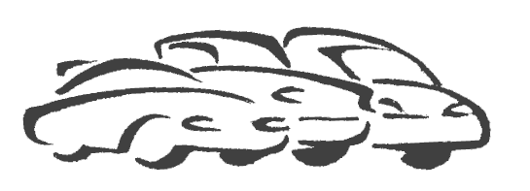

Program Administration:
Contact Name
Contact Phone
Contact Email
ARB Program Contact:
Contact Name
Contact Phone
Contact Email

Released: February 2007

Prepared By:

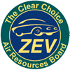

Zero Emission Vehicle Implementation Section
Mobile Source Control Division

This page intentionally blank

EXECUTIVE SUMMARY

Assembly Bill (AB) 1811 (Chapter 48, Statutes of 2006) authorized the creation of the Alternative Fuel Incentive Program (AFIP) and the appropriation of $25 million in total funding to promote alternative fuel infrastructure and buses, PHEV vehicles, education and outreach, and vehicle incentives. Approximately $1.5 million of the appropriation will be directed toward vehicle incentive grants. The grants of up to $10 thousand will be made available to consumers who purchase or lease eligible zero emission vehicles (ZEVs), plug-in hybrid electric vehicles (PHEVs) and alternative fuel vehicles (AFVs) between July 1, 2006 and June 30, 2009. This report constitutes the California Air Resources Board (ARB or Board) guidelines for the implementation of the alternative fuel vehicle incentive program (AFVIP) within AFIP.

An ARB Program Manager will implement and administer the AFVIP. Duties will include developing application and outreach materials, communicating with customers via phone, fax, and email, reviewing and approving applications, allotting and auditing funds, and providing a quarterly report to the ARB Program Contact on AFVIP activities. The Program Manager will ensure that each consumer receives the maximum grant amount available at the time of purchase or lease.

This program provides grants up to $10 thousand for the purchase or lease of new ZEVs, PHEVs and AFVs between July 1, 2006 and June 30, 2009. ZEVs capable of operation on freeways, also referred to as full-function battery electric vehicles (BEVs) or hydrogen fuel cell vehicles (FCEVs), are eligible for the full grant amount. PHEVs, AFVs, low speed electric vehicles (NEVs) and motorcycles are eligible for lesser amounts.

Eligible applicants include individuals, businesses, public agencies and entities, and private organizations. ARB retains the right to reserve, allocate and reallocate funds to any eligible grant recipient. The ARB will periodically review grant applicants and the award of grants to ensure, to the greatest extent possible, that all grant funds are used. The ARB may also reduce the grant amount or eliminate the grant if the applicant receives a grant from another component of AFIP.

Eligible applicants must accept the grant directly; the AFVIP does not provide applicants an option to assign their grant payment to a participating lessor. The grant shall be paid in a single allotment.

Eligible vehicles will be placed in one of several categories for the purpose of determining vehicle eligibility and the grant amount. The vehicle categories are: Full-Function ZEVs (FFZEVs), PHEVs, AFVs, City ZEVs (CEVs), Neighborhood ZEVs (NEVs), and Zero Emission Motorcycles (ZEMs). The ZEM category is subdivided into freeway-capable and non-freeway capable fully-enclosed, 3-wheel motorcycles and unenclosed 2-wheel motorcycles for purposes of establishing grant amounts.

Eligible vehicle models will be determined on a case-by-case basis. Vehicle eligibility criteria include certification by ARB as a New ZEV, PHEV, or AFV, compliance with all applicable Federal Motor Vehicle Safety Standards (FMVSS), and a minimum 36-month manufacturer warranty on the vehicle’s alternative fuel delivery system or power train and battery pack. The proposed grant amounts range from $500 up to $10 thousand per vehicle. Grant amounts are based upon 36 months of vehicle operation and may be prorated for operating periods of less than 36 months or for instances where the vehicle spends a portion of the 36 months—not to exceed 24 months—outside the state of California.

A summary of the eligible vehicle categories and grant amounts is provided in Table I.
Table I: Summary of Alternative Fuel Incentive Program
Vehicle Category | Manufacturer Earns ZEV Regulatory Credit | Grant Amount
Full Function ZEV (BEV or FCEV) | Yes | Up to $10,000
PHEV or City ZEV | Yes* | Up to $5,000
AFV | Yes* | $2,000
Neighborhood ZEV | Yes | $1,000
Zero-Emission Motorcycle (ZEM) | No | Up to $2,000
* Depending upon certification status

Implementation Schedule

A potential implementation schedule is provided in Table II.

Table II: Proposed Implementation Schedule

Date or Time Period | Action Item
April 2007 | Guidelines finalized
Current – June 30, 2009 | Applications accepted
July 2007 – June 2009 | Quarterly Status Report to ARB Program Contact

Table of Contents

GUIDELINES FOR IMPLEMENTING
AN ALTERNATIVE FUEL VEHICLE INCENTIVE PROGRAM (AFVIP)

- INTRODUCTION 1
1.1 Background 2
  - Air Resources Board Zero Emission Vehicle Program 2
  - Need for Incentives 3

2.0 PROGRAM ADMINISTRATION 4
2.1 Program Access 4
2.2 Program Manager 4
2.3 Overview: Grant Payment Process and Effective Dates 5

3.0. ELIGIBILITY CRITERIA 6
3.1 Criteria for Applicant Eligibility 6
3.2 Criteria for Vehicle Eligibility 7

4.0. INCENTIVE STRUCTURE AND ALLOCATION 11
4.1 Distribution of Vehicle Grants 11
4.2 Grant Calculation 12

5.0. SUMMARY 12

Appendices

- List of Definitions
- List of Eligible Vehicle Models
- Sample Quarterly AFVIP Activity Reporting Form
- Table of Federal Motor Vehicle Safety Standards
- Sample AFVIP Grant Application

- INTRODUCTION

A number of recent state policy directives call for Californians to reduce their dependence on petroleum-based fuels and expand substantially their use and production of non-petroleum based alternative fuels. To support these policy directives, Assembly Bill (AB) 1811 (Chapter 48, Statutes of 2006) provided $25 million to the California Air Resources Board (ARB or Board) and the California Energy Commission (CEC) to incentivize and fund:

- Market-based incentives for high efficiency, high mileage, alternative fuel light, medium, and heavy-duty vehicles, both individual and public fleets, in California.
- Production incentives for alternative fuel production in California;
- Market-based incentives for the construction of both publicly accessible alternative fuel retail refueling stations and fleet fueling facilities; including E85.
- Funding for research, development, and testing of alternative fuels and vehicle technology.
- Incentives to replace the current state vehicle fleet with clean, high mileage alternative fuel vehicles.

This report constitutes the California Air Resources Board (ARB or Board) guidelines for the implementation of the Alternative Fuel Vehicle Incentive Program (AFVIP) of the Alternative Fuel Incentive Program (AFIP). Zero emission vehicles (ZEVs), plug-in hybrid electric vehicles (PHEVs) and alternative fuel vehicles (AFVs) are an integral part of California's efforts to meet health-based air quality standards. These vehicles also present an opportunity to address two ancillary negative impacts of conventionally-fueled cars and small trucks – global climate change and energy dependence.

The purpose of this incentive program is to offset a portion of the incremental additional cost of advanced automotive technologies like ZEVs, PHEVs and AFVs so that the vehicle cost is comparable to that of a conventionally fueled vehicle. This in turn helps with commercialization of these technologies and supports a critical ramp-up in ZEV, PHEV and AFV production that is necessary to meeting our clean air goals. The program provides grants of up to $10 thousand to qualified individuals, businesses, public agencies and entities, and non-profit organizations for the purchase or lease of an eligible PHEV or AFV between July 1, 2006 and June 30, 2009. The grants reduce the incremental cost of new PHEVs and AFVs. Up to ten percent of the program funds may be used for grant program administration.

This guideline document establishes the administrative process and both applicant and vehicle eligibility criteria. A timetable for implementation of the program is shown in Table 1 below. ARB and CEC are committed to a quick, successful implementation of the program.

Table 1: Proposed Implementation Schedule

Date or Time Period | Action Item
April 2007 | Guidelines finalized
Current – March 31, 2009 | Applications accepted
July 2007 – June 2009 | Quarterly Status Report to ARB Program Contact

  - Background

Air quality in California has improved dramatically over the past 30 years, largely due to continued progress in controlling pollution from motor vehicles. Faced with ever more stringent regulations, vehicle manufacturers have made remarkable advances in vehicle technology. Thousands of zero- and partial zero emission vehicles are now in everyday service on California roads, and the latest conventional internal combustion engine vehicles achieve emission levels that seemed impossible just a few short years ago.

Despite this progress, however, air quality in many areas of the state still does not meet federal or state health-based ambient air quality standards. Mobile sources are still responsible for well over half of the ozone-forming emissions in California, and passenger cars and small trucks are responsible for a significant portion of the mobile source contribution. State and federal law requires the implementation of control strategies to attain ambient air quality standards as quickly as practicable.

The ARB has administered several vehicle "buy-down" incentive programs that are designed to work synergistically with these control strategies. The programs offset the incremental additional cost of advanced automotive technologies until production economies of scale bring the costs down to a competitive level.

Since 1996, the ARB, the local air districts, CEC, and the South Coast Air Basin Mobile Source Air Pollution Reduction Committee (MSRC) have administered several incentive programs, providing grants for electric, hybrid electric, and dedicated natural gas passenger cars and light-duty trucks. The grants ranged from $1 thousand for hybrid electric vehicles to $11 thousand for battery electric vehicles operating in fleets in environmental justice communities.

  - Air Resources Board Zero Emission Vehicle Program

In 1990, the ARB adopted the Zero Emission Vehicle (ZEV) program as part of the Low Emission Vehicle regulations. The ZEV program is an integral part of California’s mobile source control efforts, and is intended to create a market for advanced technologies that will secure increasing air quality benefits for California now and into the future. ZEVs have significant long-term benefits because they have no emission control equipment that can deteriorate or fail, and they generate only minimal “upstream” refueling and fuel cycle emissions.

ZEVs also have the capability to provide comprehensive energy benefits. High-efficiency ZEVs result in significant reductions in emissions of carbon dioxide (CO₂) and other greenhouse gases. Vehicles powered by grid electricity and/or hydrogen will increase the diversity of California’s fuel consumption and reduce our dependence on imported oil. In addition, electric drive vehicles have the potential to be powered by renewable sources of energy such as wind, hydropower, or solar energy.

Since 1990, the Board has reconvened several times to consider, and ultimately adopt, modifications to the originally proposed ZEV program. In its revised form, the ZEV program allows automakers a choice as to which technology to use to meet the requirements – battery electric or hydrogen fuel cell vehicles. It also provides for optional sales of partial zero emission vehicles (PZEVs) and advanced technology PZEVs (AT PZEVs) in lieu of a portion of the ZEV requirement. The revised regulation also includes an alternative path that allows a small number of early-deployment fast-refuel ZEVs (usually fuel cell vehicles) to substitute for larger numbers of other ZEV types.

ZEVs continue to be a substantial and important part of ARBs clean air strategy, and the lowered cost of PHEV batteries and drivetrain components resulting from a ramp-up in production appears likely to represent the bridge to ZEV commercialization. But PHEVs are also expected to be costly until manufacturing reaches economies of scale significant enough to bring battery prices down.

Concurrently, the CEC has been promoting alternative fuel vehicles through both regulation and incentives. The CEC’s last incentive program sunsetted in 2004 after making grants available to both hybrid electric and alternative fuel vehicles.

AFVs are also important to our clean air strategy. While only modestly more costly than similar conventional vehicles, they can have higher infrastructure costs (for example, a home refueling station for a natural gas vehicle can cost a few thousand dollars).

  - Need for Incentives

Government incentives are one way to address the incremental additional vehicle and infrastructure cost associated with advanced vehicle technologies. Incentives are commonly used to promote the introduction of new technology that will benefit society. Because ZEVs, PHEVs and AFVs are relatively new technologies and are currently produced in limited quantities, they are more expensive than conventional vehicles. To enhance vehicle marketability in the near term and to assist in the transition to large volume production, it is vital to provide support, both monetary and non-monetary, in the form of vehicle and infrastructure incentives. Under AFVIP, these buy-down incentives will be awarded to the consumer to reduce the capitalized cost of ZEVs, PHEVs and AFVs; this program does not provide for incentives to be transferred through to the lessor.

- PROGRAM ADMINISTRATION

This chapter describes how the AFVIP will be administered. Specifically, this chapter outlines roles and responsibilities of the Program Manager and how the program will operate from the consumer's perspective, including how consumers will get information about the program, how they will apply for grants and how grants will be distributed.

  - Program Access

It is important that incentive program information be centrally available to the public and other interested parties. The ARB has an established website for disseminating this information (www.driveclean.ca.gov). The website was primarily established to provide easy and up-to-date information on the family of clean cars with special emphasis on zero emission vehicles, their availability, attributes, incentives and benefits. The website allows potential consumers to indicate the type of vehicle they are interested in purchasing or leasing and the city where they live; and then the consumer is given specific information on incentive grant eligibility and how to apply (grant applications and instructions may be downloaded from the website). It also contains information on other incentives provided by agencies like the CEC and local air districts.

Program information is also available through the Program Manager’s toll-free information line, which will be provided at a later date. Operators of this information line will use the www.driveclean.ca.gov web site to provide information about available incentive programs; they will also direct callers to the appropriate staff person at the ARB, CEC, or local air district for non-AFVIP incentive programs.

  - Program Manager

The AFVIP will be administered by a third-party Program Manager selected through a request for grant proposal. The Program Manager will be responsible for administering the program in a manner consistent with these guidelines.

At a minimum, the Program Manager will:

- Review applications for eligibility
- Approve or disapprove grant applications
- Verify that all required information has been submitted prior to grant distribution
- Authorize grant distribution
- Track program status, including funding allocations
- Submit quarterly reports on program status to the ARB Executive Officer
- Recommend changes to the guidelines, as needed
- Prepare outreach and educational materials in consultation with ARB staff
- Provide information, upon request, to individuals or organizations that wish to appeal a grant denial to the Executive Officer
- Coordinate with ARB and vehicle dealers to assist buyers in receiving all other incentives that may apply to the vehicle (buy-down, infrastructure, HOV etc).

  - Overview: Grant Payment Process and Effective Dates

At any time, a potential consumer may access the www.driveclean.ca.gov web site or call the Program Manager to receive information on program eligibility. Both of these resources will be designed to assist consumers with their purchase or lease decisions. Information will be provided on the amount of total funding available, vehicle eligibility, and the maximum grant that is available for each qualified vehicle.

    - Payment of Grant to Vehicle Lessee/Owner

Consumers who purchase or lease (for a period of 36 months or more) an eligible ZEV, PHEV, or AFV may apply for direct payment of the grant. Grant payments will be distributed in a single allotment. Consumers will receive the grant payments directly from the Program Manager.

At any time following the purchase or lease transaction, an applicant may either download a grant application package from the www.driveclean.ca.gov website, or contact the Program Manager by telephone or email to request that the package be mailed to them. The applicant will submit the application to the Program Manager, along with the required supporting documentation of the purchase or lease, such as a copy of the sales or lease contract, along with an itemization of discounts, incentives and credits received, and appropriate proof of temporary or permanent vehicle registration. The Program Manager will issue a grant check to the owner or lessee once the application with the valid required documentation is received.

This program is retroactive to July 1, 2006. Applicants may submit a completed application and required documentation for eligible ZEVs, PHEVs, and AFVs purchased between July 1, 2006, and the date of program implementation to the Program Manager. In such cases, applicants do not need to obtain voucher numbers prior to submitting applications.

    - Assignment and Reversion of Grant Allotments

The intent of this program is to place ZEVs, PHEVs, and AFVs in the 2006-2009 timeframe and to reduce the cost of these vehicles over a 36-month period. With that said, the ARB realizes that some vehicles may be sold or returned to a dealer within the first 36 months after purchase or lease initiation. If a vehicle is resold, staff requires that grant awardees assign a prorated portion of their grant benefit, in an amount equivalent to the original grant amount divided by 36 months and then multiplied by the number of months remaining in the original 36 month period (rounded to the nearest month), to the new owner or lessee of the vehicle. If the vehicle is returned to the dealer, the same prorated portion of the grant benefit should be directed to the Program Manager.

    - Appeal Process

If an applicant is denied a grant, the Program Manager will provide the applicant with the reason for the denial in writing. Any applicants who feel that they have been unfairly denied a grant may submit an appeal to the ARB Program Contact. Such an appeal must be submitted to the ARB Program Contact within 30 days of the date shown on the written denial letter. The appeal must be made in writing, and be signed by the applicant. Appeals made by e-mail, fax or phone will not be considered. A written response to the appeal will be provided by the ARB Program Contact within 60 days of receipt.

ELIGIBILITY CRITERIA

This chapter describes which applicants and vehicles are eligible for the grants provided by this program.

The program is authorized to provide grants to all entities purchasing or leasing an eligible ZEV, PHEV, or AFV. Applicants must meet the eligibility criteria specified in Section 3.1.

Section 3.2 specifies AFVIP eligibility criteria. Vehicles must meet all of the criteria to be considered eligible. ARB staff has created an Initial List of Eligible Vehicle Models based upon the eligibility criteria (see Appendix B) (the list is accessible from the AFVIP website: www.driveclean.ca.gov), and will update the list to reflect new additions as they become available. The vehicle manufacturer is responsible for providing the ARB with sufficient information to determine a vehicle's eligibility.

  - Criteria for Applicant Eligibility

The following applicants are eligible grant recipients:

- Individuals (i.e., retail or private customers/consumers),
- Federal, State, regional or local government entities or agencies,
- Nonprofit organizations,
- Private businesses, or
- Vehicle manufacturers demonstrating prototype ZEVs, PHEVs, or AFVs.
Applicants must be California residents and demonstrate through their applications that the vehicles:

- Are registered. The vehicle must meet DMV registration requirements and be registered with the DMV for use in California. Appropriate proof of temporary or permanent vehicle registration must be submitted with the grant application. A copy of the Application for New Vehicle Registration submitted by the dealer to DMV is acceptable proof of temporary vehicle registration if submitted within one year of sale. Local, state and federal agencies and entities may submit other documents with the prior approval of the Program Manager.
- Were leased or purchased within the grant eligibility window. The vehicle must be purchased or leased on or after July 1, 2006, and on or before
March 31, 2009. For the purposes of this program, the date of purchase shall be the day of sale. Typically, a sale is deemed completed and consummated when the purchaser of the vehicle has paid the purchase price, or, in lieu thereof, has signed a purchase contract or security agreement and taken physical possession or delivery of the vehicle. For purposes of this program, a vehicle shall be deemed to be leased on the date upon which the lease of the vehicle commences, which is typically specified in a signed lease agreement.
  - If leased, the vehicle must be leased for a minimum term of 36 months. For a leased ZEV, the grant applicant shall be the person or entity that is financially responsible for registration of the vehicle. Vehicles leased or offered for lease for a minimum term less than 36 months are not eligible.

Criteria for Vehicle Eligibility

This section discusses the categories of vehicles eligible for grant funding under the AFVIP and the specific criteria that a vehicle model must meet to be considered eligible.

    - Vehicle Categories

There are three general categories of vehicles eligible for grant funding under the AFVIP. They are ZEVs, PHEVs, and AFVs.

ZEVs

The ZEV category is divided into Full Function Zero Emission Vehicles (FFZEVs), City Zero Emission Vehicles (CEVs) Neighborhood Zero Emission Vehicles (NEVs) and Zero Emission Motorcycles (ZEMs).

- Full-Function Zero Emission Vehicle (Full Function ZEV or FFZEV)
Vehicle models placed in the FFZEV category are typically zero emission passenger cars and light-duty trucks powered by batteries and/or a hydrogen fuel cell that are capable of operation on freeways. Specialty fleet versions based on passenger car or light-duty truck chassis will be considered FFZEVs. FFZEVs are subject to the same federal motor vehicle standards (FMVSS) as passenger cars or light-duty trucks. FFZEVs must be certified as Tier 2 or Tier 3 ZEVs. FFZEVs may be used in many typical passenger car and light-duty truck applications. Current and past FFZEV models include two-seat pickup trucks, two-seat coupes, sedans, sport utility vehicles and minivans. For a vehicle model that is not yet ARB-certified as a New ZEV, the OEM or its authorized licensee may apply to ARB for the necessary certification. It is ARB staff’s experience that the approval process typically takes approximately four weeks, provided a complete application with the results of applicable test procedures is submitted. Staff recommends that manufacturers of new vehicle models, in particular models not previously available for sale in California, contact the DMV Registration Operations Division to ensure that the vehicle model meets California registration and safety requirements.

- City Zero Emission Vehicle (City ZEV or CEV) These vehicles are subject to the same eligibility criteria as FFZEVs
Vehicle models placed in the CEV category may be similar to FFZEVs and may be suitable for many of the same applications. However, vehicle models that have manufacturer-imposed limitations or restrictions on their operation on freeways will be placed in the CEV category. CEVs are subject to the same FMVSS for passenger cars or light trucks. However, CEVs will typically be smaller in size, seat two passengers and have less range (miles that the vehicle can travel when starting with fully charged batteries) than FFZEVs. CEVs are typically equipped with smaller battery packs, which reduce the cost to produce the vehicles. City EVs typically have lower top speeds than FFZEVs. CEVs would be suitable for use as local commute vehicles in urban and city centers.

- Neighborhood Zero Emission Vehicle (Neighborhood ZEV or NEV)
Vehicles placed in the NEV category are zero emission low speed vehicles. Per California Vehicle Code (CVC) Section 385.5, a low speed vehicle is a motor vehicle, having four wheels on the ground and an unladen weight of 1.8 thousand pounds or less, that is capable of propelling itself at a minimum speed of 20 miles per hour and a maximum speed of 25 miles per hour on a paved level surface. NEVs may be legally operated on public streets with maximum speed limits of 35 mile per hour or lower. Therefore, NEVs are particularly suited for operation in residential neighborhoods, planned communities, campus environments, business parks, and, possibly, transportation centers. Low speed vehicles are not subject to FMVSS applicable to passenger cars and light trucks. Instead, low speed vehicles are subject to a single safety standard (Standard Number 500) that requires ten specific items of safety equipment.

- Zero Emission Motorcycles (ZEMs)
Fully-enclosed zero emission vehicles designed to travel on three wheels are motorcycles in the ZEM category. ZEMs are subject to the FMVSS applicable to motorcycles, which are less extensive than the FMVSS for passenger cars and light-duty trucks. Three-wheel motorcycles not fully enclosed may be considered ZEMs for the purposes of the AFVIP if they can perform the same transportation needs as FFZEVs and CEVs. ZEMs provide a person who commutes alone with a lower cost, zero emission transportation option.

PHEVs

- Plug-in hybrid electric vehicle (PHEV)
Also known as Grid-connected HEV or GHEV, these hybrid electric vehicle models are placed in the PHEV category. PHEVs have a zero emission vehicle range capability, an on-board electrical energy storage device with a useful capacity equivalent to 10 or more miles of Urban Dynamometer Driving Schedule (UDDS) range on electricity alone, are equipped with an on-board charger, and are rechargeable from an external connection to an off-board electrical source.

AFVs

- Alternative fuel vehicle (AFV)
Vehicle models placed in the AFV category are also freeway capable, are required to meet numerous FMVSS, and have the same functionality as the typical passenger car or light-duty truck on the road. AFVs have an internal combustion engine with a dedicated fuel system that operate solely on a single alternative fuel. A list of alternate fuels is included in the Alternative Fuel definition in Appendix A.

To be eligible for AFVIP grants, vehicle models must be ARB certified as new ZEVs, PHEVs, or AFVs and must comply with all applicable FMVSS and State safety standards. A table summarizing the FMVSS for a number of vehicle categories is provided in Appendix D.

Eligible Vehicle Models

Vehicle models will be approved by ARB staff on a model year basis and placed on a List of Eligible Vehicle Models for AFVIP grants (Appendix B). Manufacturers of vehicle models not currently on the list should request in writing to the ARB Program Contact that their vehicle model be considered for addition to the list of eligible vehicle models. The written request should include a description of the vehicle model, the manufacturer’s certification that the vehicle model meets all applicable State and Federal safety standards and be accompanied by copies of the vehicle operation and service manuals and applicable warranties.

Eligible vehicle models must meet the following criteria:

- Be new. The vehicle model has been certified by the ARB as a new ZEV, PHEV, or AFV. To be eligible, the vehicle shall be a new vehicle as defined in Section 430 of the California Vehicle Code. The Original Equipment Manufacturer (OEM) or its authorized licensee must manufacture the vehicle. Vehicles considered new vehicles solely for determination of compliance with state emissions standards pursuant to Health and Safety Code, Article 1.5, Prohibited Transactions, (Sections 43150-43156) and CVC Section 4000.2, Registration of Out-of-State Vehicles, are not eligible vehicles.
  - If the vehicle is not new, has been re-leased, is the subject of a lease assumption or has been transferred into California after previously having been registered out-of-state, the vehicle is not eligible.
- Be newly converted (this option is still under review). Used vehicles converted within the grant eligibility window (see section 3.1) as part of a batch conversion by a certified converter or having received a certified conversion kit.
- Be a specialty fleet version. The eligibility of specialty fleet vehicle models based on an eligible passenger car or light- or medium-duty truck model will be determined on a case-by-case basis.
- Be certified. The manufacturer has certified that the vehicle model or conversion kit complies with all applicable Federal and State safety standards, including, in the case of vehicles, applicable FMVSS. The FMVSS are safety standards for new motor vehicles and new motor vehicle equipment issued by the National Highway Traffic Safety Administration (NHTSA). The FMVSS are found in Title 49 of the Code of Federal Regulations (CFR) Part 571. If a written statement and documentation have been previously provided to ARB in the course of applying for ARB approval/certification of the vehicle model, no additional written statement is required. In the case where vehicles of a particular vehicle model are to be utilized solely for a demonstration project, the written statement must include documentation that the applicable waivers for those vehicles have been received from NHTSA or that the manufacturer has submitted the appropriate applications or required notifications to NHTSA.
  - Eligibility of imported vehicles with an exemption from applicable federal or state safety standards will be determined in a case-by-case basis.
- Be capable of operation on the freeway. For the purpose of this program, the ARB may request that a vehicle manufacturer provide a written statement on whether or not vehicles of a particular vehicle model are capable of operation on the freeway. Per California Vehicle Code (CVC) Section 22400 (Minimum Speed Law), no person shall drive upon a highway at such a slow speed as to impede or block the normal and reasonable movement of traffic. In order for a vehicle to be considered capable of operation on a freeway, it must be in compliance with CVC Section 22400. CEVs may be considered freeway capable assuming they are not subject to any of the circumstances listed below. A vehicle shall be presumed not capable of operation on the freeway if any one of the following circumstances apply:
  - The vehicle is a low-speed vehicle as defined by CVC Section 385.5;
  - The vehicle is prohibited by law from being operated on the freeway or is only capable of limited operation on the freeway;
  - The manufacturer has required, or will require, the purchaser or lessee to sign an agreement that limits, or prevents, the operation of the vehicle on the freeway; or
  - There is a written manufacturer's statement or recommendation (which can include the owner's manual for the vehicle) that the vehicle should not be operated on the freeway or should have limited operation on the freeway.
- Have warranty provisions. To be eligible, a vehicle, including the battery pack of ZEVs, must be covered by a manufacturer warranty for a minimum of 36 months. At a minimum, a full warranty shall be provided for the first 12 months of the coverage period. If the warranty for the remainder of the coverage period is prorated, the percentage of the battery pack's original value to be covered or refunded must be at least as high as the percentage of the prorated coverage period still remaining. For the purpose of this computation, the age of the battery pack must be expressed in intervals no larger than three months. For vehicle purchases and lease periods greater than 36 months, manufacturers are encouraged to provide or offer extended warranties. Prior to approving a vehicle model for addition to the List of Eligible Vehicles, the Program Manager may request that the manufacturer provide copies of representative vehicle and battery warranties and a description of the manufacturers’ plans to provide warranty and routine vehicle service.
- Under the AFVIP, NEV manufacturers need not retire or forego ZEV regulatory credits earned from the production of a vehicle offered for sale in California and the placement of the vehicle into service. This differs from the previous ARB incentive programs which required the manufacturer to enter into an agreement with the ARB to retire or forego the ZEV regulatory credits earned by a specific vehicle model on a model year basis in order to make the NEV eligible for a grant.

- INCENTIVE STRUCTURE AND ALLOCATION

This chapter describes staff's plan for distributing the grant, how the amount of the grant will be calculated, and allocating the grant funds.

  - Distribution of Vehicle Grants

The grant for an eligible vehicle will be distributed to the qualified recipient in a single allotment. The distribution of this grant allotment will be made as soon as possible, but no later than 60 days after receipt and verification of the documentation required for approval of the grant application.

  - Grant Calculation

The ARB will establish a maximum grant for each eligible vehicle model. The maximum grant shall be equal to “the maximum available grant”, up to $10 thousand. The ARB will include the information on the maximum grant for each eligible vehicle model in its List of Eligible Vehicle Models (See Appendix B).

- SUMMARY

In summary, the incentive program provided by AB 1811 is a positive step towards supporting California’s clean car goals. It provides grants to reduce the incremental cost of new ZEVs, PHEVs, and AFVs from 2006 to 2009. These vehicles will thus be more affordable for the general public, public agencies, and private fleets.

Incentive programs such as the one created by AB 1811 are essential to increase sales volumes and reduce the cost of advanced vehicle technologies. This program was intended to encourage manufacturers to increase the number of clean cars available.

However, AB 1811 alone will not achieve all of our goals. Other incentives such as access to high occupancy vehicle lanes, decreased vehicle license fees, and preferential parking are also valuable for making clean cars more attractive to consumers. In addition, continued support for the current incentive and infrastructure programs is encouraged.

Appendix A

List of Definitions

“Advanced Technology Partial Zero Emission Vehicle” (AT PZEV) means any PZEV with an allowance greater than 0.2 before application of the PZEV early introduction phase-in multiplier. AT PZEVs are 90% cleaner than the average new car and have near-zero evaporative emissions. They also incorporate alternative fuel, gas electric, or other advanced technology. AT PZEVs must have a 15 year/150,000 mile warranty on the emission control system.

“Alternative Fuel” means;
- Mixtures containing 85 percent or more by volume of alcohol fuel, including methanol and denatured ethanol
- Natural gas (compressed or liquefied)
- Liquefied petroleum gas (propane)
- Hydrogen
- Fuels derived from biological materials
- Electricity (including electricity from solar energy)
- 100 percent Biodiesel (B100) or Renewable Diesel meeting ASTM D-975.
- Blends of two or more alternative fuels, for example, natural gas and hydrogen

“Alternative Fuel Vehicle” (AFV) means a vehicle fueled exclusively by alternative fuels (must be 100 percent alternative fuel use)

“Battery Electric Vehicle” (BEV) means any vehicle that operates solely by use of a battery, or that is powered primarily through the use of an electric battery but uses a flywheel or capacitor that also stores energy to assist in vehicle operation.

“Hybrid Electric Vehicle” (HEV) means any vehicle that can draw propulsion energy from both of the following on-vehicle sources of stored energy: 1) consumable fuel, and 2) an energy storage device such as a battery, capacitor, or flywheel.

“Light-duty truck” means any 2000 and subsequent model motor vehicle certified to the standards in section 1961(a)(1), Title 13, California Code of Regulations (CCR), rated at 8.5 thousand pounds gross vehicle weight or less, and any other motor vehicle rated at 6 thousand pounds gross vehicle weight or less, which is designed primarily for purposes of transportation of property or is a derivative of such a vehicle, or is available with special features enabling off-street or off-highway operation and use.

“Medium-duty passenger vehicle” means any medium-duty vehicle with a gross vehicle weight rating of less than 10 thousand pounds that is designed primarily for the transportation of persons. The medium-duty passenger vehicle definition does not include any vehicle which: 1) is an “incomplete truck”, i.e., is a truck that does not have the primary load carrying device or container attached; or 2) has a seating capacity of more than 12 persons; or 3) is designed for more than nine persons in seating rearward of the driver’s seat; or 4) is equipped with an open cargo area of 72.0 inches in interior length or more. A covered box not readily accessible from the passenger compartment will be considered an open cargo area, for purposes of this definition.

“Medium-duty vehicle” means any heavy-duty low-emission, ultra-low-emission, super-ultra-low-emission or zero-emission vehicle certified to the standards in
Section 1961(a)(1) or 1962, Title 13, CCR, having a manufacturer's gross vehicle weight rating between 8,501 and 14,000 pounds.

“Neighborhood Electric Vehicle” (NEV) means a motor vehicle that meets the definition of “low-speed vehicle” either in section 385.5 of the Vehicle Code or in 49 CFR 571.500 (as it existed on July 1, 2000) and is certified to zero-emission vehicle standards

“Partial Zero Emission Vehicle” (PZEV) means any vehicle that is delivered for sale in California and that qualifies for a partial ZEV allowance of at least 0.2.

“Passenger car” means any motor vehicle designed primarily for transportation of persons and having a design capacity of twelve persons or less.

“Plug-in hybrid electric vehicle” (PHEV), (also known as a Grid-connected HEV or GHEV) means a hybrid electric vehicle which has:
- zero emission vehicle range capability,
- on-board electrical energy storage device with useful capacity equivalent to greater than or equal to ten miles of Urban Dynamometer Driving Schedule (UDDS) range on electricity alone,
- is equipped with an on-board charger, and is
- rechargeable from an external connection to an off-board electrical source.
Note: A light-duty PHEV must be ARB AT-PZEV certified.

“UDDS” means urban dynamometer driving schedule as set forth Appendix I of title 40, Code of Federal Regulations, Part 86.

Appendix B

List of Eligible Vehicle Models

An initial list of eligible vehicle models will be provided in the final guidelines document. The initial list and subsequent additions will be available from the http://www.driveclean.ca.gov website.

Appendix C

Sample Quarterly AFVIP Activity Reporting Form
Alternative Fuel Vehicle Incentive Program (AFVIP)
SAMPLE Activity Report:
January 1, 2007 through March 31, 2007

I.

Grant Requests1
Received | Approved | Disapproved | Pending

II.

Approved Grants by Vehicle Make and Model
Model | Quantity | Grant Funding ($)
Total vehicles |  | Total $

III.
Individual | Business | Local/Public Agency

IV.

Status of ARB Funds
Original/Reduced Appropriation: | $1,350,000
Approved Grants:
Pending Grant Applications:
Remaining Funds: | ($x,xxx,xxx)

Appendix D

Table of Federal Motor Vehicle Safety Standards

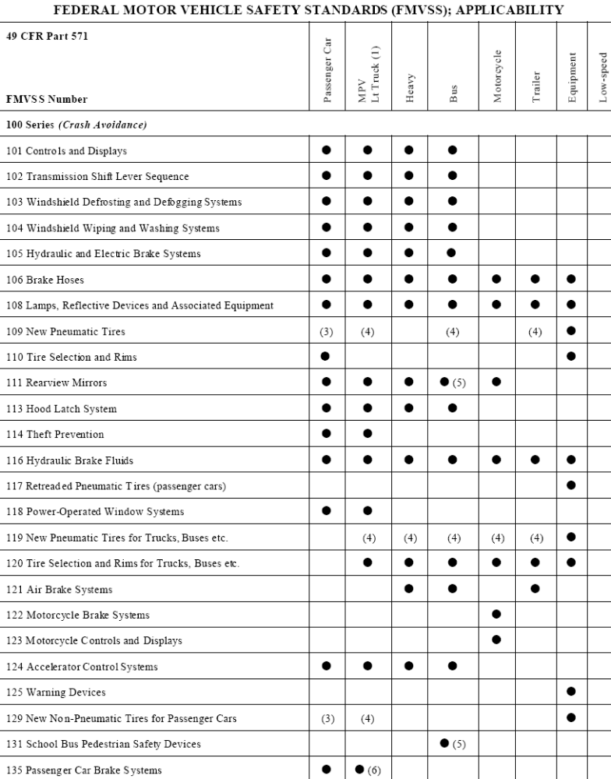

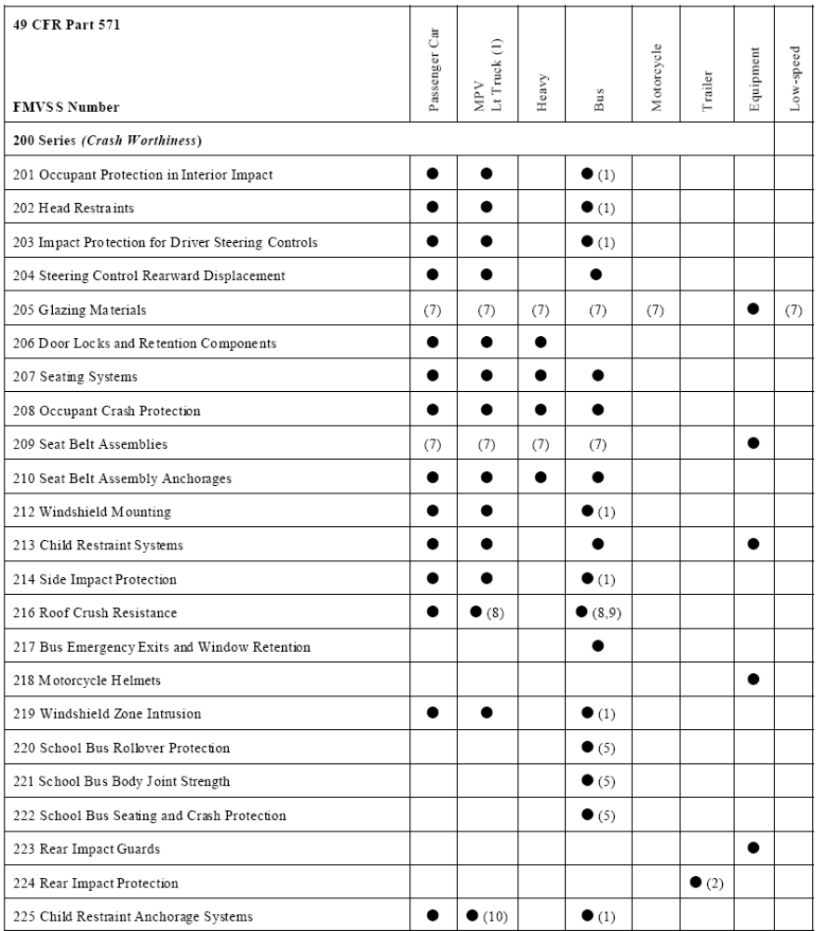
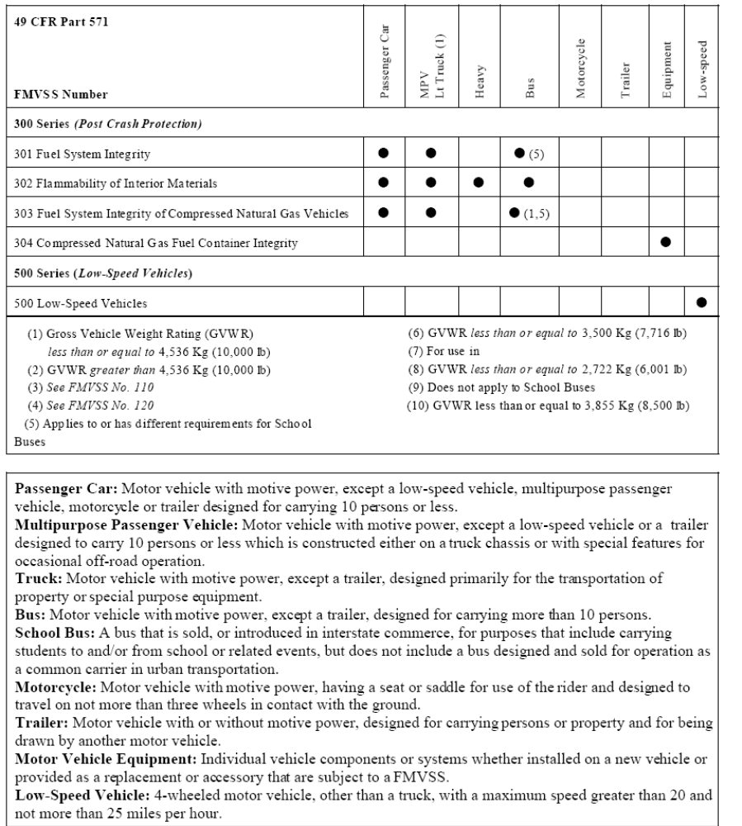

Appendix E

SAMPLE AFVIP Grant Application

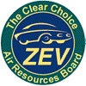 | Alternative Fuel Vehicle Incentive Program (AFVIP)  SAMPLE Grant Application  Complete and Submit to: | Obtain from ARB Voucher Number:  N/A

Program Manager, Statewide Alternative Fuel Vehicle Incentive Program, California Air Resources Board, MSCD/ZEV P.O. Box 2815, Sacramento, California 95812
Toll Free Line: (866) 808-0189

- APPLICANT INFORMATION (Please print.)
Name of Vehicle Owner/Lessee: |  |  |  |  | PURPOSE: Information contained in this form will be used by the Air Resources Board for determining grant eligibility, processing grant allocations, and to prepare Information Returns (Form 1099).  (See Privacy Statement in Requirements and Instructions)
Street Address:

City: |  |  |  |  | State: | Zip Code:
Mailing Address:

Telephone Number: | FAX Number: |  |  | E-mail Address (optional):
Please check one box below, as applicable, and provide the requested information:
Private Individual, Sole Proprietor  Federal Government Agency  State Government Agency  Local Government Agency  Non-profit Organization  Corporation  Partnerships, Estates or Trusts |  | Social Security Number:
 |  | OR
 |  | Federal Employer's Identification Number:
B. VEHICLE INFORMATION (Multiple vehicles-Form MSCD/ZEV-05B is attached. Initial here: _____)
Date of Purchase or Date on Which Lease Commences: |  |  | Lease Term in Months (if applicable):
Make, Model and Model Year of ZEV: |  |  | Vehicle Identification Number (VIN):
Manufacturer/Lessor Contact (Please print name and title.): |  |  |  |  | Telephone Number:

I hereby certify to the best of my knowledge and belief that the requirements for this grant as specified in H&SC 44260-44265 and the Air Resources Board's (ARB’s) program guidelines have been met and that all information provided in this application and supporting attachments are true and correct.

Name of Applicant, or Authorized Representative and Title (Please print.):

Signature: | Date:

Name and Title (Please print.): | Date: | Approval Number
Signature: | Grant Amount: | Area Reserved
FOR PROGRAM MANAGER USE ONLY

(a PZEV is a super ultra low emission vehicle (SULEV) with zero evaporative emissions and a ten year/150 thousand mile emission warranty)
(AT PZEVs advance zero emission technologies by incorporating advanced drivetrain components such as electric motors into PZEVs)
The results of tests specified in, and in conformance with, “California Exhaust Emission Standards and Test Procedures for 2003 and Subsequent Model Zero-Emission Vehicles, and 2001 and Subsequent Model Hybrid Electric Vehicles, in the Passenger Car, Light-Duty Truck and Medium-Duty Vehicle Classes, Adopted August 5, 1999.”
Per Section 430 of the California Vehicle Code, a "new vehicle" is a vehicle constructed entirely from new parts that have never been the subject of a retail sale, or registered with the department, or registered with the appropriate agency or authority of any other state, District of Columbia, territory or possession of the United States, or foreign State, province, or country.
The application or notification required by applicable FMVSS including Part 555 –Temporary Exemptions from Motor Vehicle Safety Standards (Effective 1-29-73) and Part 591- Importation of Vehicles and Equipment Subject to Federal Safety, Bumper and Theft Prevention Standards (Effective 3-28-90).

